COLD STRATEGIC PLAN SURVEY RESULTS  
*COLD Strategic Plan 2018-21 - Update*  
**November 28, 2022, 2:35 pm MST 83% response**

**Q1 - Do you agree the Task Force should focus on a revision of the current plan or "start from scratch" on a new plan?**

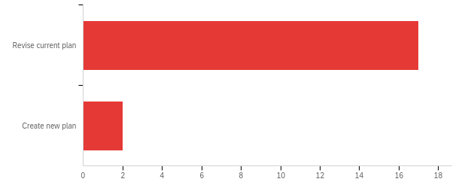

|  |  |  |  |
| --- | --- | --- | --- |
| # | Answer | % | Count |
| 1 | Revise current plan | 89.47% | 17 |
| 2 | Create new plan | 10.53% | 2 |
|  | Total | 100% | 19 |

**Q2 - Should the plan cover 3, 5, 10 years or other?**

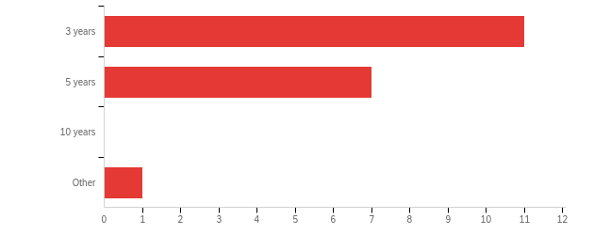

|  |  |  |  |  |  |  |  |
| --- | --- | --- | --- | --- | --- | --- | --- |
| # | Field | Minimum | Maximum | Mean | Std Deviation | Variance | Count |
| 1 | Should the plan cover 3, 5, 10 years or other? - Selected Choice | 1.00 | 4.00 | 1.53 | 0.75 | 0.57 | 19 |

|  |  |  |  |
| --- | --- | --- | --- |
| # | Answer | % | Count |
| 1 | 3 years | 57.89% | 11 |
| 2 | 5 years | 36.84% | 7 |
| 3 | 10 years | 0.00% | 0 |
| 4 | Other | 5.26% | 1 |
|  | Total | 100% | 19 |

**Q2_4 Other**

|  |
| --- |
| Other - Text |
| I'd like to see us focus on strategic priorities, with an annual review. I don't like affixing a long-term outlook. |

**Q3 - Do you agree the Task Force should focus strongly on DEI and social justice as one approach to revising the plan?**

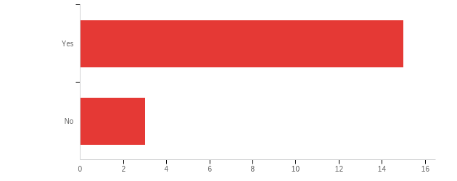

|  |  |  |  |
| --- | --- | --- | --- |
| # | Answer | % | Count |
| 1 | Yes | 83.33% | 15 |
| 2 | No | 16.67% | 3 |
|  | Total | 100% | 18 |

**Q4 - Does the Vision Statement need any modifications?**

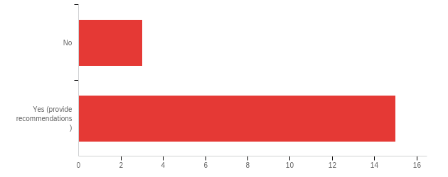

|  |  |  |  |
| --- | --- | --- | --- |
| # | Answer | % | Count |
| 1 | No | 16.67% | 3 |
| 2 | Yes (provide recommendations) | 83.33% | 15 |
|  | Total | 100% | 18 |

Q1_2_TEXT - Yes (provide recommendations)

|  |
| --- |
| Include innovative collaboration and leadership in advancing both physical and digital/online learning environments |
| If the strategic plan is going to center DEI/social justice, that should be reflected in the vision. |
| Current statement does not fit CSU |
| Strong DEI focus and a clear definition of COLD's impact on practical daily operational work of the CSU libraries. We, as a leadership team need to have mte consistent best practices that we all support and can be communicated throughout the system so that library employees understand our values and mission. |
| I don't have particular recommendations but think that we should review the language to see if it is still what we want. |
| Need to call out DEI |
| Add DEIA focus into the vision |
| International recognition doesn't see like a high priority. |
| Mission and Vision are both good, but also generic at the system level. Can they be revised to reflect the CSU context more clearly? |
| It still is relevant, but I feel it doesn't emphasize the role libraries play in student career readiness. |
| focus beyond teaching, incl. learning (student focused) and research (some campuses are shifting strongly in that direction) |
| I like this vision statement, but I do not believe we do the work necessary to make the vision a possibility. Are we, as a group, willing to think big and work towards active change? |
| Being "internationally-recognized" doesn't seem like the right vision for the CSUs. We need a more concise, action-oriented vision. I don't have something to recommend off the top of my head, but it would be worth talking about. |
| Vision for me is where we would like to be by the end of the planning cycle. It is a great statement, but I am interested in where we were by the end of 2021? Also, we may focus on collectiveness of all the libraries in the new statement. |
| The CSU Libraries enrich the learning environment, informing and educating communities, and transforming knowledge and scholarship by connecting people and ideas. |

**Q5 - Does the Mission Statement need any modifications?**

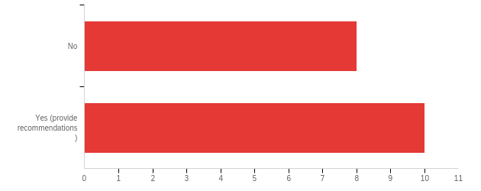

|  |  |  |  |
| --- | --- | --- | --- |
| # | Answer | % | Count |
| 1 | No | 44.44% | 8 |
| 2 | Yes (provide recommendations) | 55.56% | 10 |
|  | Total | 100% | 18 |

**Q2_2_TEXT - Yes (provide recommendations)**

|  |
| --- |
| Include student success and faculty excellence |
| Again, I think equity could be foregrounded a little more. |
| We simply need to redefine our mission |
| See previous answer - we should review to reconsider |
| add DEIA focus into it |
| See above |
| Should we emphasize the spaces, along with expertise and information resources? |
| Its pretty good. But it could be shinier. |
| Nothing specific except that "leverage opportunities" sounds like meaningless business-speak to me. If we are going to update, we should revisit and talk about the mission |

**Q6 - Does the Statement on Diversity and Social Justice need modifications?**

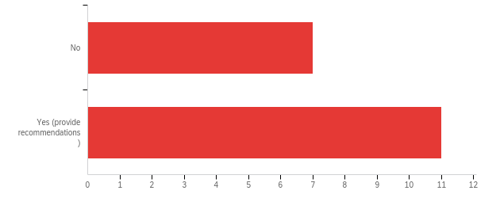

|  |  |  |  |
| --- | --- | --- | --- |
| # | Answer | % | Count |
| 1 | No | 38.89% | 7 |
| 2 | Yes (provide recommendations) | 61.11% | 11 |
|  | Total | 100% | 18 |

**Q3_2_TEXT - Yes (provide recommendations)**

|  |
| --- |
| Include more than just hiring practices, such as retention and advancement |
| I think it should be more oriented toward our commitment to continuous reflection and improvement in this area. |
| include best practices and what we value with clear practices |
| We should always reconsider and discuss |
| Yes, add DEIA action component |
| Current statement focuses on EDI more than social justice. More broadly, diversity is a defining characteristic of the CSU system and, again, I wonder if there is something more reflective of the organizational context that belongs here |
| This is something that the DEIA task force can work on. |
| I'm unclear as to what we consider "equitable" services |
| I want to say, no but, we need to embed DEI in ALL of our strategic priorities as accountable action points. |
| As above, if we are going to revise the document we should review and revisit. |
| Add accessibility somewhere. |

**Q7 - Do the Guiding Principles need modifications?**

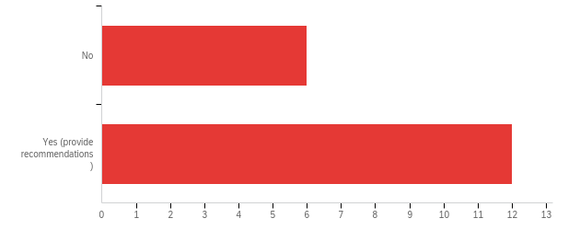

|  |  |  |  |
| --- | --- | --- | --- |
| # | Answer | % | Count |
| 1 | No | 33.33% | 6 |
| 2 | Yes (provide recommendations) | 66.67% | 12 |
|  | Total | 100% | 18 |

**Q4_2_TEXT - Yes (provide recommendations)**

|  |
| --- |
| Yes (provide recommendations) - Text |
| Expand information literacy to include other literacies (i.e metaliteracy) |
| What's there is good; do we want to add something about our libraries' role in cultivating socially and civically engaged citizens, centering voices of the historically marginalized... |
| same as above |
| We should reconsider and discuss |
| Add a DEIA component, for example under or adding to A culture of communication, honesty, respect, |
| We need another principle that emphasizes commitment to protecting privacy |
| I don't have a specific recommendation but would welcome a conversation |
| they are okayish. again, spiff them up |
| I like all principles, but I need some specifics on how to protect user data privacy. It is a complex issue, particularly with vendor supported services. |
| Define Innovation principle |

**Q8 - Please mark the status of the strategic priorities as accomplished, still in progress, or no longer a priority.**

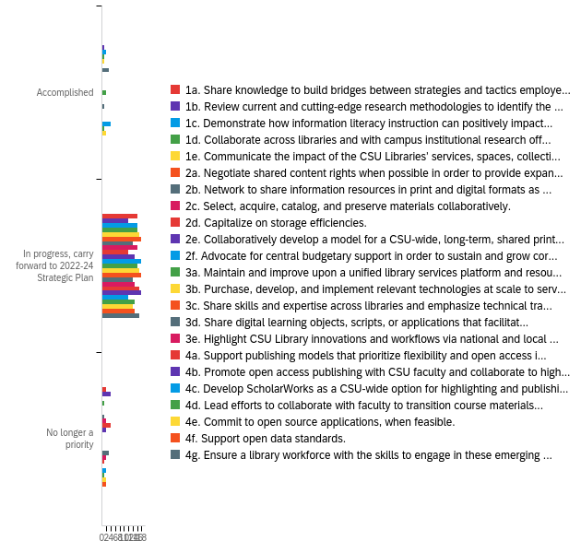

|  |  |  |  |  |  |  |  |  |
| --- | --- | --- | --- | --- | --- | --- | --- | --- |
| # | **Question** | **Accomplished** |  | **In progress, carry forward to 2022-24 Strategic Plan** |  | **No longer a priority** |  | **Total** |
| 1 | 1a. Share knowledge to build bridges between strategies and tactics employed by individual campuses in support of Graduation Initiative 2025. | 0.00% | 0 | 88.89% | 16 | 11.11% | 2 | 18 |
| 2 | 1b. Review current and cutting-edge research methodologies to identify the most promising approaches. | 5.88% | 1 | 70.59% | 12 | 23.53% | 4 | 17 |
| 3 | 1c. Demonstrate how information literacy instruction can positively impact student learning and success and campus accreditation goals in order to develop CSU best practices. | 11.11% | 2 | 88.89% | 16 | 0.00% | 0 | 18 |
| 4 | 1d. Collaborate across libraries and with campus institutional research offices to build models to triangulate library data with institutional, programmatic, and course data. | 5.56% | 1 | 88.89% | 16 | 5.56% | 1 | 18 |
| 5 | 1e. Communicate the impact of the CSU Libraries’ services, spaces, collections, and information literacy activities on student success to CSU stakeholders. | 5.56% | 1 | 94.44% | 17 | 0.00% | 0 | 18 |
| 6 | 2a. Negotiate shared content rights when possible in order to provide expanded access to our students and faculty, while maximizing buying power and reducing duplicative costs. | 0.00% | 0 | 100.00% | 18 | 0.00% | 0 | 18 |
| 7 | 2b. Network to share information resources in print and digital formats as seamlessly and porously as possible across campuses. | 16.67% | 3 | 77.78% | 14 | 5.56% | 1 | 18 |
| 8 | 2c. Select, acquire, catalog, and preserve materials collaboratively. | 0.00% | 0 | 88.89% | 16 | 11.11% | 2 | 18 |
| 9 | 2d. Capitalize on storage efficiencies. | 0.00% | 0 | 75.00% | 12 | 25.00% | 4 | 16 |
| 10 | 2e. Collaboratively develop a model for a CSU-wide, long-term, shared print collection. | 0.00% | 0 | 88.24% | 15 | 11.76% | 2 | 17 |
| 11 | 2f. Advocate for central budgetary support in order to sustain and grow core collections. | 0.00% | 0 | 100.00% | 18 | 0.00% | 0 | 18 |
| 12 | 3a. Maintain and improve upon a unified library services platform and resource sharing network. | 11.11% | 2 | 88.89% | 16 | 0.00% | 0 | 18 |
| 13 | 3b. Purchase, develop, and implement relevant technologies at scale to serve all twenty-four libraries. | 0.00% | 0 | 100.00% | 17 | 0.00% | 0 | 17 |
| 14 | 3c. Share skills and expertise across libraries and emphasize technical training and  continuing professional development for library faculty and staff. | 0.00% | 0 | 100.00% | 18 | 0.00% | 0 | 18 |
| **#** | **Question** | **Accomplished** |  | **In progress, carry forward to 2022-24 Strategic Plan** |  | **No longer a priority** |  | **Total** |
| 15 | 3d. Share digital learning objects, scripts, or applications that facilitate the discovery and delivery of library resources. | 5.56% | 1 | 77.78% | 14 | 16.67% | 3 | 18 |
| 16 | 3e. Highlight CSU Library innovations and workflows via national and local conferences and publications. | 0.00% | 0 | 88.24% | 15 | 11.76% | 2 | 17 |
| 17 | 4a. Support publishing models that prioritize flexibility and open access in our collections decisions. | 0.00% | 0 | 94.44% | 17 | 5.56% | 1 | 18 |
| 18 | 4b. Promote open access publishing with CSU faculty and collaborate to highlight the scholarly, creative, and unique collections produced by the CSU community. | 0.00% | 0 | 100.00% | 18 | 0.00% | 0 | 18 |
| 19 | 4c. Develop ScholarWorks as a CSU-wide option for highlighting and publishing research, scholarship, and creative works produced by the CSU system. | 22.22% | 4 | 66.67% | 12 | 11.11% | 2 | 18 |
| 20 | 4d. Lead efforts to collaborate with faculty to transition course materials to open education resources. | 5.88% | 1 | 88.24% | 15 | 5.88% | 1 | 17 |
| 21 | 4e. Commit to open source applications, when feasible. | 11.11% | 2 | 77.78% | 14 | 11.11% | 2 | 18 |
| 22 | 4f. Support open data standards. | 0.00% | 0 | 88.24% | 15 | 11.76% | 2 | 17 |
| 23 | 4g. Ensure a library workforce with the skills to engage in these emerging scholarly communications conversations. | 0.00% | 0 | 100.00% | 17 | 0.00% | 0 | 17 |

**Q9 - What new strategic priorities should be added?**

|  |
| --- |
| What new strategic priorities should be added? |
| Deepen collaborative relationships with CSU and CO Research Officers, CIOs and Directors of Teaching & Learning Centers |
| I wonder if we need a strategic priority that looks a lot like 1a but is in support of efforts to respond to enrollment declines (are we calling it an enrollment crisis?). I also wonder if the plan should more generally be oriented in this direction. |
| I don't have new priorities, but would like to see emphasis on shared everything: skills, people, collections |
| I have strong concerns that certain items, particularly those in #4 are underbuilt or underoperationalized and we need to refocus attention in this area. |
| a lot of strategic priorities, our energy is stretched... maybe consider prioritizing |
| Transform library spaces to support student and faculty success |
| I do not like that I can't edit comments above. It is not a yes/no option for most of the priorities. It is complicated and not one of the priorities can ever be "accomplished." |
| Being new, it was challenging to address where we are with above goals. So, mine are what I thought critical. With that said, we should seriously consider shared infrastructure support, such as IT, Web, etc., among all libraries. |
| Define library's role with Entrepreneurship & Innovation for changing higher education landscape |