ULMS Survey Responses – Dec 2022

Executive Summary

In late Fall semester, we conducted a set of surveys to assess current satisfaction with Ex Libris as a vendor and Alma and Primo products currently in use systemwide. Surveys were distributed to CSU library staff and chairs of the ULMS working groups. The summarized results of these are contained in this document. As in past years, we will share these results with both COLD and Ex Libris to better communicate our concerns and general satisfaction with Alma and Primo VE with both vendor and chief stakeholders.

Last year, I observed that CSU staff reported higher satisfaction scores for Alma, Primo VE and Support, while committee satisfaction with Primo VE and Support decreased slightly compared to the previous year. This year, satisfaction with Ex Libris products and support decreased across the board.

Reasons for this decrease are unknown at this time, but it is fair to say that a number of factors certainly contribute to current dissatisfaction with Alma, Primo VE and Support. It is clear that the implementations of Primo VE and Rapido could have gone more smoothly, and that lingering issues with Rapido affected smooth operations for both patrons and staff over the first 4-6 months of service. Significant issues remain with e-resource management since the introduction of the Central Discovery Index (CDI) in 2019-2020. Changes to Ex Libris’ SalesForce support portal have resulted in less access to information between CSU campuses. It is also likely that library staff and faculty are exhausted from COVID and too many system changes over the past two to three years, impatient for long-standing issues to be resolved by Ex Libris development and no longer able to rely on the advantages of the ULMS (not the least of which continued collaboration between CSU libraries) to help them overlook the shortcomings of the current system.

We will need to apply increased pressure on Ex Libris to respond to these issues in a timely manner. “Working as intended”, an answer which has never been acceptable to customers, will need to be actively rejected and combated with evidence of negative impact on patrons and staff. We will continue to work with Ex Libris on Rapido product improvements and follow through on our evaluation with an eye towards deciding on whether to make a long-term commitment to Rapido or return to Alma resource sharing along with ILLiad.

Chairs Survey Satisfaction Scores
 | Alma | Primo VE | Support
2019-2020  (n=7) | 7.3 | 6.7 | 6.4
2020-2021  (n=7) | 7.0 | 6.9 | 6.4
2021-2022  (n=6) | 7.5 | 6.5 | 6.3
2022-2023  (n=6) | 6.3 | 5.5 | 6.2
𝚫 (last two years) | -1.2 | -1.0 | -0.1

This year, the ULMS working group chairs gave notably decreased scores to Alma and Primo VE and a slightly lower score to Support. This may reflect our problematic experiences with the Primo VE and Rapido implementations, impatience with the speed in which fixes to persistent problems are delivered with the new quarterly release schedule, impact of issues with the newer products (Primo VE and Rapido), or other.

Staff Survey Satisfaction Scores
 | Alma | Primo VE | Support
2019-2020  (n=129) | 6.1 | 5.6 | 5.6
2020-2021  (n=129) | 7 | 6.5 | 6.4
2021-2022  (n=61) | 7.3 | 7.3 | 7.2
2022-2023  (n=70) | 7.0 | 6.6 | 6.1
𝚫 (last two years) | -0.3 | -0.7 | -0.9

CSU Staff reflected the same net decreases in scores across the board, likely for similar reasons.

It is worth noting that, while the scores have decreased from last year, the tenor of submitted comments has not changed over time. There are also a similar number of positive and negative comments in the general sections of the survey. This may reflect recognition of the continued positives of being on a shared system with peer support while showing increased unhappiness with the unaddressed problems appearing in parts of Alma and Primo VE.

While Ex Libris continues to be the best choice of library management system for our needs, we keep using the CSU's collective purchasing power to push for improvements, and to keep an eye on developments with competing library management systems such as FOLIO in the event that satisfaction with Ex Libris does not improve over the next terms of our contract.

Chairs’ Survey

The chairs’ survey was shared with the seven working group chairs, all of whom were asked to poll their committee and community of practice to provide a summary of how well Ex Libris and their products are working for them. As we anticipated little crossover between groups, we provide scores by group as well as an average score to show how much better or worse the products may be working for a functional area.

Q1: On a scale of 1-10, how satisfied are your committee and community of practice with how Alma currently performs in your functional area?

Average: 6.3

Analytics: 7
Discovery: 7
ERM: 7
Fulfillment: 6
Resource Management: 7
Resource Sharing: 4

Q2: On a scale of 1-10, how satisfied how satisfied are your committee and community of practice with how Primo VE currently performs in your functional area?

Average: 5.5

Analytics: 6
Discovery: 7
ERM: 6
Fulfillment: 6
Resource Management: 6
Resource Sharing: 2

Q3: Please list the top five issues you and your functional area are currently facing below.
On a scale of 1-5, how impactful is the issue to your community of practice?

Analytics | - One of the most frequent responses involves the documentation for both Alma and Primo VE analytics. Mention was made of incomplete or non-existent descriptions of certain fields. Users speak to the need for more complete descriptions of fields with examples of possible values being helpful. Users mention the difficulty of navigating the product documentation. While some of these might be covered in webinars/presentations, there seems to be a need to include or link to the product documentation. "Frequently, the field description provided by Ex Libris just repeats the name of the field. Example: The description for the Request Type field in the Item Event Details table of the Physical Items Historical Events subject area is “The request type of the item.” I expect proper documentation to have a better description, list (or point to the documentation that already lists) the possible values and when needed, explain what kind of events/actions would lead to an entry of such value in Analytics." "While working on reviewing the reports for the Rapido dashboard, I felt that the documentation on the Borrowing and Lending Requests were insufficient. If Ex L documentation provided even a little information on one or two of the possible values for the Partner Active Status field and how they map to the Partner table, it would’ve been so much easier to figure out how the reports should be designed. Such lack of documentation makes it very difficult for users to learn how to work with data in Analytics." "For Primo VE, we could not find anywhere in Ex L documentation on whether the searches that are initiated from our library’s homepage search box are included in any of the fields in analytics. I’d think this is a common question but we could not find the information in Ex L documentation" (4)  - Multiple users point to analytic login session problems. When working on large reports, especially in the network zone, the session logout times can create problems when saving reports. Is the Network Zone session logout time the same as institutional Alma logins? There may not be a solution other than to extend the logout time within Alma. "Login session connection problems between Alma and Alma Design Analytics. Sometimes I'm auto-logged out of Alma while working in Analytics, and I just need to log back into Alma to get back into Analytics. Usually I'm able to log back into Analytics this way, but sometimes I hit an error page when trying to open Design Analytics that shows this error message - "Invalid path (Check the input path entered.) -- Error Details Error Codes: QM3V3HLV". When this occurs, I have to close my entire browser (all tabs), then open up a fresh browser session to log back into Alma and Analytics. I primarily use Chrome, and I'm not sure if this is a browser specific issue, or a general issue." (3)  - There were a few mentions of the limitations of the Primo VE analytic reports. There was mention that the out of the box reports are limited and the documentation isn't as detailed as the Alma analytic documentation. "It still doesn't seem like I should trust the data I get from Primo Analytics. What do those results in "popular searches" mean? Why am I missing data from various months and is it only keeping data for three years now? Entering tickets on these questions seem to go nowhere." "Primo VE essentially only offers an out of the box analytics and the documentation is not as detailed nor as robust as Alma analytics. I don't think they're going to do much since they know a lot of users rely on Google Analytics." "I think another important issue that I have with Alma and Primo VE is with the data. Sometimes the data is inaccurate. Sometimes the data is missing. Sometimes the data is not provided. Here are a few examples. (1) When an item is created by duplicating an item that is already in a temporary location, Analytics (the Physical Item Events subject area) does not keep track of when the item comes out of temporary location. I filed a case but Ex Libris said that this will not be supported. (2) Primo data does not exist before certain data is an example of missing data. (3) I’ve also found that a COUNTER report that contains only 1 month’s data is somehow associated with 3 month’s non-zero usage data. The erroneous non-zero usage data is only in single digit so not much is being affected. However, Ex Libris could not find an explanation and decided to do nothing for the case so the inaccurate data still exists in Design Analytics." (3)  - There were many mentions of the relative slowness and intermittent downtimes of Analytics. The slowness especially seemed to impact those that wanted to use the Visualization features for both Alma and Primo VE. One user remarked that the slowness might be the reason that some staff are reluctant to engage with analytics. Some reports might be too big for Dashboards, so this should be a consideration on the users behalf to be aware of the experience of reports that have large datasets to pull from. The below statement explains the ways in which the slowness impacts the report writing process, including the editing of Analytic Objects. "As someone who frequently works in Analytics including Data Visualization, the speed really matters. I frequently have to troubleshoot reports which means that the report has to be rerun numerous times. If the report takes 30 seconds to load and if I have to rerun the report 40 times, it means that 40 minutes of my time is wasted just sitting in front of the computer waiting for the report to run. It’s not just the report loading that is slow. When I insert a graph in my report and try to change the fields that are being included and excluded, the editor takes a while to load, to save and to display the newly edited graph. When I am editing a graph, I make multiple edits and want to see the graph after each edit. So for any reports that also have graphs, additional time is wasted waiting for the editor to load, to save and for the graph to reload. It’s not just Design Analytics that is slow. Editing information for Analytics Objects List is excruciatingly painful because of the slowness. For Analytics Objects, I am not even trying to load a report. I am only trying to update the descriptions or only trying to update the subscriber list or the user role list for one analytics object but the form takes forever to load. (If needed, I guess I could measure exactly how long this takes in the afternoon but I don’t have the exact length now.) Data Visualization module is even slower. It’s so slow that we’ve decided that the module is useless. Several months ago, I created a project in the Data Visualization module for Primo VE. However, when my colleagues tried to view the dashboard in the Data Visualization module, the browser would just display a blank screen and the DV module would not even load. We have not filed a ticket but I had this happen to me on multiple afternoons when the Data Visualization module has been slow. We’ve decided that the dashboard that I’ve created in the Data Visualization module is not usable as it is not accessible and I had to recreate the whole dashboard in the regular Analytics module." (3)  - There are reports that would benefit from having certain details across subject areas. One user remarks that the lack of a physical items details folder in the borrowing subject area leading to reports that cannot produce lending call numbers, barcodes, etc. (2)
Discovery | - Problems with CDI records and indexing appear to remain the top issue with discovery, though search indexing is close second. Several responses to the Primo VE evaluation survey mention issues with CDI Global Index titles. I think we can group the uResolver matching issues as described in the 2021-22 top issues report with this. (5)  - Several responses to the survey, and mentions in Slack, point to frustration with understanding and managing ranking/boosting controls/options in Primo VE. (5)  - Quirks in the front end display and brief record holdings display performance are mentioned several times in the survey and in Slack convos. (4)  - We're working towards more collaborative efforts with other ULMS committees/areas but finding the time to discuss and plan how to address issues that cross over between functional areas needs more attention. (3)  - Satisfaction with analytics ease-of-use and functionality is mixed. Some find the analytics are good while others find it difficult to use. Others have mentioned that more granularity is needed, and question why integration with Google Analytics is not better. (3)
ERM | - Full text options displaying when physical and electronic inventory title match - regardless of coverage. All or nothing display hiding ILL options (5)  - Global Title index - duplicating records from other libraries (3)  - Streaming media title matching to completely unrelated resource (4)  - Display logic configuration options not robust enough for our purposes (4)  - CDI grabbing lots of incorrect data for OA resources i.e. displaying full text availability in Primo when we don't actually have access (3)
Fulfillment | - In Transit Configuration - Sometimes when an item goes into a transit status, this status can be missed and an item gets stuck in transit rather than being scanned in again at its home library. These in transit items may end up getting reshelved and potentially lost. This can ultimately affect the requesting availability of an item in OneSearch and prevent library users from being able to find where the book is supposed to be. If libraries have their requesting configured to not allow requesting on unavailable (checked out or in transit) items, then the items are not available for users to request even though it may actually just be stuck in a transit status while sitting on the shelf. (3)  - Course Reserves not very intuitive to manage. (4)  - Letters. Please make them easier to alter, like a simple Word doc that uses mail merge, or text docs. (4)  - Primo doesn’t prioritize Book/eBook results. Too often, Reviews are placed as top results. (3)  - Provide more options for when particular jobs can run. Our patrons get automatic emails at times we are closed, then they want to call or email us and we’re not available to respond. That’s not a great experience for them. (3)
Resource Management | - Records de-duping that shouldn't and records merging that shouldn't. What a hassle to open a ticket for each of these. (4)  - bad/very little metadata in CZ & CDI records does not bring up resources when not searching by specific data - the fact that so many of these are duplicates/duplicated (4)  - primo ranking - things with complete ALMA records should have higher weight - would like to have the ability to weight primary versions of titles above reviews and derivatives (4)  - being able to bring up the bib record from the holdings record in the metadata editor (2)  - indexing in Primo isn't live - often have to wait to see if data changes in ALMA affect search results as desired (3)
Resource Sharing | - The Rapido Global Title Index has such varied issues (duplications, bad metadata, records for e-resources and other impossible to obtain materials). The ability to rank/boost within the CDI at each institution to allow local and consortial materials to be put in-front of patrons first would mitigate a part of this issue. (5)  - Alma letters are not configurable or difficult to configure for resource sharing tasks due to sharing letters with other fulfillment functions. Separation of letter functions with clear activation paths outlined and expansion of fields that can be configured within each letter. Additionally, configuring the address From field in the Query to Patron letter doesn't do anything. Our main library is our resource sharing library so the query to patron letter shows as coming from the email address of our Circulation Department instead of Resource Sharing. Users reply back to Circulation instead of Resource Sharing. https://3.basecamp.com/3765443/buckets/23330201/messages/5496295154 (4)  - Rapido can't figure out if we own one issue of a serial or all of it in print so we either have to hide the boxes in this case or we show the boxes all the time (Basecamp: https://3.basecamp.com/3765443/buckets/23330201/messages/5422217407). (4)  - The expiry function is not working in Rapido. Requests should be expiring and moving onto the next lender after 4 days but it doesn't appear that they are. This means that some requests could sit at a lender forever and never get filled and the patron will not be notified. (4)  - The lender of last resort integration still doesn't work for a lot of campuses. The integration also has some issues. For example, pickup location doesn't transfer over into ILLiad so we have to manually add in the the pickup location for requests that export to ILLiad. It would be great if we could customize the mapping of Alma fields to ILLiad fields. For example we are able to indicate the ILLiad field where the Alma ExID imports into. It would be great if this was allowed for additional fields. (3)

Q4: On a scale of 1-10, how responsive is ExL Support in addressing issues in your functional area?

Average: 6.2

Analytics: 6
Discovery: 7
ERM: 5
Fulfillment: 5
Resource Management: 6
Resource Sharing: 8

Q5: Any comments on why ExL Support received that score?

Analytics | The response scores were either on the very low end or the higher end in terms of satisfaction. Below are a selection of responses:  - "Well, we opened cases about Alma and Primo VE. Some responses were helpful, pointing to the documentation to help us interpret results. Others were not so helpful. For example, we have some weird analytics in Primo VE that we believe reflect users in other countries that may be using VPN but Ex Libris really didn't know either. We asked whether Primo VE searches also include searches that start on a library website using a search box for VE. They said yes. However, there's nothing in the documentation that says this explicitly. There was chatter about this on the Primo listserv."  - "It seems like a losing cause to enter a ticket on Analytics, both Alma & Primo. I had much better luck being on the Analytics Community of Practice to ask or have these questions addressed directly of the product management."  - "I don’t think Ex Libris is any less or any more responsive in addressing issues in Analytics vs. other modules of Alma/Primo VE. I think in general, their responsiveness is slow."  - "They respond to tickets but usually just tell me something isn't possible or I'm not understanding it correctly."
Discovery | Ex Libris Support is responsive with initially addressing a case. However, survey responses and the open Primo issues tracked in the new Trello board show that some cases linger for a long time without resolution or updates. It appears difficult or not possible to track cases created by another campus, or did determine whether a solution actually works.
ERM | Small issues like fixing metadata are typically no problem, but major things like title matching and display logic are often brushed off as "working as intended"
Fulfillment | Fixes usually take several months (or longer), or as in the case of the In Transit issue, resolutions are unknown. Folks seem to have a lot of questions like 'How do I do . . . ' or 'Is there an option to do xyz' and those types of questions seem to go unanswered.
Resource Management | When I do enter a ticket on de-duping or merging, it is usually resolved quickly. I can imagine there are a lot of people in Ex Libris that focus on just these tickets. All fine if it's a tier 1 issues - tier 2 is a joke - SJSU has items waiting tier 2 review that have been in the queue for almost a year
Resource Sharing | The continued activation of Basecamp and RSFC ExL bi-weekly joint meetings is why the support teams score is as high as it is. When this is phased out, this score will be subject to change.

Q6: What needs does your functional area have that require Alma and/or Primo VE development to address?

Analytics | The community would like publicly accessible dashboards that don't require going to Alma to login. "I would love publicly viewable dashboards. The people who need to see data aren't going to log into Alma to get it so I just have to pull it on demand." "Improved interface design that is more accessible and intuitive to work with."
Discovery | I think those are documented in the survey responses and open cases.
ERM | Title matching and all-or-nothing display are the two major issues that we need addressed. It confuses/frustrates our patrons, and bogs eresource staff/faculty down with having to respond to patron inquiries.
Fulfillment | Focus more on developing letters and Course Reserves based on survey responses.
Resource Management | Primo ranking control on an ALMA record basis, so we can weight original/authoritative versions of certain works with lots of derivatives and reviews It would be great if the new MDE had the same 'Exit' back to search results option that the Old MDE has
Resource Sharing | CDI clean up and the ability for individual institutions to rank and filter results from the CDI at their site. Letter separation, activation chart, and increased configuration ability (adding content to letters). Improved integration with outside companies (Illiad and Article exchange)

Q7: Anything else I should know about your functional area's satisfaction with Ex Libris?

Analytics | In general there is an understanding that not all of the problems that users have with analytics are within the control of Ex Libris to address. Documentation needs seem to be a common thread that carried throughout the issues that were presented. "I generally do think Analytics is great and the amount of data we can get out of the system compared to our previous ILS is amazing. I'm overall happy with it, but sometimes baffled by why the particular metrics I want are not available." "We understand it's not a perfect system. We need to feel that we can count on the reliability of the numbers. And we'd like the documentation to be better." "I did have one success story with a ticket on Analytics in the last year, they helped me with a complicated formula that I needed to use for some research data. It took about 6 weeks to answer but the answer was very helpful once they provided it."
Discovery
ERM
Fulfillment | FFC only received 7 responses to our survey, so it was a bit difficult to compile the results. I did the best I could with what came through. Responses were anonymous (there was an option to leave a name but only one person left a name), so follow-up was not possible.
Resource Management
Resource Sharing | Here are some of the comments from the community:  - It is understandable that some things take time to get resolved, but the update process seems cumbersome and drawn out.  - I recently needed help configuring Mediated Patron Renewals for ILLiad items in Alma. I submitted a support case and received no help for two weeks before I decided to escalate the issue. After escalating I was provided a link to a knowledge article that was written very confusingly and did not have the correct answer in it. I then decided to write to the Alma listserv for help and was provided with the correct answer from a non ExLibris person within 24 hours. This person was not even able to look at my configurations and was able to help me better than ExLibris.  - They acknowledge issues but that hasn't always translated into speedy action. However, they have been fairly prompt in fix some of the more obvious bugs.  - Basecamp answers in the middle of the night instead of when we can respond to them in a timely fashion, and often not answering what we are asking. We lost a lot of time on back and forth with questions when the answers would come in the middle of the night and then we would respond the next day, then an answer in the middle of the night, and so on.

Staff Survey (70 responses)

Q1 - On a scale of 1-10, how satisfied are you with how Alma currently supports your job tasks?

Average of 7.0

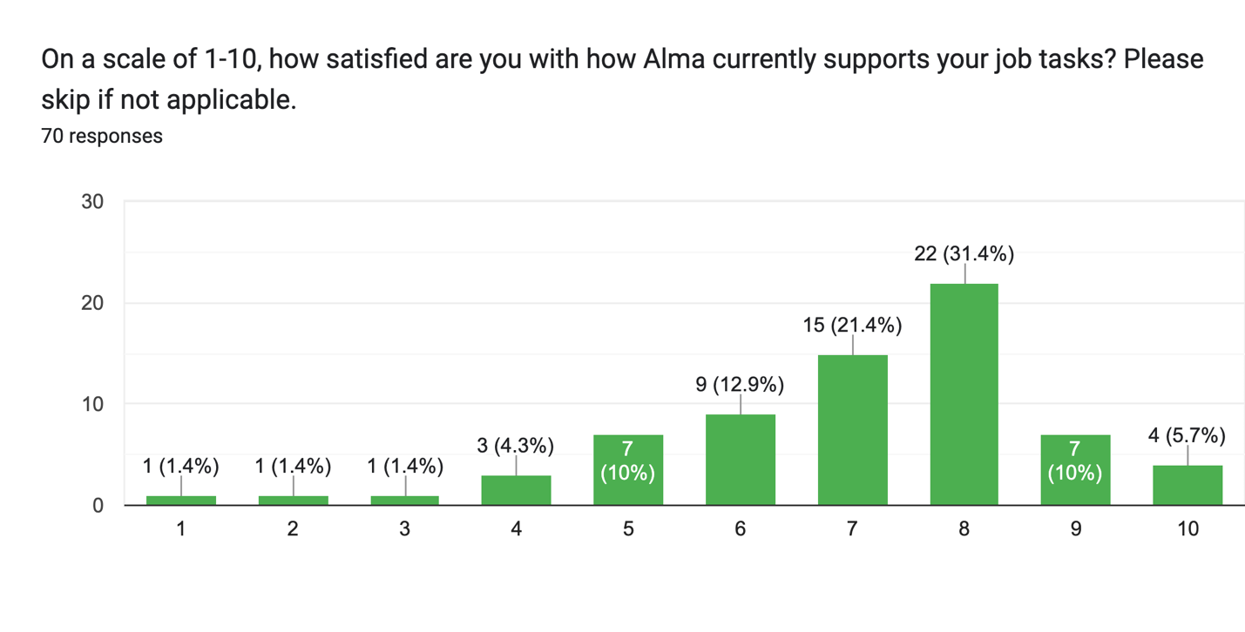

Q2 - On a scale of 1-10, how satisfied are you with how Primo VE currently supports your job tasks?

Average of 6.6

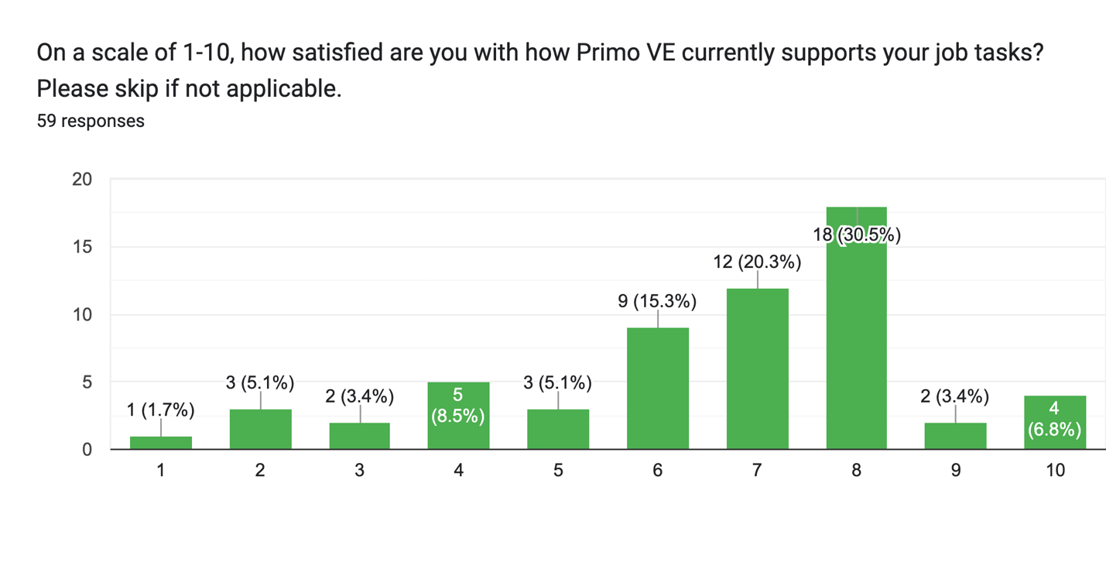

Q3 - On a scale of 1-10, how satisfied are you with the support that Ex Libris provides?

Average of 6.1

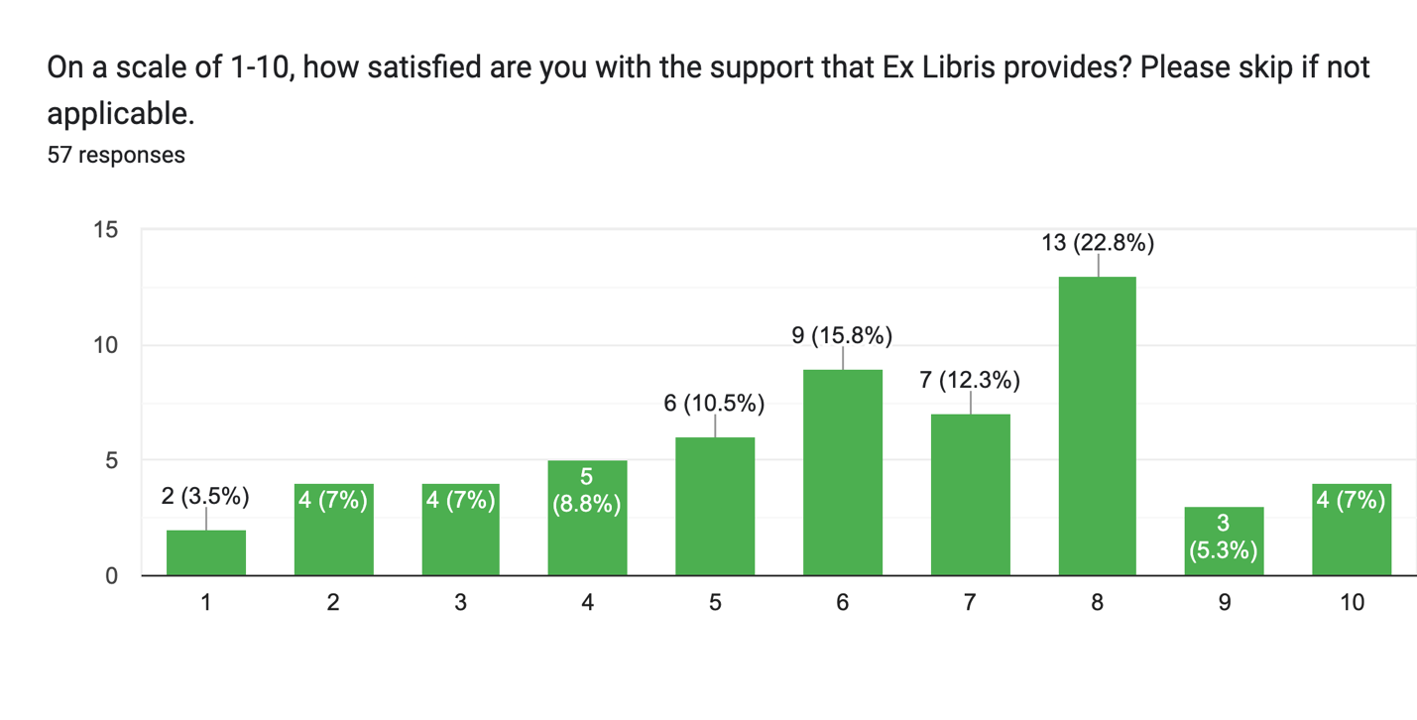

Q4 - What Alma issues currently affect how well you perform daily tasks, if any? (42 responses)

By design, responses to this question ranged widely across the product. A summary grouped by system/functional area follows.

Acquisitions: PO Lines do not update as expected via the “Update PO Lines Transactions” job, and batch changing funds causes encumbrances to show in both the old and new funds. Rialto users complain of some unclear error messages and a lack of message definitions to refer to when confused.

Analytics: Analytics users complain of persistent slowness and complexity of report creation hampering their ability to use the system as expected.

ERM: CZ update task lists complaints continue due to both the frequency of changes and the problems that are regularly introduced by updates, such as erroneous deactivations and coverage indications. Inaccurate full-text availability was a frequent complaint as well.

Fulfillment: Claiming, course reserves and letters continue to receive many complaints of being non-intuitive to manage and clunky to use.

General/UI: While Alma still takes “too many clicks” for some, most complaints focused on Alma as “generally unintuitive”, “time consuming” or “not user-friendly” for general use. Switching between areas of Alma was described as “counterintuitive”, poorly configured “out of the box” and application functions are difficult to find for infrequent users of Alma. One requested the ability for clicking in a search box to insert the cursor where clicked instead of defaulting to highlight the terms in the box at the time.

Other: Sites with Dematic systems mentioned problems with communicating between Alma and their ARS systems, including errors adding inventory to their Dematic system.

Performance: Alma continues to run slow or lock up for some. The inability to work in multiple tabs is a concern thwarting efficient user of the system.

Resource Management: Many continue to report frustration with the quality of metadata in the CZ, as well as the frequency of record updates.

Searching: Staff continue to report difficulty in searching for materials, especially for searching by call number, patron name or even by title.

Q5 - What Primo VE issues currently affect how well you perform daily tasks, if any? (32 responses)

By design, responses to this question ranged widely across the product. A summary grouped by system/functional area follows.

CDI/Linking: CDI, full text linking and the associated indexes received the most negative comments in this year’s survey. Full-text availability is frequently inaccurate, and full text links often don’t work. The inability for ExL to address these issues directly was described as “my [largest] pain point at the moment”. One response said that they are finding less “broken links” than before, while others said these issues have “degraded a system that was finally starting to work well”. The introduction of Rapido seems to have raised the visibility of these issues by introducing additional problems with requesting articles that aren’t resolving as they should.

Dedup/Merging: Issues with records either failing to merge or mering with the wrong records continues to be oft cited in survey responses and in general conversations. As one response mentioned, these issues create “significant user discovery problems.” Often, these issues cannot be solved by user intervention and require ExL Support intervention to mitigate. ExL has not yet indicated a willingness to find long term solutions to title merging, which will mean a continuation of these issues.

Display: Issues with display rules linger, particularly based on an impactful bug in Rapido that took months to resolve. Display configuration could be more flexible and customizable, particularly around request forms, scopes and collections. One response mentioned “glitches” with how multiple versions of items are displayed in search results.

Filtering: Filtering seems improved from previous years. One response mentioned that “too many clicks” are needed to determine availability of items through filtering.

Rapido: A few responses mentioned the impact of Rapido implementation on discovery and noted the bugs (since fixed) that affected Primo VE during the beginning of the semester.

Requesting: Issues with requesting options appearing as required or with the aforementioned Rapido bug were mentioned in multiple responses.

Searching: Known item searching continues to be problematic for some, especially involving specific titles or ISBN. Two responses mentioned that they needed to use “subject terms” to supplement title or location searching in Primo VE. One response opined that default search scope should be local rather than CSUwide as needed to support resource sharing.

Q6 - What are we unlikely to have heard yet about how well Alma and/or Primo VE is working for you? (22 responses)

There were some generally positive or negative responses to this question that will not be called out here. Some further issues were reported, although most were previously reported in the previous questions. Sample responses are below:

Positive:

“I am pretty impressed at how fast support has been moving on the issues I report. It's been a huge improvement! There are still issues that can't be fixed promptly and I understand that part but I just want to bring this up to you.”

“I've used some of the Cloud Center Apps that were recently introduced (like Copy User roles) that were extremely useful and has made onboarding new staff/students easier when it comes to privileges. The chat support has also been very helpful for questions that might not rise to the level of a ticket.”

“So as not to be entirely negative, most of Alma really is working well; the integration of all the functional areas is particularly a boon for cross-functional work; Primo VE for all its flaws has some nice customization features.”

Negative:

“I think my issues are the same as pretty much everyone else's: poor quality metadata for e-resources, mystifying relevance ranking, availability, and record display in Primo VE, and declining quality of support since the merger with ProQuest/Clarivate.”

“Not sure if this is frequently heard or not, but when teaching or providing reference, I usually discourage students from using Primo VE for basic research, and encourage them to use subject-specific databases instead. I find that it's a much better workflow, especially for beginning researchers. And the challenge is that the more things we add to the default Primo search, the worse the user experience gets.”

“Some of my SF cases are complex but waiting months and months for Ex Libris to respond with just, 'we're working on it' is not satisfactory. When are we going to be allowed to see our consortial cases? I really appreciate certain SF analysts, particularly those who share supporting documentation.”

Q7 - Anything else that you want me to communicate to Ex Libris or to ULMS Governance?
(24 responses)

As above, there were some generally positive or negative responses to this question that will not be called out here. Some further issues were reported, although most were previously reported in the previous questions. Sample responses are below:

Positive:

“No, I appreciate your work on this! Overall I think we have a great system but I am mostly thankful for the opportunity to collaborate with folks across the CSUs. Thank you!”

“Nothing ex libris is great.”

“once learned, Alma suits all my needs.”

Negative:

“Attempting to regularly use and teach what seems to be a continually breaking or "improved" Primo VE is an exercise in frustration, and worse, provides an unpredictable experience for student users.”

“Ex Libris support has been historically so slow to fix anything or they don't know their own system functionalities and it seems like they haven't changed their ways even after promising that they would.”

“It is sometimes tempting to feel that the success of the ULMS is maintained by the quality and dedication of CSU employees, in spite of Ex Libris and some enduring issues with their products. This could be remedied by ExL being more receptive to customer suggestions. For example, no metadata expert would believe matching VE records by title (in the absence of unique identifiers) is a good idea. When we suggest this to ExL, the response is typically a confirmation that the behavior is expected. Fair enough, we believe it is, but a more constructive approach would be to try to recognize why such expected behavior will cause issues for library users, and subsequently reassess the strategy inherent in the product.”

