Cal Poly Humbolt:

a. We are planning the Innovation Summit for May 1-2nd, and starting to secure speakers - suggestions are welcome https://library.humboldt.edu/innovation-summit Theme is EdTech & Learning Skills in Digital Environments

b. The Launch date is set for the 3D Digital Herbarium: January 25th; the beta version looks nice... but wait until you see Version 1. This is designed to be a 3D digital exhibit tool for any discipline, and the code will be released on GitHub, with a celebration at the library.

c. We are seeking approval to open the Director of Access & Technical Services position, and Systems & Data Sciences Librarian position soon, we shall see.

Side note: Cyril's current research project is looking at strategies to develop career skills (and NACE Competencies) in our programming, internships, and student employees that are badged and stackable, and has both curricular and co-curricular integration. Finished the initial stack of reading, and preparing a grant application is next.

Cal Poly SLO:

- Hired two tenure track librarians in new positions: DEI and Student Success Librarian and Digital Initiatives and Engagement Librarian. Both are starting on January 8th.
- Started the academic year in temporary locations and spent the fall assessing the impact of closing the library building. Student satisfaction with temporary study spaces has been low at the start of the school year; doing another survey before the end of the year to see if there has been any change in satisfaction level since September.
- Adopted Occuspace to monitor occupancy for temporary study locations: https://afd.calpoly.edu/facilities/planning-capital-projects/project-news/kennedy-library/temporary-locations
- The library renovation is on track: https://afd.calpoly.edu/facilities/planning-capital-projects/project-news/kennedy-library/
Kennedy Library Renovation - Facilities Management & Development - Cal Poly
As stewards of the University resources, we provide high quality, efficient support and planning services as an integral part of the campus community in support of student learning.
afd.calpoly.edu
- University updates: starting Year Round Operations in summer 2024 with a target of 600 first time freshmen admitted to summer quarter. University is relocating departments and units that are not public facing to an off-campus location in order to increase classroom capacity in response to higher enrollment demand.

Chico State:

We are expecting to open the 3rd with our main collection in the Spring. A search for the Library Dean will be launched in early spring. The Meriam Library is altering operating hours, closing 2 hours earlier Sunday-Thursday.

From CSU Bakersfield

Here are my two updates for Bakersfield. I hope to have a final answer for the first item soon…
- Our Provost announced that all positions within Academic Affairs may be captured for the next 1-2 years. We will receive a final decision soon. This would affect two of our open FERP lines in the library.

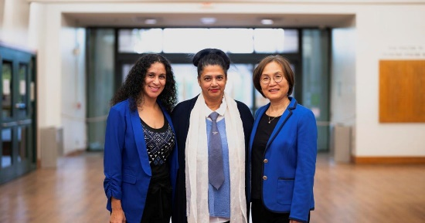 | CSUB launches first zero-cost textbook degree  Cal State Bakersfield has achieved a milestone for the campus and the entire CSU system in the quest to expand affordability: the first “Z degree,” a bachelor’s degree that requires  www.bakersfield.com

From CSUCI

CSUCI is conducting final interviews for Dean of Library and Learning Redourced during the week after Thanksgiving and expects to make a final decision soon. The new dean is expected to start in January.

From CSUF:

CSUF will have a new associate dean for collections and scholarly communication, Wendy Vermeer, formerly of Dominguez Hill. Sorry Stephanie!

WE WILL MISS YOU EMILY!

From CSULB:

We submitted two grants. One for the ALA Americans and the Holocaust traveling exhibit. The second is for a California State Library LSTA Inspiration Grant. We had a fantastic Celebration of Reading (Banned Book) panel with Jerry Craft and faculty panelists and a Librarian moderator. Almost 100 folks attended, including folks from CSUSB (thanks so much, Rebecca!).

We will have Lucy Anne Hurston (niece of Zora Neale Hurston), Sociologist, giving a talk on her iconic aunt entitled, "The Experiences of Zora Neale Hurston: The Complexities and Intricacies of Race, an Examination." This will be held on February 7th during Black History Month from 7 pm to 8:30 pm.

Finally, we are in negotiations for Dr. Yusef Salaam, one of the Exonerated Five (formerly Central Park Five) to speak in January for Dr. Martin Luther King Jr. Day (although it won't be held until the students return on January 25. If it works out, his talk will be about prison reform. Fingers crossed!

From Maritime:

Enrollment and budget woes continue. Need to cut an additional $900k from 23-24 campus budget. Anticipating a $1.9 million additional cut for 24-25. Much spending has been curtailed, including travel.

The Training Ship Golden Bear (TSGB), which hosts classrooms and other hands on training, is in drydock repair at the Vigor Shipyard in Portland, Oregon until end of December 2023.

Regardless of budget woes, Cal Maritime and the CSU have begun work on the boat basin and new pier in anticipation of the new "National Security Multi-Mission Vessel" slated for spring 2026. The current estimated project budget is $102 million, (~$48 million from CSU, and $54 million from MARAD). Construction will begin in the summer of 2025.

A fascinating summary of the NSMV capabilities is in this short video: https://youtu.be/C0TIWW_df-E (No mention of a Library yet. We're advocating for one.)
Complete coverage of the NSMV projects is at, https://www.maritime.dot.gov/national-security/nsmv-%E2%80%93-national-security-multi-mission-vessels.

Overall, the Cal Maritime Library is weathering the budget woes and continuing to offer needed services to our cadets.

From CSUN:

At CSU Northridge we are in the midst of a nationwide search for a University Archivist, with an offer soon to be made. Two other library faculty recruitments are currently in the works: an Ethnic Studies Librarian and a Systems Librarian. We also recently hired a staff level position (Digital Services Specialist), and we hope to have a new ScholarWorks Specialist on board soon as well. We also recently hired two Temporary Librarians for our Research, Instruction and Outreach Services department.

From CSU San Marcos:

Our Makerspace is under construction with a soft opening scheduled for early spring semester. We are in different stages of recruitment for two faculty positions: Outreach and Inclusion Librarian (this is our bilingual librarian) and Head of Library Technology Initiatives and Development. We have a new role of DEIA advocate role in the Library, a portion of Dr. Toni Olivas’ assignment of responsibility. She will work with our IDEA Committee and the Outreach and Inclusion Librarian (primarily student focused) on accountability for DEIA initiatives in the Library. She will also coordinate with the Office of Inclusive Excellence on campus-wide DEIA initiatives, bringing in others from the IDEA committee and wider in the library as necessary; liaise between the IDEA and Library Wide Learning Committees to further learning, reflection, and professional development for DEIA; and other initiatives, as needed.

Sacramento State:

- I have performed the miracle of walking on water. In partnership with our Provost, there will be an increase to the University Library’s base budget.
- We have finished interviewing candidates for the Dept. Head of Special Collections & University Archives – I hope to make an offer soon.
- Sacramento State is expected to move to R2 this Carnegie Classification period.

From SFSU:

Library:
Campus-wide University Retreat in January 2024 that has been online since the COVID years returning to in-person in the Library using many rooms and other spaces throughout the day, including a performance by a Music faculty member using the Clementi pianoforte that is a part of the de Bellis Collection (https://library.sfsu.edu/de-bellis-collection),a library-museum of Italian authors and subjects representing the civilization of ancient to modern Italy that form a cultural bridge between California and Italy, the first special collection to be donated to the California State University to be housed at the Library at San Francisco State.

Interaction with students @ 1st floor entrance for feedback on Library website usability has led to revision of Library website homepage to make frequently used features more visible:https://library.sfsu.edu/

Anticipated 7-8% reduction in salary budget for faculty and staff possibly for 2024-25, likely for 2025-26 and for the years of CSU reallocation of FTES targets and state funding.

Campus:
Attention focused on enrollment decline, associated budget reduction from loss of tuition and fees, reduction of 374 course sections for Spring 2024 compared to Spring 2023 with associated non-reappointment of lecturer faculty in the academic departments/Colleges.

Student protest/walk out Tues. 11/28 as may have occurred on your campuses as well. SF Chronicle article:

https://www.sfchronicle.com/bayarea/article/frustrated-sf-state-students-walk-class-cuts-18518424.php?utm_content=hed&sid=5452b9473b35d010308c6657&ss=A&st_rid=ea964e0e-4e29-4361-88b0-a18e68e2f549&utm_source=marketing&utm_medium=copy-url-link&utm_term=headlines&utm_campaign=article-share&hash=aHR0cHM6Ly93d3cuc2ZjaHJvbmljbGUuY29tL2JheWFyZWEvYXJ0aWNsZS9mcnVzdHJhdGVkLXNmLXN0YXRlLXN0dWRlbnRzLXdhbGstY2xhc3MtY3V0cy0xODUxODQyNC5waHA%3D&time=MTcwMTMwNTkwNTgwMg%3D%3D&rid=ZWE5NjRlMGUtNGUyOS00MzYxLTg4YjAtYTE4ZTY4ZTJmNTQ5&sharecount=MQ%3D%3D
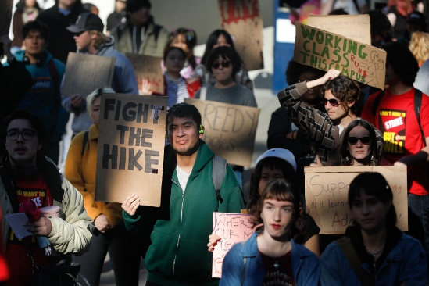 | Frustrated S.F. State students walk out over class cuts, rising tuition and executive pay hikes  Students protest SF State plan to cut hundreds of classes this spring, citing falling enrollment. Tuition is also set to rise, even as execs get big raises.  www.sfchronicle.com

The Academic Senate hosted a “Conversation with the President and Provost” for faculty, staff and administrators, on Wednesday Nov. 29th with the President and Provost answering questions mostly submitted in advance about budget and financial matters local to San Francisco State, including implications for curriculum, course offerings, and employment.

From SDSU:

We are busy recruiting this semester. Unfortunately, our search for an AD for Collections and Discovery Services failed. I will be working on a plan to re-post with the Provost, but, in the meantime, if you know any good candidates . . . We are beginning finalist interview for our Instruction Librarian and we should have our Assessment Librarian and Social Sciences Librarian searches open in December. We also have several senior positions on campus currently vacant, including the VP for Student Affairs + Campus Diversity, Provost, CIO, and Dean of the College of Arts and Letters.

We worked with our colleagues in Student Affairs to open the Esports Engagement Center last month and it has quickly become very popular (over 300 users in its first week with limited hours). There is continuing development of curricular, co-curricular, and research engagement, so I am looking forward to seeing the program grow. We also worked with Associated Students on a very success Banned Books Week program.

We are in the early stages of a deep dive into the student employee experience and will be connecting with campus efforts around career readiness and the enhancement of student employment as a High Impact Practice. We plan to do data collection in the Spring. We are concluding data collection for our participation in the Ithaka S+R study of campus collaboration in support of research data services.

Finally, while we continue to deliver health information literacy programming as part of our collaboration with libraries across San Diego County, we have just launched the next phase of the partnership with a focus on climate change misinformation and sustainability. Our faculty will be presenting on this as part of the ARL President's Institute in February.

