Zoom Cheat Sheet for March 1, 2019 COLD Meeting

At the bottom of your Zoom Window, you will see the following icons.

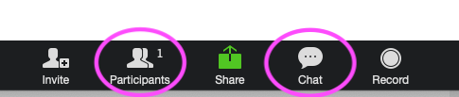

* DO log in with a name that we can recognize as you!
* DO click on participants to see who is on the call.
* DO click on chat in order to type comments for the group to see. I will pause at times to check in to chat and address your comments.

Once you click on Participants, you will see the following icons.

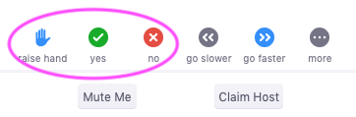

* DO raise your hand if you would like to be next in line to talk. I will call on you.
* DO use “yes” for a yes vote when I call for a vote.
* DO use “no” for a no vote when I call for a vote.
* To abstain, do not click yes or no.