2021 CSU Digital Repositories Annual Meeting

Attendance: 105 people registered.

Session title Attendees

|  |  |
| --- | --- |
| Digital Archives and New Digital Initiatives in Special Collections | 69 |
| CSUN Thesis Digitization Project | 66 |
| Assessing Scholarly Communication Programs | 60 |
| LibGuides Open Review Discussion Sessions (LORDS Project) | 49 |
| The CSU Japanese American Digitization Project: A CSU Collaboration | 55 |
| Implementing a Harvard-style Green OA Policy | 50 |
| ScholarWorks / Digital Repositories Update | 42 |

Survey responses

What did you like about this year's meeting?

The casual forum component following most presentations.

This ran so well, and the timing was great. Plenty of breaks too.

Hearing about what other campuses are doing and systemwide progress.

Very informative sessions and nice to hear from fellow CSU colleagues about their work

It was well organized.

There was a great range of presentations.

The content was really top-notch.

Learning about CSUJAD was very inspiring. I look forward to perusing the website to take advantage of various resorces in our future Fred Korematsu Day events and other JA related events at HUmboldt.

Expert opinions based on experience.

All the presentations were meaningful and well put together.

Everything, really.

The variation in topics! So many different projects going on but all under the theme of digital repositories.

Well, I like our "pluck" and "resolve" to hold a meeting under difficult circumstances. I was pleased about the topics for the meeting.

Lot's of interesting projects and expertise shared!

The reasonable timeframe each day. And presentations.

I appreciated the ease of attending virtually. Had it not taken place on Zoom, I probably wouldn't have been able to attend.

I didn't see all of the presentations, but those that I saw were practical and interesting.

It was online, so I didn't have any issues with travelling to attend.

Everything, it was great to see everyone

The timing was great for an online meeting; 8 hours would have been way too much. Also, the session ranged across the CSU and involved folks outside the normal scholcomm/digital group. Being online allowed attendees who normally wouldn't be there, and the ability to pick and choose sessions of interest.

I couldn't make all of the sessions, so I'm looking forward to being able to view the recording

Well run and diverse content

Appreciate it being on Zoom and having the sessions recorded for later viewing/sharing with colleagues who could not attend

What needed improvement?

It was pretty smooth!

Nothing I can think of.

Nothing - programming was great, communication was awesome, overall a stellar meeting.

The timing could be tightened up a bit.

"Topics" of presenters in Agenda are too short. I believe their proposals documented longer descriptions. It would be nice to have longer descriptions of the topics.

I would have appreciated having Dave's ScholarWorks update on the first day, as that would have helped frame some of the conversations in the working group meetings -- not all who attended were up-to-date on development projects.

Would be great to meet again in person.

None

There is a homogeneity of voices. Can we shake it up? More student and research faculty voices.

I can't think of anything.

Maybe an opportunity to go into breakout rooms just to catch up would have made it a little more conversational. Though everyone might be too tired to do that these days.

It was fine.

Everything went well, without a hitch.

Different presentation lengths depending on the presentation. 30 minutes can be both too short or too long depending on the number of presenters.

Can't think of anything

N.A.

I thought it all went smoothly

maybe some more ice breakers or games, I guess it would depend on virtual or not

Perhaps less time devoted to working group meetings; those folks tend to have their ducks in a row anyway; that said, if we're in person that might be a different setting for discussion.

I appreciate the permanence and use of the Confluence page, but it would have been nice to receive Zoom links and the schedule via email, as well.

Nothing that I encountered

I would have liked more time to discuss ____ topic

Digital Publishing

maybe some sort of open chat, round table time? But can also be awkward on Zoom.

We should reevalute our working groups now that publishing falls under the ScholComm meeting so there's more opportunities for group work at this meeting next year.

digital collection building initiatives

Green open access policies

I enjoyed reading in the Chat about participants' Japanese American/Incarceration experience.

There is never enough time to fully discuss IP.

There was ample time for discussions.

Technology tools that other campuses are using and how they successfully navigated the IT/Procurement process.

The digital archives repository project.

Perhaps more time to discuss transformative agreements and CSU-wide OA initiatives.

NA

N.A.

not that comes to mind at the moment

Advocacy and funding efforts for digital and OA work (including working with Sponsored Research offices that don't always grok what we do); ethics and sustainability in digitization w/in the CSU, working partnerships with IT, another web archiving session

What people are doing on their campuses in digital repositories and tangential topics

I learned about/discussed ___ topic, and expect to use what I’ve learned at my campus.

Digital Publishing

The OA policy discussion with Lana

Theses digitization using student fees; LORDS; DR update

some great digital archives initiatives at Fresno

CSU East Bay's green open access policy

We host a variety of public programs about Asian American experience. We are also interested in utilizing a project like this to create other Asian/Asian American experiences and history.

I learned more about the teaching module in CSUJAD. This was very helpful to me.

Learned about AWS Transcribe. Not sure if we'll be able to implement, but I'm going to look into it. I found the concept of "documenting the silences" very interesting.

Open Access policy building

Was excited to hear about the CSU East Bay OA policy.

DEI-related projects.

Digital Humanities outreach and DEI priorities; Reflective use of language in curating information.

It was great to see the results of the CSU Japanese American Digitization Project--what a fantastic endeavor!

Some good ideas about digitizing theses

Digital Archives projects on other campuses. We're doing similar things, nice to see others' workflows so I can steal their ideas.

the green OA policy at East Bay; retrospective digitization of theses

TBD, after I view more sessions. I tuned in for Lana Wood's presentation, as it was not going to be recorded

Open Access policy creation

Do you have any comments that you would like to share regarding the Digital Repositories Meeting?

I would be down to help plan and attend next year, but I will be leaving CSUS. Thanks for an amazing meeting! Feel free to toss my data is it messes up the aggregation :)

Thank you to the organizers! Great work!

Great job all!

It would be nice to hear updates from all Working Groups before their breakout meetings. I thought the working group meetings were open to non-members and attended one of those as a non-member. But apparently I looked suspicious to the group and appeared that I was "spying on them."

Just a big thank you to you all. It was a great event!

The planning committee did a great job. Thanks to everyone who put in the time and work to make the meeting a success.

This conference is always very useful. Learning from my colleagues is invaluable. They understand CSU specific issues. I'd prefer to meet in person, if possible.

The agenda, spacing/timing, and people were great.

Good job! I thought it was helpful to reconnect with others and to hear and see people I've not seen for some time. Since CSUN hosted recently, I won't volunteer us, but I can help out and lend any ideas as needed. Best, Andrew W.

Thanks for putting together a valuable group of presentations!

Virtual works well. I'm wondering if we can offer a hybrid format in future years. This could increase participation.

Thank you all for your great work!

Good job!

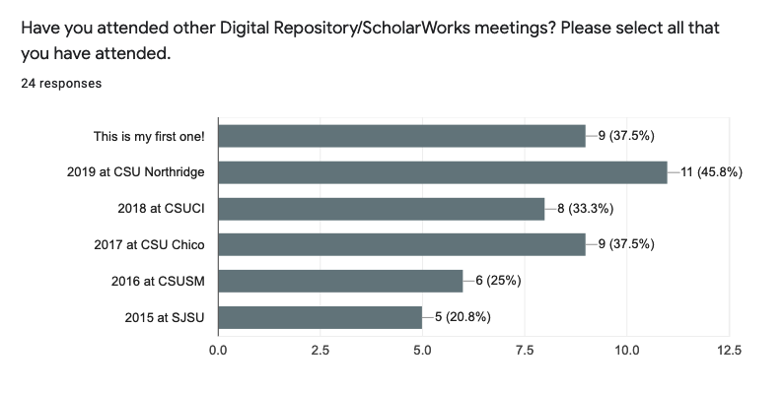14 not willing (63.6 %)

8 willing (36.4%)

14 are very likely (58.3 %)

4 likely (16.7%)

6 not sure (25%)

Is your campus interested in hosting the meeting next year? (Please note that we do not know at this time if it will be in person or virtual.)

11 maybe (61.1 %)

7 no (38.9%)