**Formula for Calculation.**

Typical column header –



% of FTE

=Sum of FTE/Total FTE

Cost

=%FTE*Sum of Cost

CPU

= Cost/Usage (Total Item Requested)

%of Usage

=sum of usage/usage

Formula for SUM =sum(firstcell:lastcell) for example=sum(c1:c6)

**Format Data Style**

For currency – Select your data, right-click then choose **Format Cells…**, the Format Cells windows open, with the Number tabs, then select **Currency** in the Category.

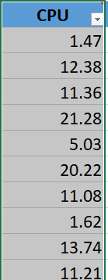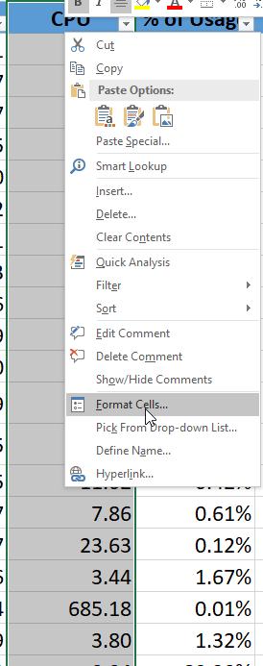 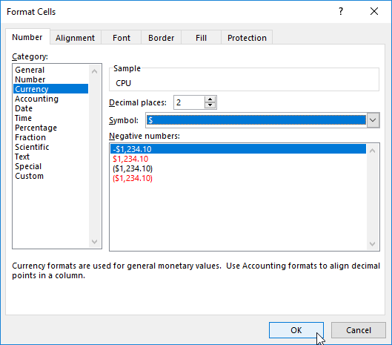 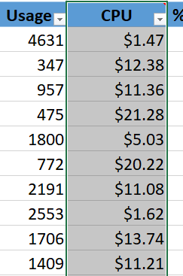

**For Percentages** –

For currency – Select your data, right-click then choose **Format Cells…**, the Format Cells windows open, with the Number tabs, then select **Percentage** in the Category. Click the OK button to apply the .

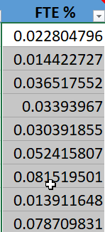 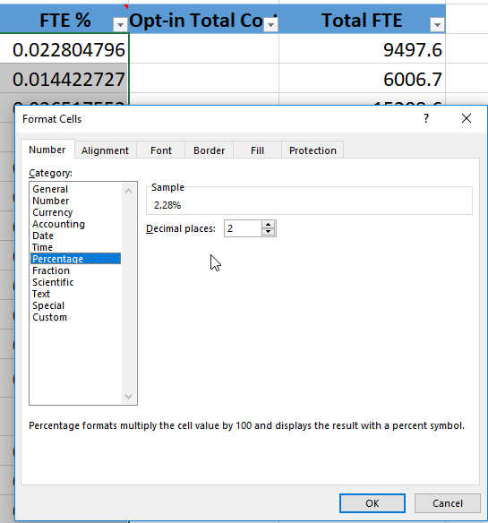 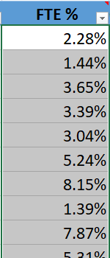

**Copy a Template** –

Chart templates are useful when you want to save and re-apply colors, layouts, font formatting, and other chart settings.

Save a Chart Template

1. To save a template based on a chart, right-click the Chart Area, then choose **Save as Template** option from the shortcut menu.   
   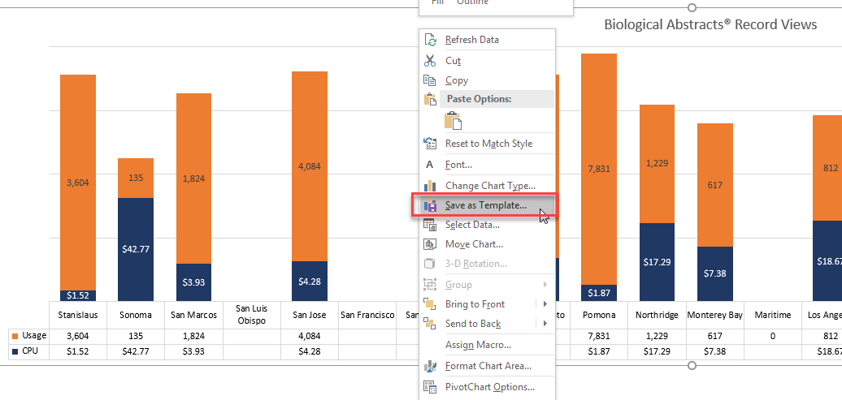
2. When Excel prompts you for a name, type a suitable file name and **Save** button.  Note: it is best to keep your template in the Microsoft Template folder

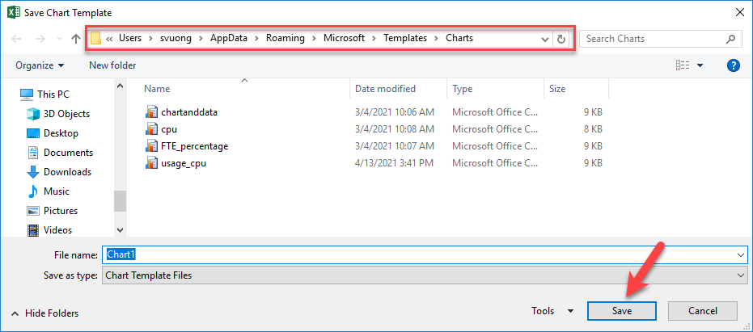

1. Excel will add the chart template extension automatically, "crtx".

**To Create a Chart**

1. Select the data for your chart
   1. To select multiple range, click the CTRL key
2. Select the Insert Menu, then choose Recommended Chart or pick a chart of your choice.
3. Click the OK.

**To apply a template to an existing chart.**

1. Right click the chart and choose **Change Chart type…**

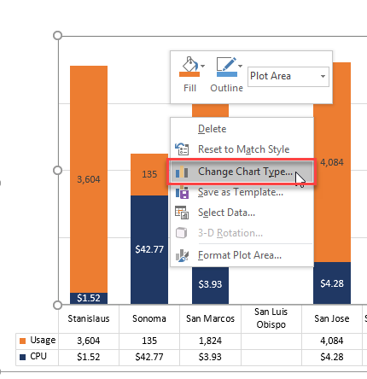

1. In the Change Chart Type window opens, select the **Templates** folder.

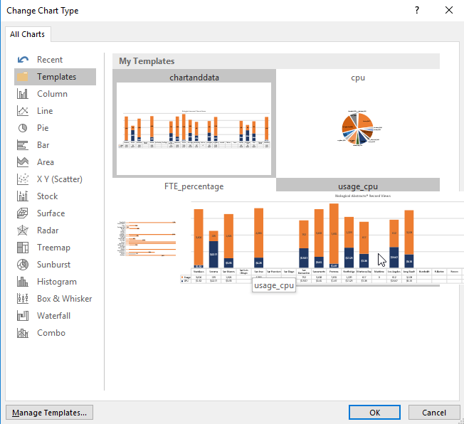

1. Then choose a template and click the **OK** button.
2. The template will then be applied to the chart. Applying a template will affect a wide range of chart elements. Font color and size are also transferred, as you can see with the chart title, legend, vertical and horizontal axes, and the data labels.

**Working with Data Series**

1. Click the data area of the chart, right-click then choose Select Data...

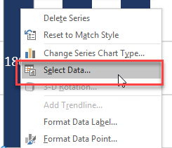

1. Once the Data source windows open, from the Legend Entries (Series) column, you can switch the order of the data by use the Move Up or Move Down order.

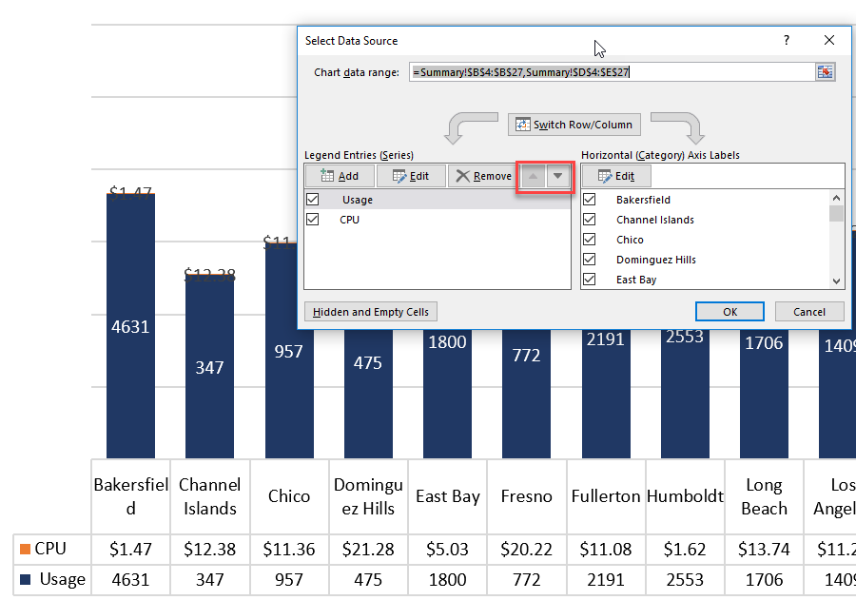

1. Once you switch the order of data, you will see a better representation of it.

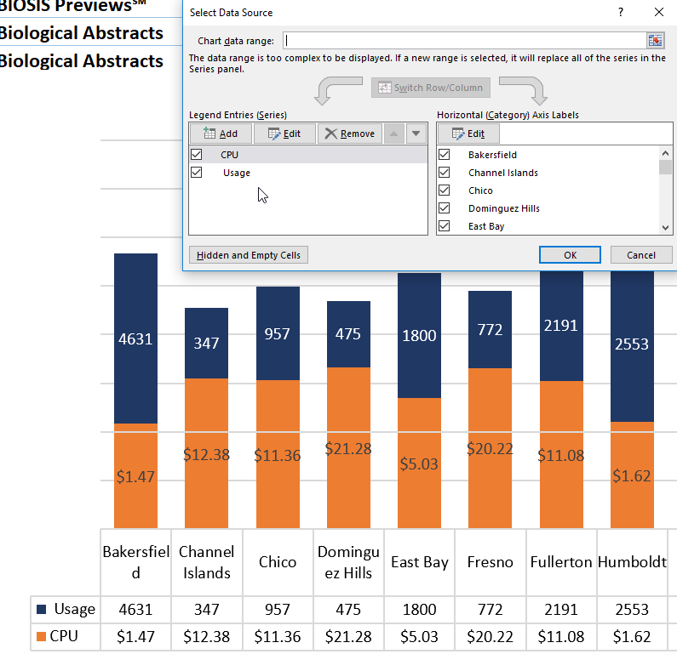

**Working with Data labels**

There are times you may want to change the alignment of the labels.

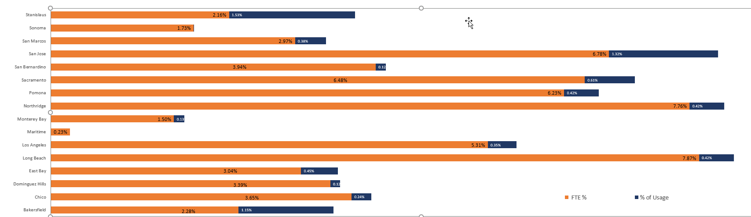

1. Select the data alignment you want to adjust
2. On the Upper right corner, next to the chart, click Add Chart Element, then choose Data Labels

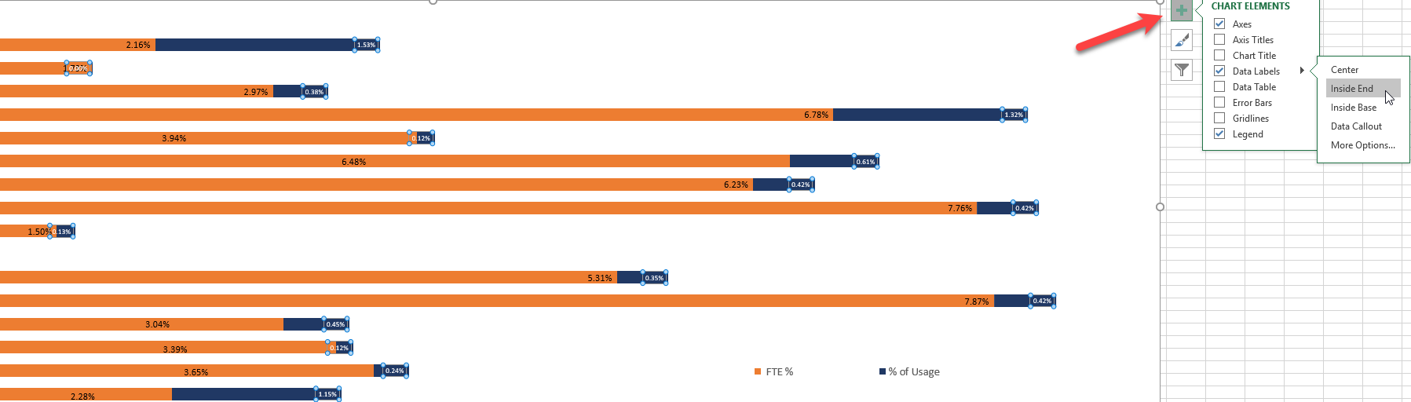

1. From the Data Labels, choose Center, Inside End, Outside End, Best Fit, Data Callout or more options.
2. If you change the Data Series – you’ll get a

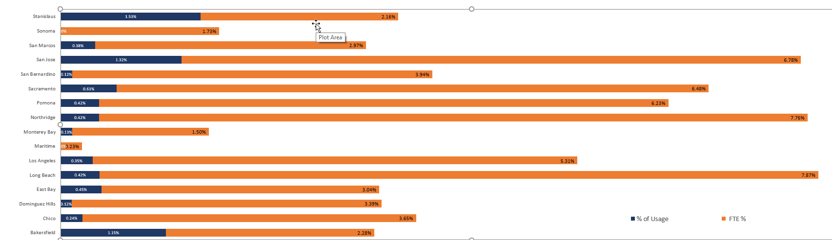

There are time, that your data label may not be legible. So, there are time, you’ll need to change the font color, so it is visible.

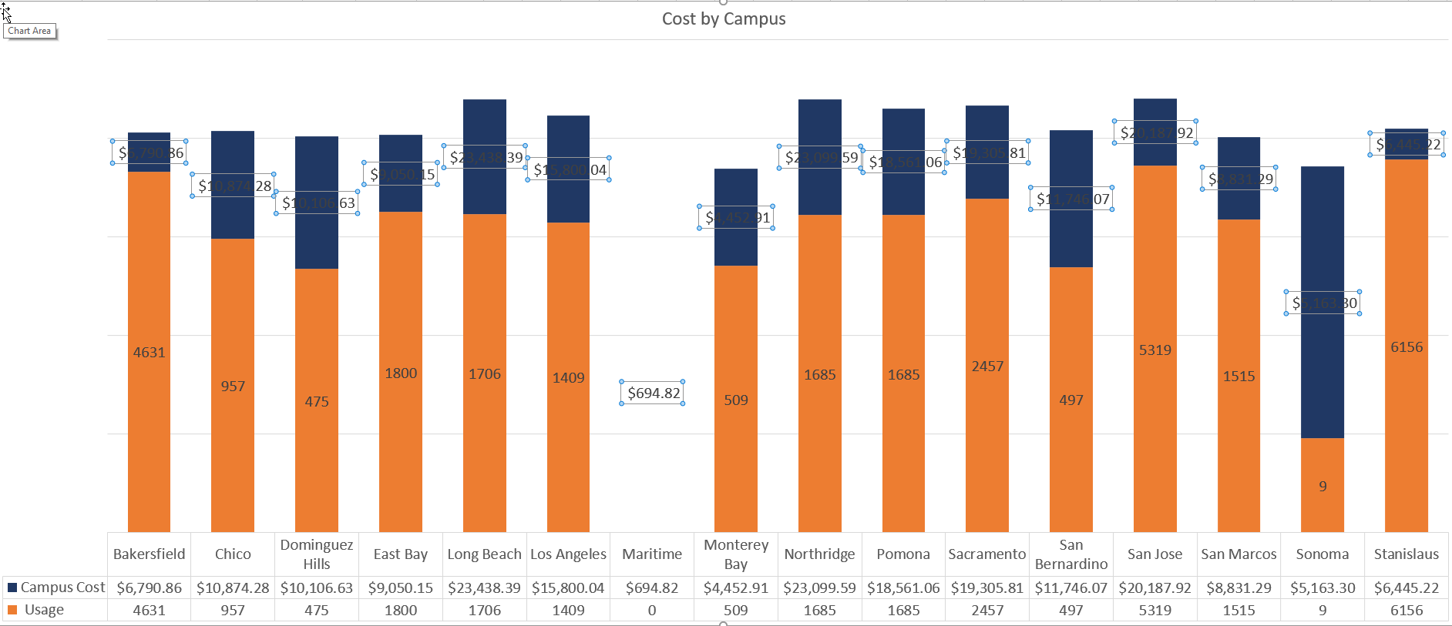

You can change the Color of text or the color of your graph.

1. First select the label then choose a color. 

