**Created by:  
Anjana H Bhatt  
E-Resources Librarian  
Florida Gulf Coast University**[**abhatt@fgcu.edu**](mailto:abhatt@fgcu.edu) **Ph: 239-590-7634.**



**Agenda**

* How to add Vendor Licenses and License terms in ALMA ‘License and Amendment’ Module.
* Explain how to make ‘Sets’ and ‘Run a Job’ to link multiple collections attached to one PO line to the ‘License Summary/PO Line’ tab.
* Explain how to make ‘Sets’ and ‘Run a Job’ to link multiple collections by one vendor to the ‘License Summary/Inventory’ tab.

**Disclaimers & other information:**

* I am not yet an expert. I am here to share what I know and learn from you as well.
* This handout contains simple instructions based on my workflow.
* Don’t worry about the length of this document or think it is complicated task. I just spaced the document well so there are no confusions, plus, it includes some screenshots and references etc.
* Note: There are multiple ways to handle a particular assignment in ALMA. I have demonstrated the ones that I found easy for this assignment.

**First thing first:**

1. **License Module** is listed under ‘Acquisitions’ option on the side bar of the main ALMA search interface.   
     
   Click on ‘Acquisitions’ and select ‘Licenses’ option under the ‘Acquisition Infrastructure” section to access it. This module is called ‘Licenses and Amendments”.
2. **ROLES:** You would need following ROLES to completely manage the License Module in ALMA and PRIMO.   
   1. License Manager Role for Acquisition functions.
   2. You may need other Roles related to E-Resources. management/Vendors/Acquisition/Invoicing/Purchasing activities.
3. PRIMO/Discovery/Configuration related Rolesare required to manage ‘SHOW LICENSE’ options, display options for license terms, add new license terms and change the order of license terms etc. in PRIMO search results under the “SHOW LICENSE” button.  
     
   **NOTE:** If you do not have Primo or configuration related roles, you can request your site coordinator or the personal responsible for PRIMO configurations to set your PRIMO discovery options for licensing terms.
4. **License copies:** Make sure you have a PDF and word copy of the license agreement available.
5. You would need to upload the PDF copy in the ‘Attachment’ tab.
6. Word copy is helpful for cutting and pasting the terms in the ‘Licensing Terms’ tab. Typing long licensing terms is time consuming and open to spelling mistakes.
7. **NOTE: These are legal terms so you should add them very carefully and they should be absolutely correct.**
8. **Vendor Records settings:** Make sure your ‘Vendor Details’ records have the ‘Licensor’ option checked in the ‘Vendor Type’ field. **If this button is unchecked, you cannot populate any ‘’License and Amendment’ module tabs.**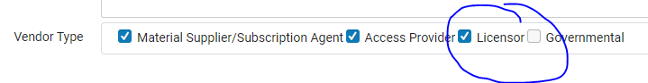

**License Tabs descriptions and my tips for adding information under these tabs.  
  
Adding licenses:** Access ‘License and Amendment’ page and click on ‘Add License’ button on upper right corner and choose ‘Manually’ option. Later when you have templates, you will be able to load a template too. As of now ONIX-PL files are not yet available to work with. **Note: There are total 10 tabs in this module, but only 6 tabs show when you first access the ‘License and Amendment’ interface. Once you save a license, you can access all 10 tabs.**

1. **Summary Tab:** Gives information regarding the Terms of Use, Restrictions, Perpetual Rights, etc. of a license. Some helpful tips for populating Summary tab are listed below:   
   1. **License Name:** This is a mandatory field. Think of a unique license name. You can add the validity of the license terms as a unique individualizing element.
   2. **License Code:** This is also a mandatory field. You may add your library’s name or consortia name to the vendor name to make it unique. Some examples to make it unique are: ProQuest FGCU, ProQuest FLVC or ProQuest Group etc.
   3. **Licensing Agent:** Make sure you add correct licensing agent in this field. Ex: for group products it could be University of Florida or FLVC for Florida Library Virtual Consortium. For local products you can use the vendor’s name from the vendors module.
   4. **Dates:** Start date of a license is a required field and you can not save the license without it. Select the dates very carefully. First choose year, then month and date.   
        
      **NOTE:** If you add a month and date first and later have to change the year, it will not work, not reload and not allow you to save the license either.
   5. **Non-mandatory fields**: Add signing authority, status of license, location of license and end dates etc. before saving it. You can save a license without adding them as well or add them later.
   6. **Save the License:** After populating each field, immediately save the license.   
      1. If you do not save it and make a mistake with dates or try to add the inventory and PO lines, it will not work properly and you will also loose all your work you did for populating the Summary Tab.
      2. You cannot link anything under the ‘Inventory’ and ‘PO lines’ tabs unless a license is saved and available in the ‘License and Amendment’ module. Once you save it, click on ‘Edit” to work with your tabs.
2. **License Terms Tab:**
   1. Have a copy of the license in PDF and word format ready. Keep your URL of the licensee handy (If you have it).
   2. Review available license terms listed under ‘License Terms’ tab and decide which license terms you want to add as per your policies and highlight them on your copy of the license in word format.   
        
      **This is your prep work that you must do to enter the terms easily under this tab. Don’t skip it.**
   3. Choose the ‘Terms of Use’ option and click on the pull-down menu and add the terms one by one.
   4. Adding terms here allow you to display them under ‘SHOW LICENSE’ button in your PRIMO search results.
   5. Choose ‘Yes’ or ‘No’ or ‘Permitted’ or ‘Prohibited” etc. options as applicable. Under the text field, copy and paste the statements from your word document or just type.

**Tips**:

* + 1. You can choose which terms to display in PRIMO searches under ‘SHOW LICENSE’ button.
    2. You can change the order of the terms that appear in PRIMO search results.
    3. You can also add a new License terms in the menu.
    4. You can choose which vendor terms to display or not in the PRIMO search results.
    5. You can suppress one or more license terms if you do not want to display them in PRIMO.
    6. You can altogether suppress the ‘SHOW LICENSE’ button.
    7. **In order to accomplish above tasks, you will need to have either the configuration roles or the primo discovery set up roles.**

1. **Inventory Tab:** Lists the active and historical packages associated with the license.  
     
   If you have just one collection from a vendor, it is super easy to link it to the license, however, if you have more than one collection from a vendor then you have two options:
   * Link the collection individually to the license agreement for each collection OR,
   * Make a Set and Run a Job.
   1. **Adding only one collection to the ‘Inventory’ tab workflow:**   
      1. Go to the ‘Electronic collection’ search page in ALMA and search for your collection for which you want to update the ‘Inventory’ tab.
      2. Click on ‘Edit collection’, then click on ‘General’ Tab and link license in the ‘Acquisitions and License Information’ area.
      3. This activity also puts in a hot link to your license module for others to review it.
   2. **Adding multiple collections to ‘Inventory’ tab workflow: It is a two-steps process.**

**First Step: Make A set**

* + 1. Go to the ‘Electronic collection’ search page in ALMA and search for your collection for which you want to update the ‘Inventory’ tab.
    2. Select collections you want to make a set for from the ‘Facet’ bar.
    3. Confirm if the collections are correct and hit the ‘Save Query’ button on top right-hand corner. It will open to the ‘Set Details’ page.
    4. Give your set a name, add description and notes etc.
    5. Select ‘No’ options as default for ‘Private’ field.
    6. Select ‘Active’ option for ‘Status’, review details and click on Save.

**Second Step: Run a Job**

1. Go to ‘Admin’ Icon on the side bar and choose ‘Run Jobs”. It will open ‘Run a Job – Select Job to Run’ page.
2. Select ‘Electronic Collection’ from the ‘Content’ type pull down menu.
3. Select ‘Change Electronic Collection information’ option and click Next.
4. Review your set you want to work with and click Next. It will open ‘Run a job – Enter Task Parameters’ page.
5. Choose ‘Change Electronic Collection Acquisitions and License information’ option and click on the pull-down menu.
6. Click on ‘three ellipsis’ button in the ‘Set License’ field and link your desired license agreement and click next. It will open ‘Run a Job – Review and Confirm’ page.
7. Review your set size and name etc. and click ‘Submit ‘button and confirm.
8. Go back to ‘License & Addendum’ page and check ‘Inventory’ tab   
   Bingo! Your collections are listed here. It may take a while so don’t get desperate or doubt your workflow>😊.
9. **PO Lines Tab:** Lists all PO Lines linked to the license.

**Tips:**

* + 1. You can only link active PO Lines. If PO Lines are closed, you would need to either open them to link and then close it again or investigate further about your workflow.
    2. If you have just one collection from a vendor, it is super easy to link a PO Line to the license, however, if you have more than one collection from a vendor which are linked to one PO line, you have two options:
    - Link the PO line to the license agreement individually for each collection, OR
    - Make a set and Run a Job.

1. **Adding PO line linked to only one collection workflow:**   
   * 1. Click the little ‘blue Card’ next to the ‘Licensor’ pull down menu line. It will open the ‘Vendor Details’ page where ‘PO Lines’ is one of the tab.  
          
        
     2. Click on ‘PO Lines’ tab and when the collection shows up, click on ‘Edit’ button.
     3. Choose ‘View License’ field and link your license in this field by clicking on the three ellipses button and selecting your license from the license list and click Save.
     4. Go back to your ‘License and Addendum’ module and check you ‘PO line’ tab to make sure it is linked. It may take few minutes so don’t get desperate or doubt your workflow.>😊
2. **Adding PO line linked to multiple collections workflow:**   
     
   It is a three-step process. First you have to ‘Create a set’ of all collections and then complete ‘Manage a Set’ workflow and then ‘Run a job’ to link the collections under the ‘PO Line’ tab.

**First step: Make a Set:**

1. Access ‘License & Addendum’ summary page and click the little ‘Blue Card’ next to the ‘Licensor’ Pull down menu line.  
     
     
   It will open the ‘Vendor Details’ page where ‘PO Lines’ is one of the tab.
2. To make sets of collections for this vendor, first click on ‘PO Lines’ tab and then select appropriate collections related to this PO line carefully from the ‘Facets’ area. When the desired collections show up, download excel spreadsheet by clicking on the ‘Export list’ button.   
     
   You may choose ‘Current view’.  
     
   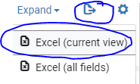
3. Download excel spreadsheet and save it where you can access it easily.
4. Open downloaded spreadsheet and copy only the ‘poLine.poLineReference’ column (column L), open a new spreadsheet and paste this column.
5. Re-name this column ‘**PO Line reference’** and save it from where you can easily get it by giving appropriate file name**.**

**Tip:** If you do not re-name the column as ‘PO line reference’ it will not work. You must name it as ‘PO Line Reference’ column only. Close the spreadsheet so you can load it later. If the spreadsheet is open, you won’t be able to load it.

**Second Step: Manage Set workflow:**

* 1. To link all the collections related to one PO line to the ‘PO Lines’ tab, go to ‘Admin Tool’ icon on the side bar andclick on ‘Manage Sets’.
  2. Click on ‘Add Sets’ button and choose ‘Itemized Sets’.
  3. Name the set appropriately, make sure it is not defaulted to ‘Private’ (you need to select ‘NO’ option here). And also, make sure ‘Status’ is selected as ‘Active’.
  4. Click on the ‘Set Content type’ pull down menu and select ‘Order Lines’ option.
  5. Upload your ‘PO line Reference’ spreadsheet from where you had saved it and click ‘Save’.
  6. Check to see if it made it. It will tell you on the side bar in green fonts if your action was successful. If you see red fonts/flags, repeat the process carefully.

**Third Step: Run the job:**

1. Go to ‘Admin Tool’ icon on the side bar and click on ‘Run A Job’.
2. Under ‘Content Type’ pull down menu click on ‘Purchase Order line’.
3. Select ‘Update PO Lines Information’ option and click next button on top. It will display all your sets.
4. Find the set you want to link, select it and click next button on right hand corner, it will open ‘Run a job- Enter task Parameters’ page and also show you how many collections this set has. At this stage you can verify them again to make sure you are running a correct job.
5. Click ‘License Parameter’ from the list and click on the three ellipses button. It will bring your main license page. From here you need to select the license you want the ‘PO line’ tab to link to and click the ‘Select’ button at the bottom most right corner.
6. It brings up the ‘License Parameter’ page again. Review your information and click Next button at the top right corner.
7. Verify all the information regarding your set size and vendor name etc.
8. Click ‘Submit’ button and click on ‘Confirm’.
9. Bingo! This will populate your PO line tab in the ‘License and Amendment’ module.
10. Go to ‘PO Line’ tab and review your PO lines. If you see your collections in there, you are successful. If not, carefully create the set again as per the process mentioned above and run the job again.
11. **Amendments Tab**: Provides an opportunity to addAmendments to the master license record.  
    1. You can upload pdf copies of the amendments to license agreements, if any.
12. **Group Settings Tab:** I am not sure what it is for. I can investigate and let you know later.
13. **Administrators Tab:**
    1. Click on ‘Add Administrator’ button; it will open a search window. Search for the name of the administrator and hit save button.
14. **History Tab:** Records all changes made to the license record. You can view your complete action history here.
15. **Notes Tab:** For registering notes about the license or any other note you may wish to add regarding the license.   
    1. This tab allows you to type in notes manually. Use it if you have any special instructions about an agreement.
16. **Attachments Tab:** Allows you to upload license agreements anddisplay pdf copies of the license that you may have loaded earlier. You can also download or print an agreement from this tab.   
    1. Click on ‘Add Attachment’ button, upload as many license agreement files one by one, as you need. You can also add a URL where this license is available and a license related note here.

**Reference:**

1. ALMA:  
   **How are License records managed in ALMA?** <https://knowledge.exlibrisgroup.com/Alma/Product_Materials/050Alma_FAQs/E-Resource_Management/Licenses>
2. **Managing License Terms: Choosing what to show and what not to or add new terms and list of Licensing terms** <https://knowledge.exlibrisgroup.com/Alma/Product_Documentation/010Alma_Online_Help_(English)/020Acquisitions/110Configuring_Acquisitions/170Managing_License_Terms>
3. **Configuring License Section Order:** <https://knowledge.exlibrisgroup.com/Alma/Product_Documentation/010Alma_Online_Help_(English)/020Acquisitions/110Configuring_Acquisitions/160Configuring_Sections_Order>
4. **Display logic Rules for license terms:**  
   <https://knowledge.exlibrisgroup.com/Primo/Product_Documentation/020Primo_VE/Primo_VE_(English)/080Configuring_Delivery_Services_for_Primo_VE/Configuring_Discovery_Interface_Display_Logic_for_Primo_VE#Displaying_License_Information>

**Show License button in PRIMO search results: How does it work and some samples:**

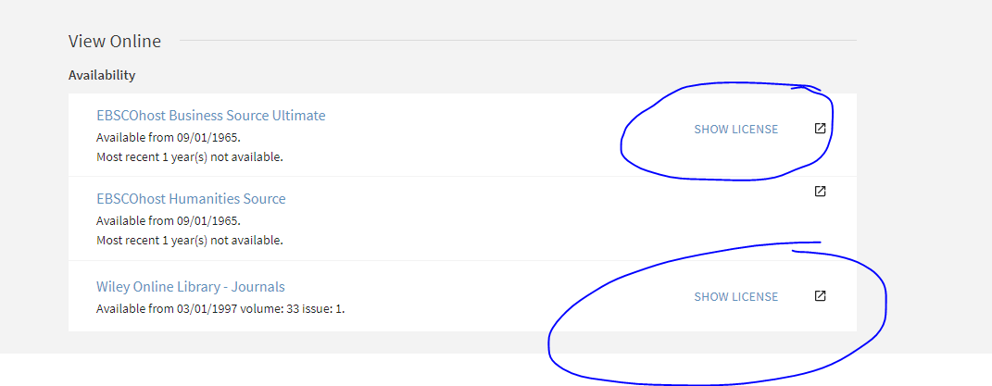

Minimum level of required license information

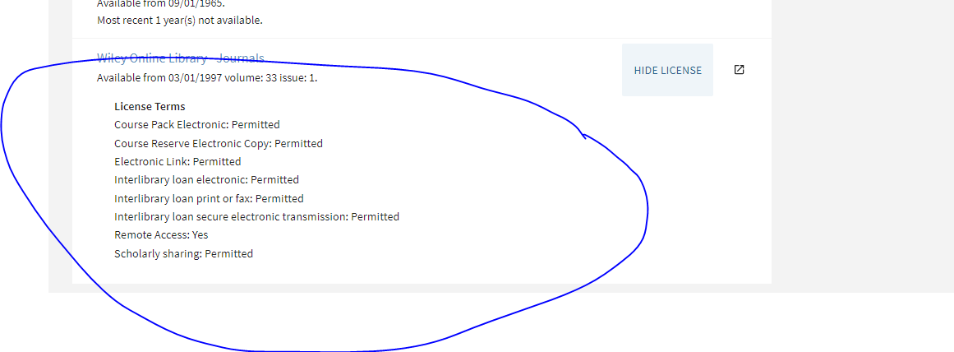

Medium Level of required license information:

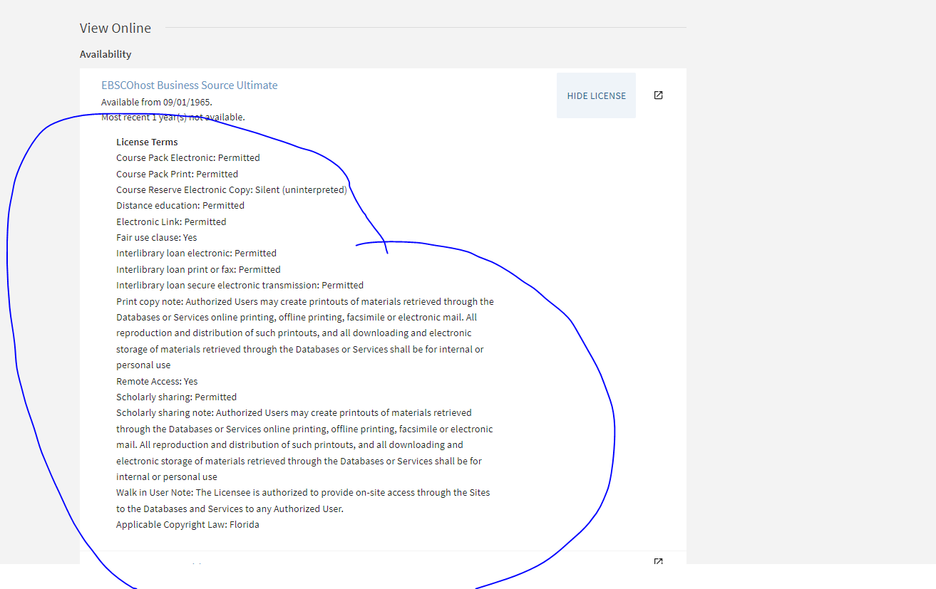

Maximum level of required info

