# Electronic Collection Quick Update or Change Electronic Collection information

## Option 1 -Electronic Collection Quick Update:

There is an API that will help speed up the process of updated electronic collections, at the collection-level. This app will help quickly update the Internal Description for RapidILL lending status note. *Highly recommend if the library has notes in Internal Description.

**Login to Alma and click on the Cloud Center App button:**

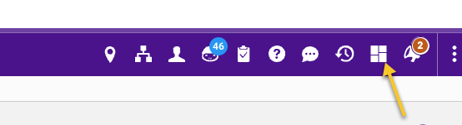

**Locate the app:**

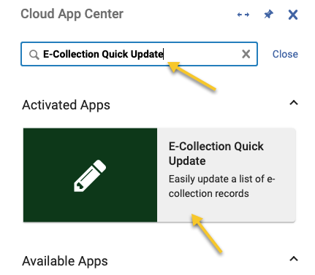

**Activate the app:**

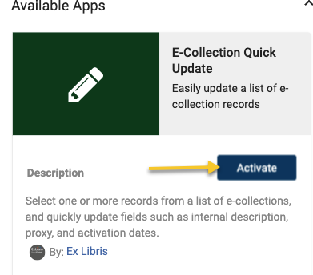

**Create list of collections to update:**

* **Search for a list of Electronic Collections**
* **Click on Cloud App button**
* **Open the E-collection Quick Update app**
* **Select collections to update**

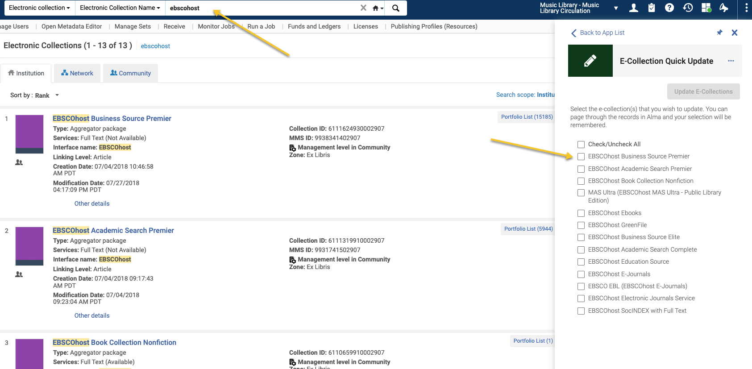

**Add the RapidILL status note to the Internal Description. Use “Append” because if there are notes in the Internal Description they won’t be lost. Click on Update E-collections button:**

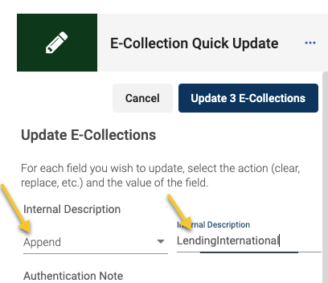

**Click OK after update:**

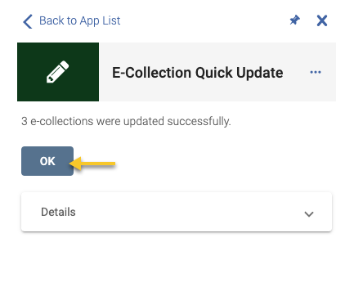

**Check on Internal Description:**

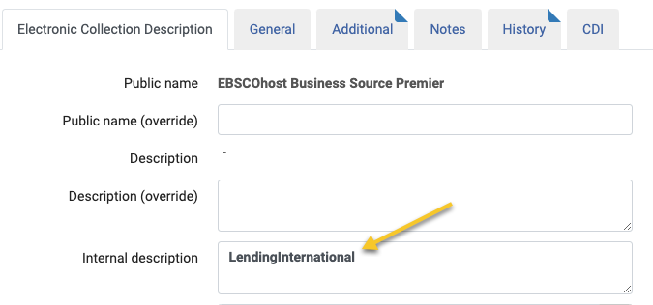

## Option 2 -Change Electronic Collection Information Job:

**Use if the Internal Description does not have an existing note.**

