**Using HTML Tags in Electronic Resources Public Notes**

* HTML tags can be used to enhance electronic resources, such as, a public note in a portfolio or electronic collection.
* Please use current HTML tags (e.g., <strong> NOT <b> for bold).
* HTML can also be used for General Electronic Services. See [How to design the GES Public Name display on ViewIt](https://knowledge.exlibrisgroup.com/Alma/Knowledge_Articles/How_to_design_the_GES_Public_Name_display_on_ViewIt)
* HTML editing appears immediately in OneSearch

**Example 1: Public or authentication note in an electronic portfolio**

In Alma, edit the portfolio. In this example, color and a header will make the note stand out.

**Here is the HTML**:

<h3 style="color:green;">An SJSU email address is required to access this book</h3>

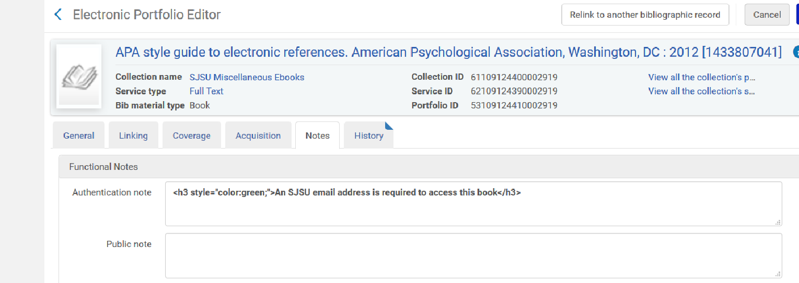

**Here is how it appears in OneSearch:**

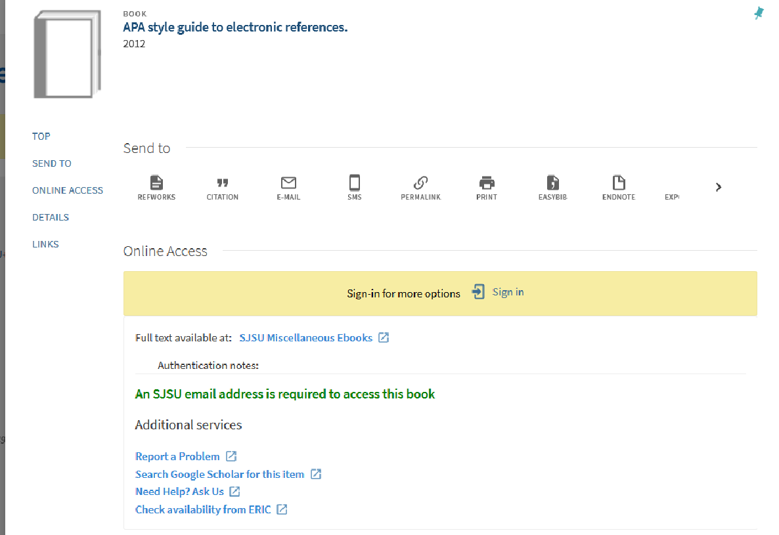

**Question: Why did you use a header tag instead of the tag for bold <strong>?**

**Answer:** The contrast is more striking using the header tag. But it’s your call. “Strong” may be a good tag to use for “multiple user access” public notes. See how it looks in the example below.

**Example 2: Using html tag STRONG**

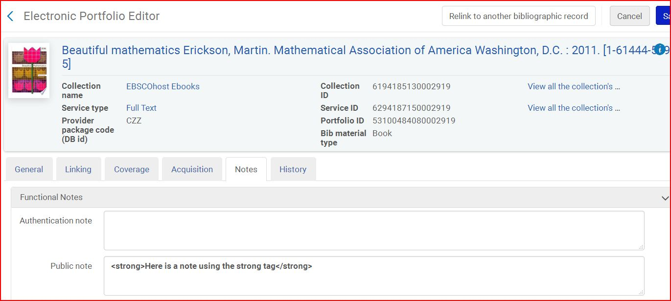

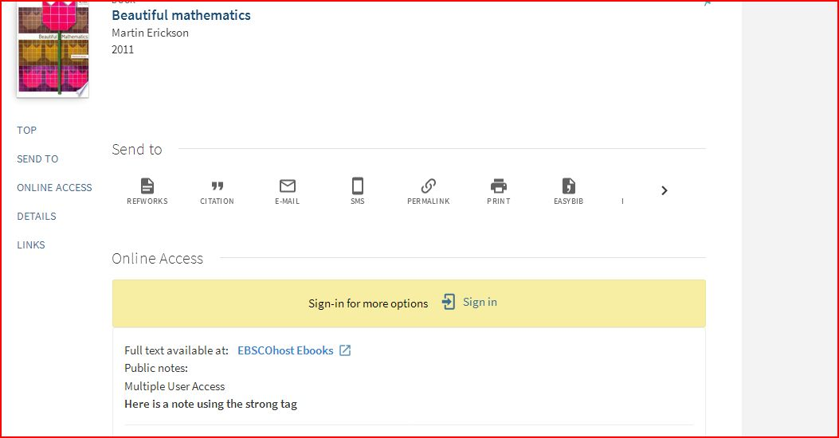

**Example 3: Opening a new window and linking to another webpage**

Here is an example using HTML to open a new window linking to another webpage for an endowment. It can be used to any page, such as a link to a password page and so on.

**Here is the HTML:**

Purchased on the <a href="http://library.sjsu.edu/giving-library/mark-trent-goldberg-endowment" target="_blank"> Mark Trent Goldberg Endowment</a>

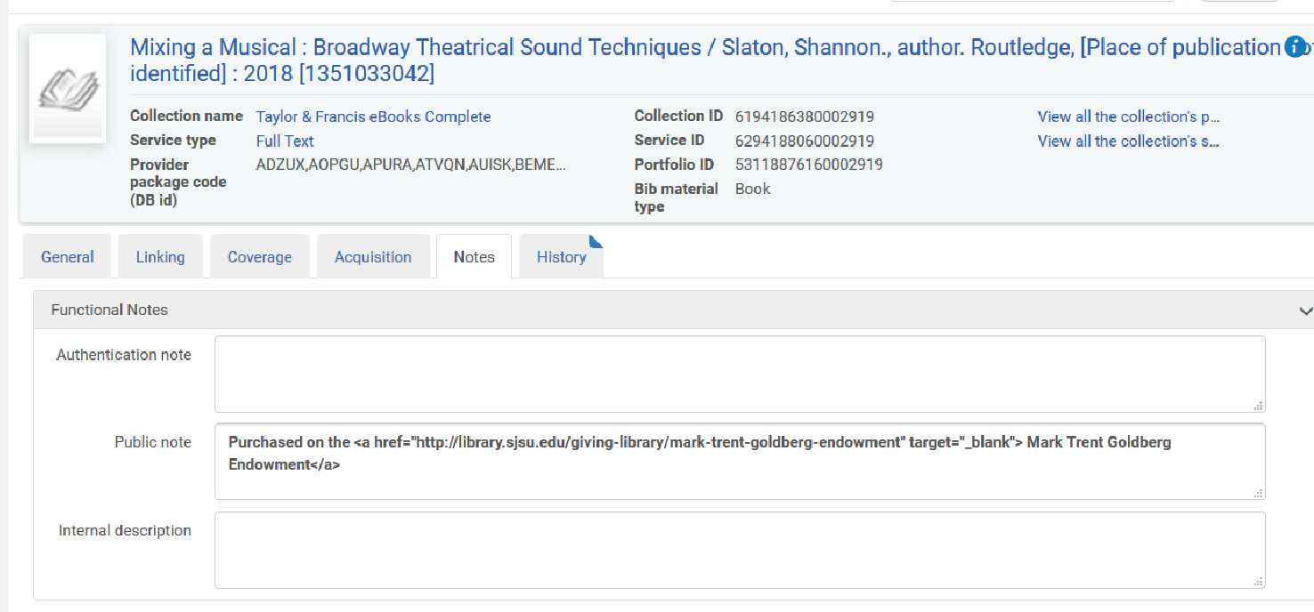

**Here is how it appears in OneSearch:**

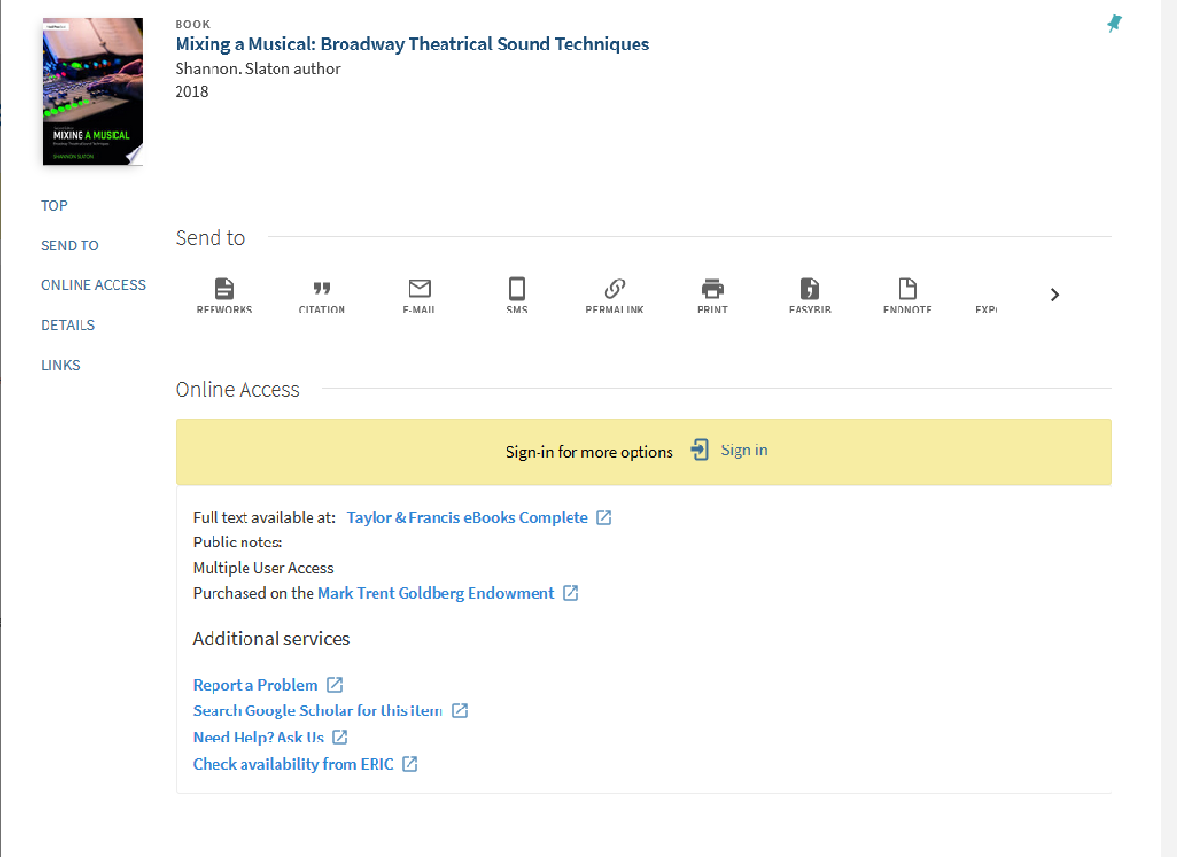

**Caution: Be wary about adding a note to a shared resource. The information will appear but only for your IZ portfolio. It can get lost in the display.**

**Example 4: a note in a shared electronic resource**

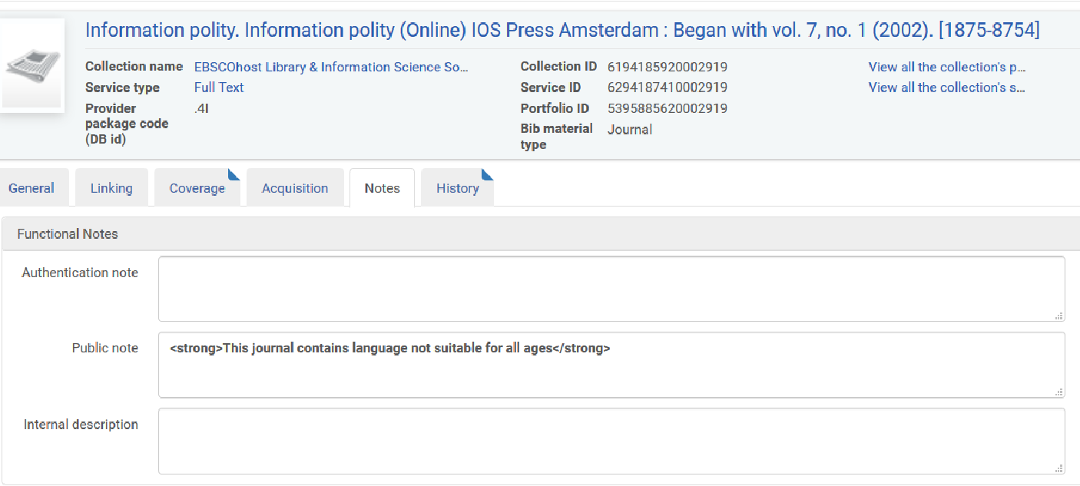

**Here is how it appears in OneSearch:**

