**April 2024: Video titles matching erroneous titles in Primo VE records**

After migrating to Primo VE, we noticed that ebook titles, generally from NZ collections, were matching on IZ streaming video records. Also, some IZ and NZ videos with similar titles also matched. The “nodedupe” rule we were able to use while in Primo Back Office could not be used in Primo VE.

Many support cases were opened. Some of our cases have been resolved but w/o any understanding as to what Ex Libris did. Ex Libris is still investigating a solution.

**Why is this happening:**

It has to do with Uresolver/link resolver matching and the algorithm used to determine matching.

Documentation:

<https://knowledge.exlibrisgroup.com/Alma/Product_Documentation/010Alma_Online_Help_(English)/Electronic_Resource_Management/051Link_Resolver/010Alma_Link_Resolver_Workflow>  
  
*"If there was no search by identifier (no identifier as part of the Context Object), a search is performed by "title" only.”* From the chart, it is searching 245 $$a, b, and so. Yet, it seems to be ignoring $$b from our experience since incorrect matching occurs. Also, this matching does not seem to understand that videos do not have ISSN, ISBN, etc.

Next ---

[August 2023 Alma release notes](https://knowledge.exlibrisgroup.com/Alma/Release_Notes/2023/Alma_2023_Release_Notes?mon=202308BASE): (This was supposed to help with the problem; but it does not seem to be doing much).

Currently, when Alma gets an open URL from Primo, it tries to find resources according to three main methods:

1. Match by identifier

If no identifier exists/no match was found:

1. Match by title and author

If no title+author exists/no match was found:

1. Search by title only ("Fuzzy Match")

If the open URL contains only a title, Alma attempts to find a match, since there are no other elements by which to search.

**Control Ability to Ignore Title Based Link Resolving**

Alma enables institutions to prevent "Fuzzy match" attempts based on title-only matches when patrons search for resources. By default, this option is disabled, and in instances that the URL had "Identifier + Author + Title" and there was no match on the "Identifier + Author", Alma tries to find a match by "Title". However, when the option is enabled, patrons no longer receive wrong search results based on title matches only. This option is controlled by the following customer parameter: **avoid_fuzzy_search_resolving**.

**Here are 2 possible solutions to implement:**

Option 1: If you use vendor supplied records, you may add a 020 field. For example, you might add a Kanopy number. This will stop ebook titles from appearing in streaming video records. Technically, using the 020 field which is generally reserved for ISBN/ISSN is not adhering to standard cataloging rules. Also, this is probably not sustainable if you have many records in which the problem occurs. Do not use this solution for CZ records.

Ex Libris explanation to Bakersfield:

“I've investigated the issue, and unfortunately the behavior you are seeing is expected due to the way Link Resolver matching is done for View It. For records/titles without any standard identifiers such as this one, the Alma Link Resolver matches can be based on title alone. This is because when there are no standard identifiers in the IZ record, the Link Resolver will perform a generic search using the metadata sent in the context object from the member institution, which would in this case is the title. In this case, the 'Gather : Richard Van Camp on the Joy of Storytelling' from the NZ is being returned because this record also has 'Gather' in 245 $$ a:”

**Their suggestion**: “Alternatively, adding identifiers if they exist would help. For titles which do not have standard identifiers, you can also try adding a dummy identifier. For example, if you add a 020 MARC field with $$&nbsp;, you will see that services for portfolios from the NZ are no longer returned.”

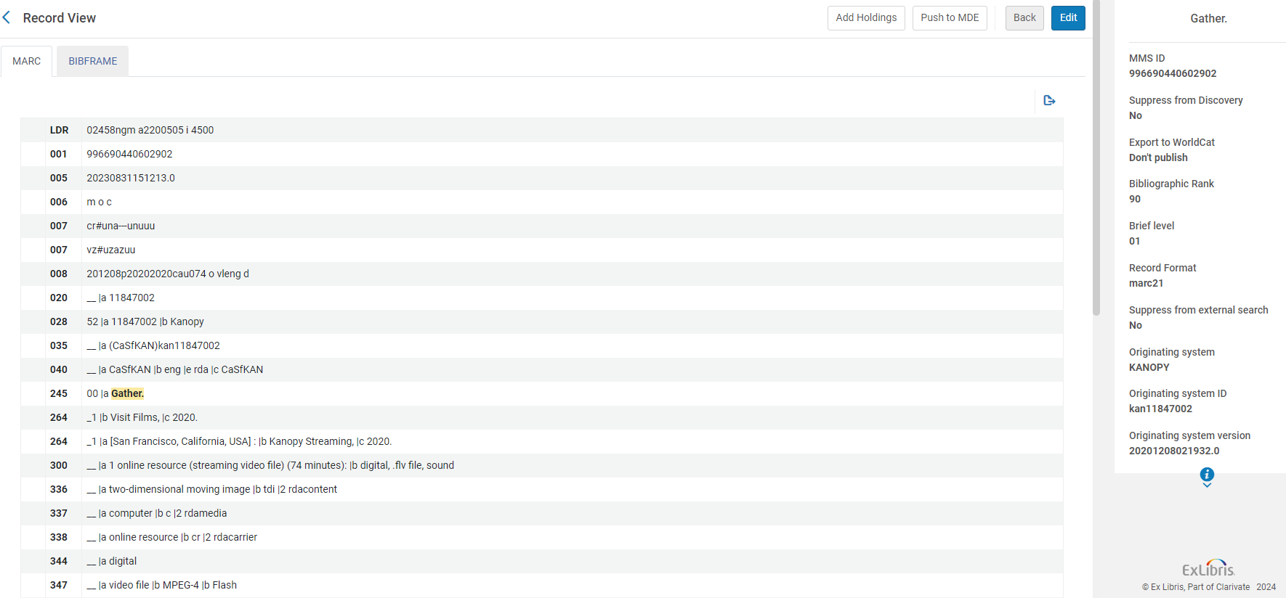

Option 2: Add Display Logic Rules. This is what SFSU and SJSU do.

You can add a broad Display Logic Rule that will prevent other collections appearing on the streaming video title. You may add just one rule or individually. Here is an example of just adding one rule.

This hides all collections including streaming collections. Do not worry, the records for those collections still appear on their own in Primo VE.

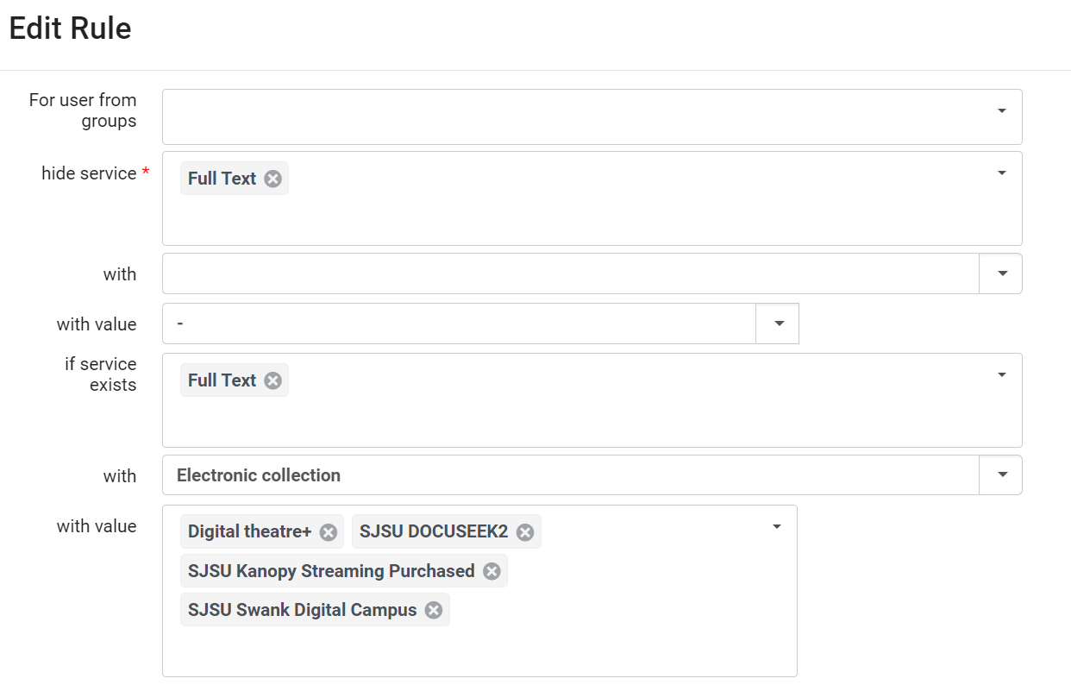

You may also choose to refine and add specific collections: This is what SLO is doing.

