**Deduping Record Numbers in 001 Fields – Part 1**

***Overview***: In this cleanup task, two types of problems commonly present in the 001 fields in Millennium will be dealt with in preparation for the deduplication process covered in part 2.

***Importance***: The presence of multiple records with the same value in the 001 will most likely negatively impact the data migration process and the follow-on linking of records to the master WorldCat records in the Network Zone.

**Problem #1 – Subfield Codes Present in 001 Field**

Millennium’s Global Update tool is unable to dedupe identical 001 fields when an invisible “|a” is present in one 001 field and not in the other. Unfortunately, even if “|a” is present in an 001 field, it is not visible in Millennium. The test record below contains two apparently identical 001 fields. Here is how the 001 fields appear in Millennium:



When the bib record is exported and opened in MarcEdit, however, the hidden “|a” in the second 001 field is now visible (the standard OCLC prefix “ocm” or “ocn” was automatically added by Millennium’s Data Exchange during export):



To remove these invisible “|a” strings, create the search query BIBLIOGRAPHIC MARC Tag 001 has "|a" in Create Lists as shown below:

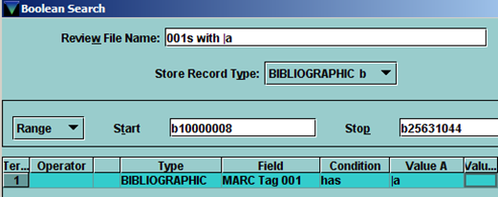

You may have to use a large review file, and may have to do this multiple times. This invisible string was present in a large number of records in my Millennium database.

The next step is to remove the “|a” string using Millennium’s Global Edit tool. Choose the “Change Variable-length Field” option and enter “001” as the Find MARC Tag and “|a” (without the quotes) in the Find Data box, as shown below:

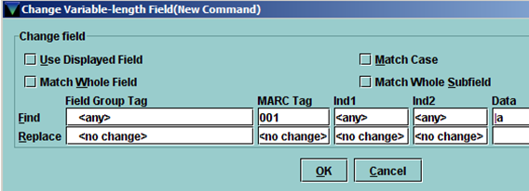

**Problem #2 – Remove Duplicate 001 Fields**

After running that global edit to remove the invisible “|a” strings, reload the same review file into Global Update and choose the “Delete duplicate field” option:

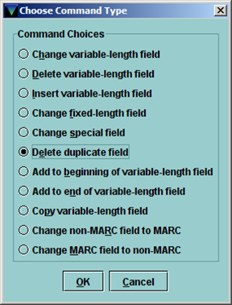

And enter “001” in the Delete duplicate MARC Tag field:

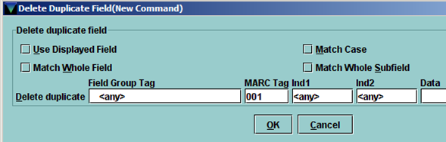

After repeating this process to insure that all problem fields present have been fixed, go on to “Deduping Record Numbers in 001 Fields – Part 2”.

*Created 2/11/2013 by Bob Thomas*