Question: Why do we need to identify serials (that are not for online electronic resources) that don’t have holding (checkin) records attached in Millennium and create holding (checkin) records for them before the migration ?

Answer: Alma needs to have a summary holdings statement to create holdings records for serials (that are not for online electronic resources).

How to identify serials (that are not for online electronic resources) that don’t have holding (checkin) records attached in Millennium?

The seach critera are:

|  |  |  |  |  |
| --- | --- | --- | --- | --- |
| Bib | BCode 3 | not equal to | ‘-‘ | [ignore suppressed bibs] |
| Bib | Blvl | equal to | s | [select Bib Level 'serial'] |
| Bib | 006 Form item (@227) | not equal to | o | [ignore if 006/Form of Item is 'o' Online] |
| Bib | 008 Form item (@337) | not equal to | o | [ignore if 008/Form of Item is 'o' Online] |
| Bib | linked record | not exist to | checkin | [select only if no check-in record is attached] |

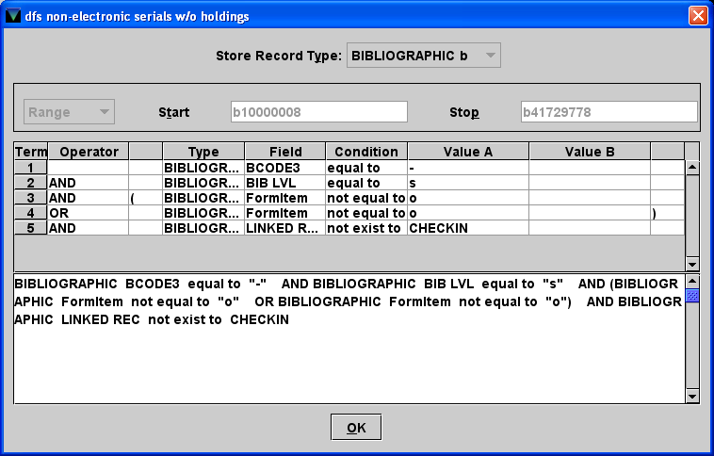

Note:

* Since libraries do not set things up the same way in Millennium, criteria may need to be adjusted depending on local system configuration and codes. Also, there will be variation in local practices that will require adjustments to search strategies.
* Character position definitions for 006 and 008 vary depending on how item is cataloged (Book, computer file, map, music, etc). Page # 107948 in the III manual is useful – it will help you to see which character positions to look at in the 006 and 008 and what III maps those to out of the box. Another way to know which to select is to identify something manually that you know needs to be transferred and choose each one in sequence until you obtain the value you expect. You can verify you found the right one by changing the value, outputting that, changing it back, and verifying that the outputs are always as expected.
* This search does not exclude electronic items attached to print bibs.

Created: 3/12/2013; updated 3/21/2013. For questions contact Lihong Zhu [lzhu2@wsu.edu](mailto:lzhu2@wsu.edu)