**Identify and fixing 007 fields containing Connexion-style subfield delimiters**

***Overview***: In this cleanup task, incorrectly-constructed 007 fields that contain Connexion-style subfield delimiters are deleted.

***Importance***: 007 is not a variable field. Programs reading MARC records expect it to have a certain number of characters. If the 007 field has too many characters, it is structurally invalid and may fail to import into Alma.

**Problem – Subfield Delimiters Present in 007 Field**

Some of our legacy retrocon materials appear have the subfield delimiters typed in the way they are entered in OCLC’s Connexion interface:



The underlying 007 field does not have subfield delimiters and is composed of a fixed number of characters where meaning is determined by position. To find out if you have records with this problem, run a review file as follows. Look for 007 fields that start with a pipe or that have some letter followed by a pipe and b. The reason you can’t just look for the pipe (delimiter symbol) is that it is also used for the fill character in 007 in Millennium.

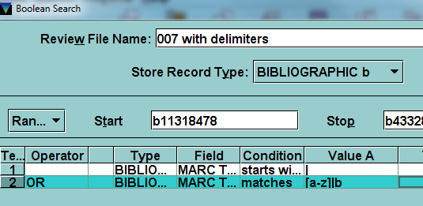

You may still get a few false drops with this approach. Look at any records in your review file and determine if you have any problematic records.

Once you’ve identified the problem records, you could fix each record individually or in batches using global update. However, that could be very time-consuming due to the large number of variations. Since the Network Zone in Alma is going to be populated by WorldCat master records, we decided to just delete the invalid 007 fields.

You can do this by going to global update and selecting your review file. On the command input tab, choose “delete variable-length field.”

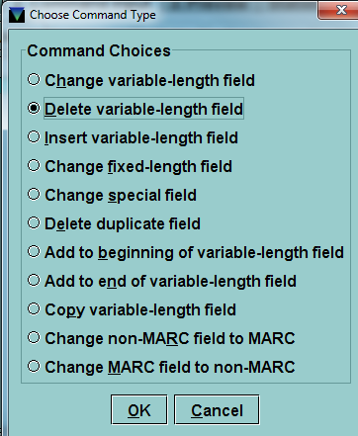

Fill in “007” in the MARC tag box and click OK.

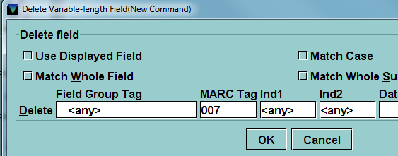

Go to the preview tab and process the entries to delete the invalid 007 fields.

*Created 3/6/2013 by Kelley McGrath*