Marc holdings records for serials

goo.gl/1YUyLX

# Resources

Library of Congress Marc21 Format for Holdings Data

<http://www.loc.gov/marc/holdings/>

OCLC documentation on the Marc holdings record (aka Local holdings record (LHR))

<http://www.oclc.org/holdingsformat/en.html>

Marc Format training (ULMS wiki)

Serials: setting up prediction patterns in Alma (Acquisitions/Cataloging crossover)

<https://docs.google.com/document/d/1ZrcTmAHM6cslIMgVpz24IpHNLKmhg5tnEEv0LhMxxss/edit?usp=sharing>

# Terms

Enumeration (volume and number)

Chronology (year, quarter, month, day)

Captions and patterns (the labels of enumeration and chronology fields and their arrangement. (Ex: v. no. (year, month); v. (year))

# Alma

[Bibliographic record](https://knowledge.exlibrisgroup.com/Alma/Product_Documentation/Alma_Online_Help_(English)/Resource_Management/050Inventory/010Introduction_to_Alma_Inventory)

[Holdings record](https://knowledge.exlibrisgroup.com/Alma/Product_Documentation/Alma_Online_Help_(English)/Resource_Management/050Inventory/010Introduction_to_Alma_Inventory)

[Item record](https://knowledge.exlibrisgroup.com/Alma/Product_Documentation/Alma_Online_Help_(English)/Resource_Management/050Inventory/010Introduction_to_Alma_Inventory)

In Metadata Editor, you can add or edit a holdings record. For step-by-step procedures, please see <https://drive.google.com/open?id=0B2w2MYBQ8fJtenRhVzhVR044eHM>

## Holdings record

[Leader](http://www.loc.gov/marc/holdings/hdleader.html) (oclc 8673888)

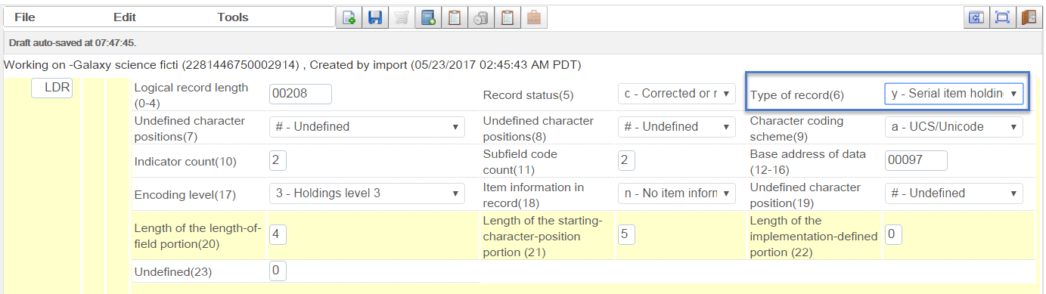

Tip: Ctrl+F will expand the leader field.

007



t: text

a: regular print

[008](http://www.loc.gov/marc/holdings/hd008.html)

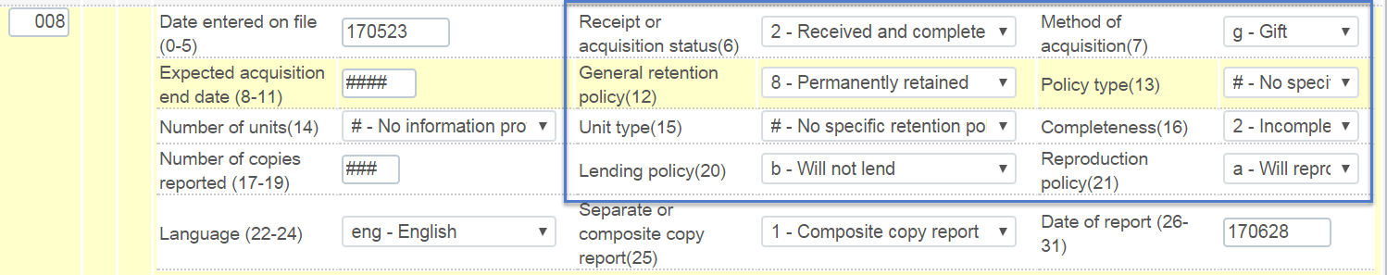

Tip: Ctrl+F will expand the 008 field.

[852](http://www.loc.gov/marc/holdings/hd852.html) location, call number



### 

### template example

The following is an example of a Marc holdings record for a serial.

You'll want to adapt it to your library and some data (such as the 852 $b (library) and $c (location) is specific to your library.

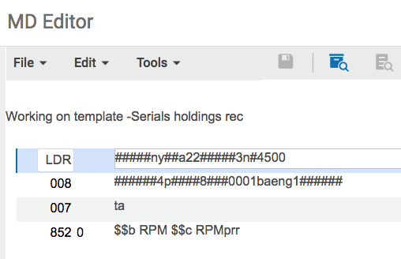

ldr #####ny##a22#####3n#4500

008 ######4p####8###0001ba###1######

007 ta

852 0_ $$b RPM $$c RPMprr

Exlibris documentation on creating, saving and deriving templates:

<https://knowledge.exlibrisgroup.com/Alma/Product_Documentation/010Alma_Online_Help_(English)/040Resource_Management/040Metadata_Management/050Working_with_Templates>

You can also specify a default holdings template for holdings records created automatically through Acquisitions. When you create a Purchase Order (PO) line in Alma a holdings and item record are automatically generated.

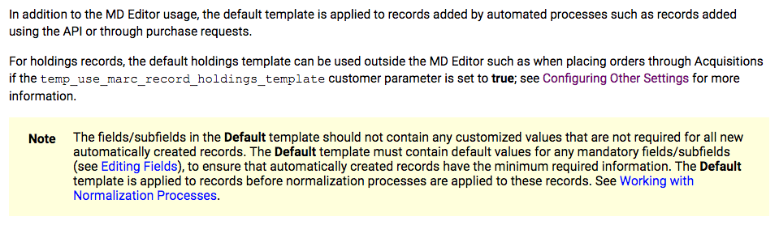

For example, let's say you want to specify the acquisition method (008/07) as p - purchase for all Marc holdings records created by PO lines. Then you can create a Marc holdings record template with the relevant data in the 008. Then save this holdings record as the default.

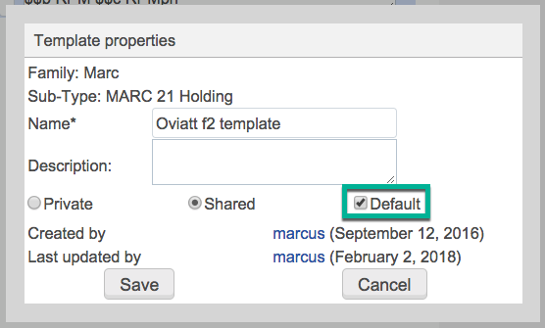

Each time a PO line is created in Alma its Marc holdings record will be generated based on this default template.

The following is a Marc holdings record template for a single-part monograph.

ldr #####nx##a22#####1n#4500

008 ######2p####8###4001ba###0000000

007 ta

### 853/863/866

[853 Captions and patterns](http://www.loc.gov/marc/holdings/hd853855.html) (the levels of enumeration and chronology)



[863 Enumeration and chronology](http://www.loc.gov/marc/holdings/hd863865.html) (based on the issues the library holds)



When you add a pair of 853/863 fields and save the holdings record, you have the option to automatically generate an [866](http://www.loc.gov/marc/holdings/hd866868.html) textual holdings field (the “free-text” holdings statement). To configure this setting see: <https://docs.google.com/document/d/1ZrcTmAHM6cslIMgVpz24IpHNLKmhg5tnEEv0LhMxxss/edit#heading=h.kwcnabkxgsmc>

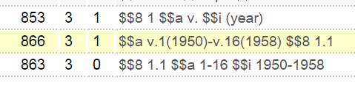

In Primo, this 866 field displays in the Get it tab

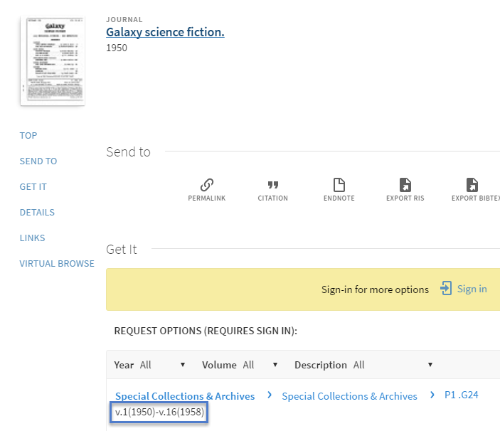

(For a more elaborate example, see oclc 1431238, Report of the state geologist)

## 

## Item record

The item record contains enumeration and chronology data at the item level

while the holdings record is an aggregated holdings of the item(s) attached to it.

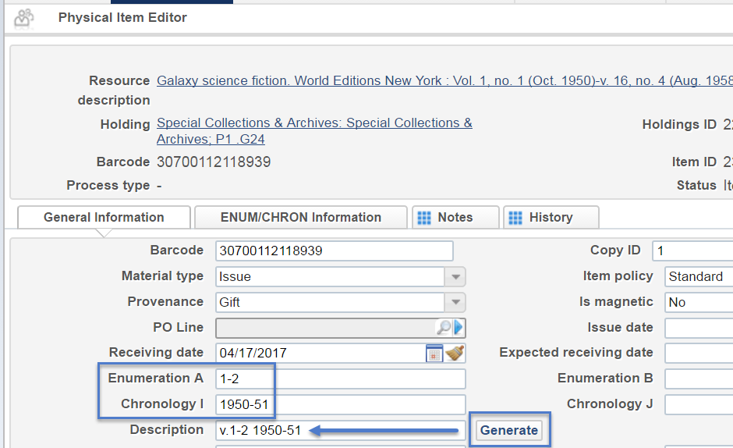

If you input the enumeration and chronology fields, they can be used to generate the description field that displays in Alma and Primo. The formatting of the description field (including abbreviations, punctuation and spacing) can be specified in Alma using description templates. <https://knowledge.exlibrisgroup.com/Alma/Product_Documentation/Alma_Online_Help_(English)/Resource_Management/080Configuring_Resource_Management/150Configuring_Description_Templates>

Primo view:

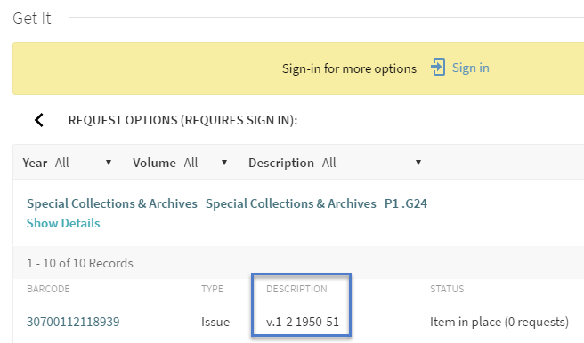

If your campus’ data migrated from Millennium or Sierra,

your migrated item records may only contain a description field and the enumeration and chronology fields are blank.

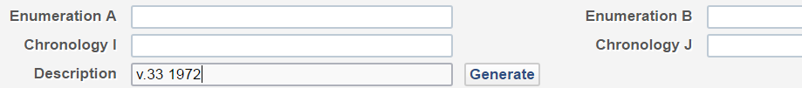

If so, and you would like the enumeration and chronology fields to be populated based on the description field, you may consider using the Alma enumerator tool. <https://bitbucket.org/wtee/alma_enumerator>

# Discussion

After go-live, I added some new item records to an existing holdings and bib record. In the item record, I input the enumeration and chronology fields which in turn generated a description field. Even without 853/863/866 fields in the holdings record, Alma displays a quasi-summary holdings statement in Primo.

Marc holdings record in Alma (Note: 853/863/866 field are not present. Oclc 7642092)

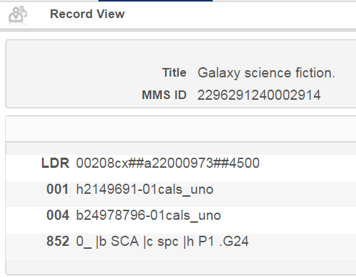

But I inputted data in the enumeration and chronology fields in the item record.

Item record #1 (barcode 30700112119085)

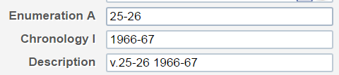

All item records under this holdings record (v.25-32 1966-72)

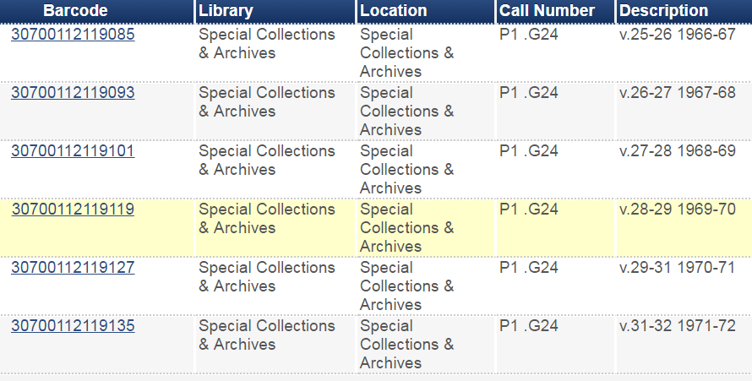

Therefore, a quasi-summary holdings statement displays in Primo.

(Note that the enumeration label (v.) does not appear in this quasi-summary statement.)

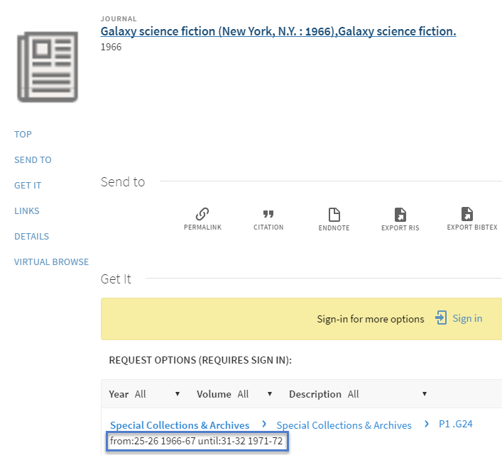

In the Enum/Chron information tab of each item record, there is a section to indicate pattern information.

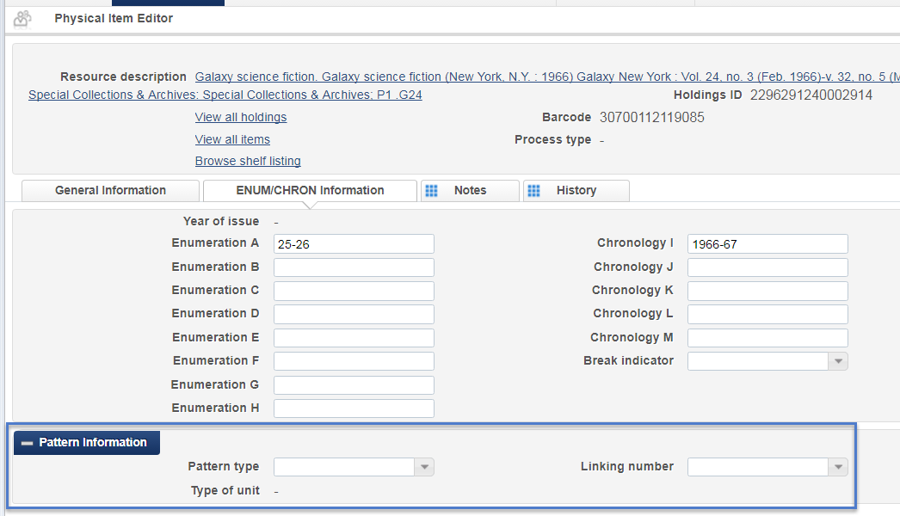

If I add an 853 field to the holdings record,

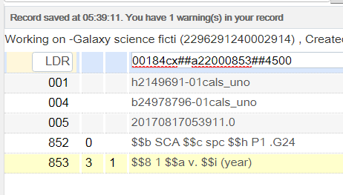

And in the item record choose the 853 pattern I just added to the holdings record,

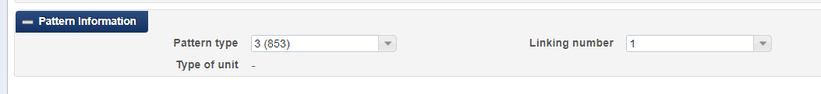

Unfortunately, you have to do this one-by-one in each item record. I didn’t see a job where you can make batch changes of the enum/chron pattern to a set of item records.

Then I open the holdings record in Metadata Editor and save it which automatically generates an 863 and 866 field.

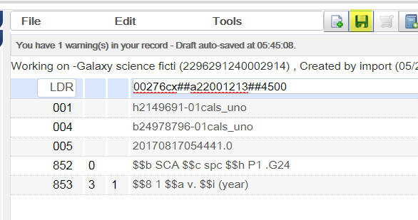

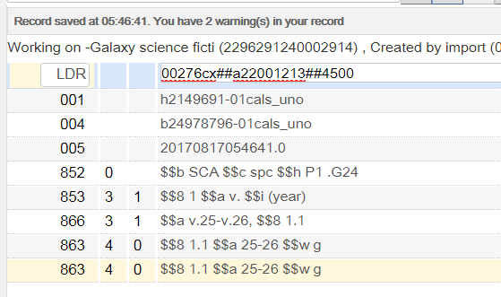

Unfortunately, Alma is only picking up the enum from the first item record and disregards the chron (year) info. This holdings record has 6 items.

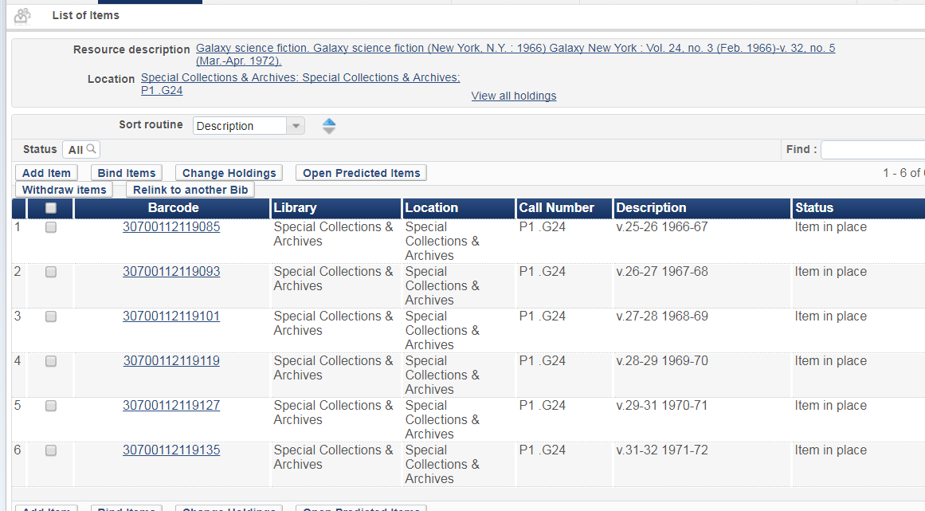

This process doesn’t work so well.