**Procedures: Publishing to OCLC**

|  |  |
| --- | --- |
| **Document status** | https://calstate.atlassian.net/wiki/plugins/servlet/status-macro/placeholder?title=DRAFT April 17, 2017 |
| **Area covered** | cataloging, systems |
| **Prepared by** | Cataloging Task Force |

**Background**

The Alma ‘Publishing to OCLC’ functionality is designed to keep both title-level holdings and Local Holdings Records (LHRs) in WorldCat in sync with the inventory in Alma for a given institution.

Libraries are able to automatically synchronize:

* Bibliographic records with embedded holdings information or holdings information only
* Electronic holdings

Publishing to OCLC is processed at the local institution level since this process is used to expose institutions' physical holdings. Each institution in a collaborative network determines how bibliographic and holdings records are published based on their requirements, regardless of any links to corresponding records in the Network Zone. Changes to the Network Zone, such as adding new bibliographic records, are independent of each institution’s record management and OCLC processing. Publishing to OCLC, whether or not in a collaborative network, is determined and processed as described in [When Records are Exported](https://knowledge.exlibrisgroup.com/Alma/Product_Documentation/Alma_Online_Help_%28English%29/Integrations_with_External_Systems/030Resource_Management/110Publishing_to_OCLC#When_Records_are_Exported).

Configuration Requirements:

1. WorldCat Data Sync Collection
2. Alma Configuration

**Procedures/Recommendations**

1. **Setting Up WorldCat Data Sync Collections (WorldShare Collection Manager)**

Obtain a Collection ID from OCLC

This collection is used to set holdings, delete holdings, or both – by either changing the Collection Type (from “Bibliographic” to “Delete WorldCat Holdings” – to delete holdings for all), or setting the “Use Record Status for Processing” radio button to “Yes” for a Bibliographic collection. The “Yes” setting will set or cancel holdings for a specific library based on the Record Status value in the incoming records. Libraries can create an additional collection, if needed, to process deletes and set holds separately.

[Data Sync Collections in Collection Manager](http://www.oclc.org/support/services/collection-manager/documentation/data-sync.en.html)

[Create a Worldcat Data Sync Collection](http://www.oclc.org/content/dam/support/worldshare/dsc/datasync_chklist.pdf)

Here's a brief outline on filling out the online form to obtain an OCLC collection ID for use with Alma.

First, libraries need to have a WorldShare Collection Manager account. Sign into WorldShare Collection manager.

Select the "Metadata" tab and select "Create a collection"

Collection type -- Data Sync Collection

Data Sync Type -- Bibliographic

Select "Create" button.

Properties:

Collection Name -- Insert a name for your collection (e.g., Alma)

Group -- No

WMS Library -- No

Collection type -- Bibliographic

Original Data Format -- MARC

Use Record Status For Processing -- YES

Bibliographic Record Information

Initial estimate for record count (e.g., 1,000)

System Tab

Provider -- Ex Libris

System name -- Alma

Version -- ??

OCLC Number Location -- 035 |a

Local System Number Location -- 001

Processing Tab

Limit added records to WorldCat staging -- Yes

Replace records in WorldCat -- No

Use Language of cataloging (040 |b) field from records --Yes

Excluded information for fixed fields -- Didn't do anything is this section

Local Bibliographic Data Information

N/A

MARC Record Output Information

Enable MARC Record Delivery -- No

Comments

N/A

Contact Information

Enter contacts (2 or 3 individuals) as contacts for this collection/service.

Click on Save Progress or Submit Collection. Once you click on either button a collection ID will be created and should display toward the top and or side of the screen.

1. **Configuring Alma**

The following instructions were modified by OCLC to assist Alma customers with the recent Batchload migration to WorldShare Collection Manager as related to Data Sync Collections.

Profiles Available for OCLC

1. Synchronize local holdings with OCLC: exports and sends the MARC Format for Holdings Data (LHR) record. For this type of project, you would have ordered a Local Holdings Record Collection in WorldShare Collection Manager.

2. Synchronize bibliographic records with OCLC*: exports and sends the full MARC bibliographic (BIB) record to maintain WorldCat holdings at the OCLC Institution symbol level. For this type of project, you would have ordered a Bibliographic Collection in WorldShare Collection Manager. (Most generally used profile)

*If the purpose of your project is to set (or delete) holdings in WorldCat for every matching record found you should choose: “Synchronize bibliographic records with OCLC”.

Define an FTP Connection:

S/FTP Connection Details

Server: scp.oclc.org

Port: 22

Sub-directory: depending on the collection type, choose one of the following:

o Bibliographic collection type: metacoll/in/bib (most generally used)

o Local Holdings Records collection type: metacoll/in/lhr

User name: your institution symbol – in lower case*

Password: Your password is supplied by OCLC

o To obtain your WorldShare Collection Manager password please contact OCLC Support

Min. number of files: 1

Max. Number of files: leave blank or choose the largest option

Max. file size: leave blank – or choose the largest option

FTP Server Type: Default or MVS

FTP passive mode - box should be checked in most cases

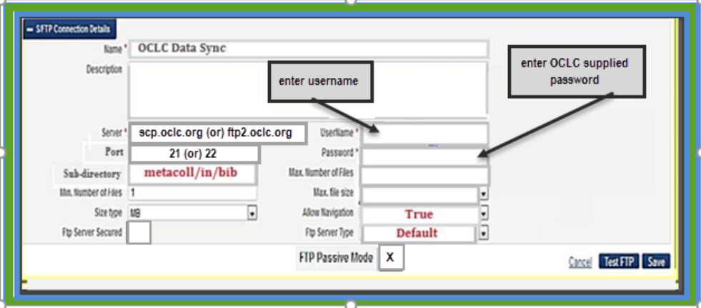

*Special characters (@, $ and #) in symbols will act as ‘command control codes’ which will halt processing. If you have a special character in your OCLC institution symbol, please convert it as follows:

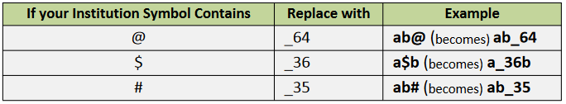

More information can be found in [Create a Data Sync Collection](http://www.oclc.org/support/help/datasync/Default.htm)

**Update the Publishing Profile**

**Profile Details**

* Profile Name: ‘Synchronize bibliographic records with OCLC’
* OCLC Institution symbol: use institution symbol
* Project ID: leave this box blank
* Collection ID: use your Data Sync Collection ID

**Submission Format**

* FTP configuration: scp.oclc.org
* Sub-directory: blank
* Status: defined by operator
* Scheduling: defined by operator

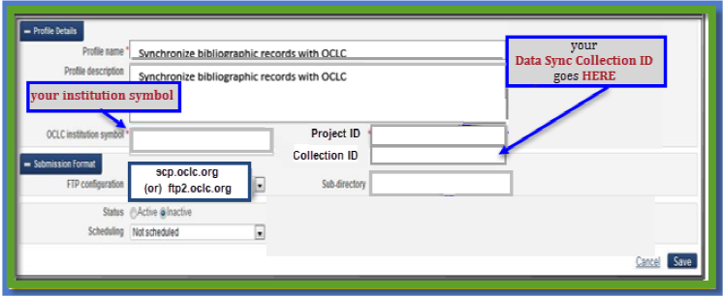

* Change Status to “Active”.

**Documentation (Ex Libris)**

[Publishing to OCLC](https://knowledge.exlibrisgroup.com/Alma/Product_Documentation/Alma_Online_Help_(English)/Integrations_with_External_Systems/030Resource_Management/110Publishing_to_OCLC)

**Documentation (OCLC)**

[Data Sync Collections in Collection Manager](http://www.oclc.org/support/services/collection-manager/documentation/data-sync.en.html)

[Create a Worldcat Data Sync Collection](http://www.oclc.org/content/dam/support/worldshare/dsc/datasync_chklist.pdf)

[About Data Sync Collections in Worldshare Collection Manager](http://www.oclc.org/support/help/datasync/Default.htm)