**How to link records to NZ that multi-matched with NZ CZ records?**

Steps:

1. Monitor Jobs – go to History tab - find the process “NetworkZoneLinkingTask” that was ran by migration.



Go to Actions – Report – download records with multi-match:

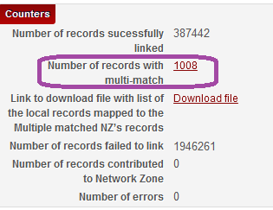

Get ‘Number of records with multi-match’ file - edit excel – leave only one column with header ‘MMS ID’.

1. Create Itemized set of bibliographic records

Go to Administration - Manage Sets – Add Set – Itemized ‘All Titles’ type of set.

Check that set is created and has proper number of records as listed in the report.

1. Run process ‘Export Bibliographic Records’ on a set

Go to Administration – Run a Job – select ‘Export Bibliographic Records’ process.

Select Binary or XML format. This process will create file of bibliographic records.

1. Go to Resource Management – Manage Exports – Actions – Download the exported file. Use this file in import profile.
2. Create Import profile with the following parameters in ‘Match Profile’ tab:

* Match method - “Unique OCLC Identifier Match method’
* Upon match – ‘Use NZ Record’
* Do not override/merge record with lower brief level – select the flag.
* Disregard matches for bibliographic CZ linked records – select the flag.
* Upon no match – ‘Do Not Import’. – Later analyze not matched records for further processing.

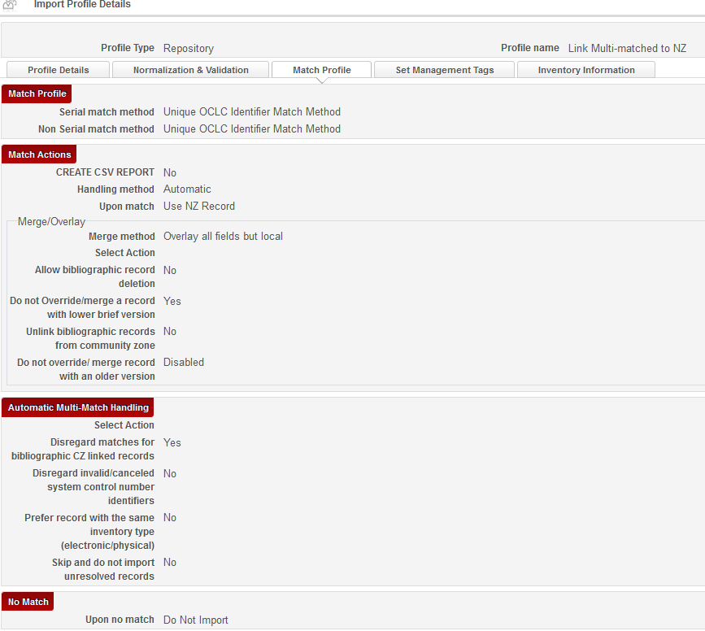

1. Run Import profile
2. Check the report

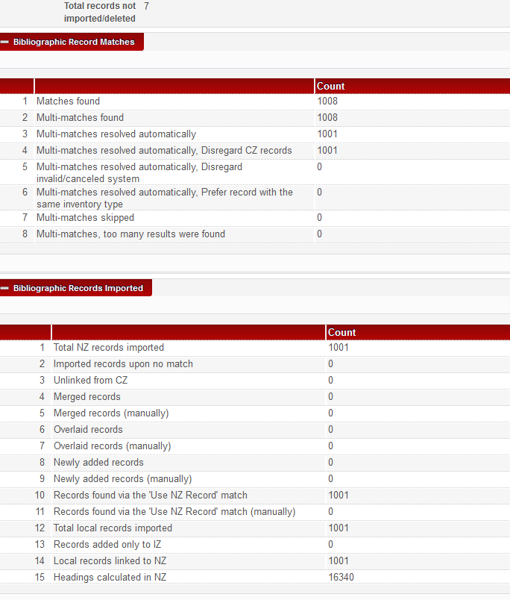

Check that records linked to NZ.