Hi Everyone,

The Unity flip card trial has concluded and flip cards are currently being distributed to campuses.  This process is a gradual roll out and no one knows exactly when or who will be getting their flip cards next.   Who will the lucky campus be to get the next batch of flip cards?  This just in…  We are getting reports that CSU Channel Islands has received their flip cards.  Can it be true?  Hold on, yes, we are getting confirmation that this is indeed true.  Channel Islands now has their flip cards. Yippee!  Corey @ Channel Islands is today’s lucky winner.  Way to go!

So yes, the Unity flip card trial has ended and cards are being sent out to our campuses.  However, the trial period revealed some issues with the new flip cards that we are going to have to deal with:

1.) There is a small issue with the size of the flip cards.  It was discovered that the flip cards are slightly too wide for some of the red CSU+ bags.  But strangely enough, the flip cards do fit perfectly inside some of the red CSU+ bags.  Check out the pictures to see for yourself:

Here we have one of the new flip cards, totally unmodified.  See the beautiful rounded corners?

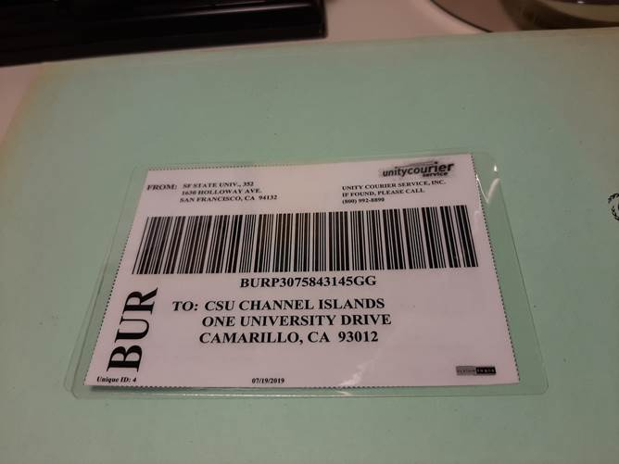

When I stuff this flip card into red bag A, the card is slightly too wide and I get a bendy kind of thing going on:

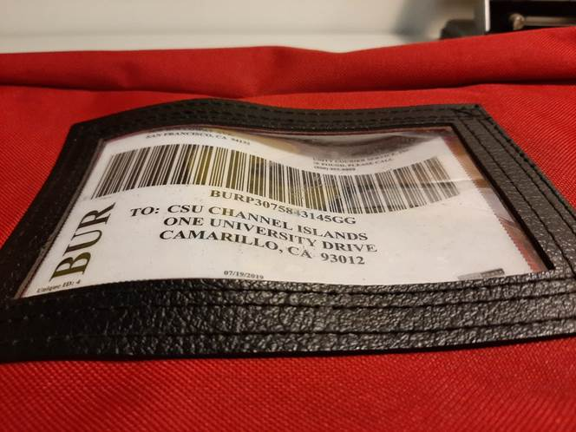

But then when I stuff the same unmodified flip card into red bag B it fits very nicely.  Look mom, no bends!

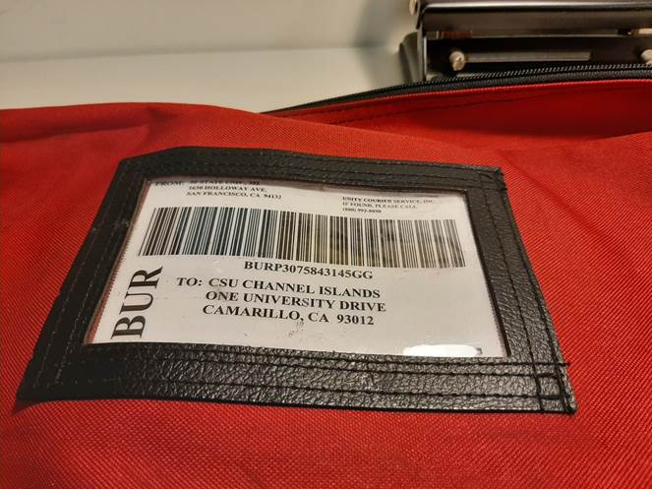

To prove that this is not a magic trick or an optical illusion, let’s take  a look inside the bag.  Check for the rounded edges of the unmodified flip card and how the card fits nicely in between the two inside lines of stitching?

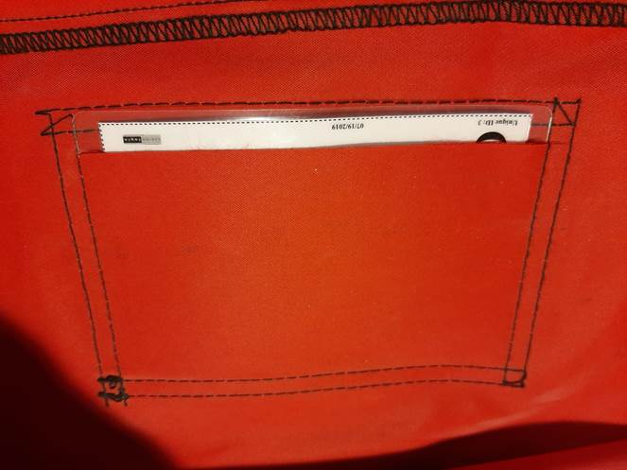

It appears that the manufacturing tolerances on our red bags is very loose, which means that the distance between the two lines of inside stitching is not exactly the same for every bag and the distance between those two lines of stitch will vary significantly enough that the flip cards will fit in some of the red bags without being bendy but will become bendy when you try to put them in other red bags.  So what are we to do about this?

We inquired with the CEO of Unity and his recommendation is to just let the cards get bendy in the bags that make them bend.  Simple as that.  Apparently Unity’s barcode scanners can still read the bendy cards and it will not cause any problems other than being aesthetically unpleasant.

But what about our people who have a bad reaction to the aesthetically unpleasant?  I have to admit that I am likely one of them.  Well, the Unity CEO recommended against trimming about 1/8 inch off of one side of your cards to make them fit better.  He didn’t give much of an explanation about why he recommended against doing such a thing and I can’t see how it would really be much of an issue.  However, trimming your cards will remove at least one set of nicely rounded corners.  So maybe the Unity CEO just finds pointy corners aesthetically unpleasant, at least more unpleasant than bendy cards.  Oh, the battles of aesthetic taste.

In any case, even though Unity CEO recommended against trimming your flip cards, we thought we should show you what it would look like if you did decide to trim your cards because you’re not someone who loses sleep over the battle between rounded vs squared corners.  Just take about an 1/8 inch off of one side and then your card should be good to go in any red bag without getting bendy.

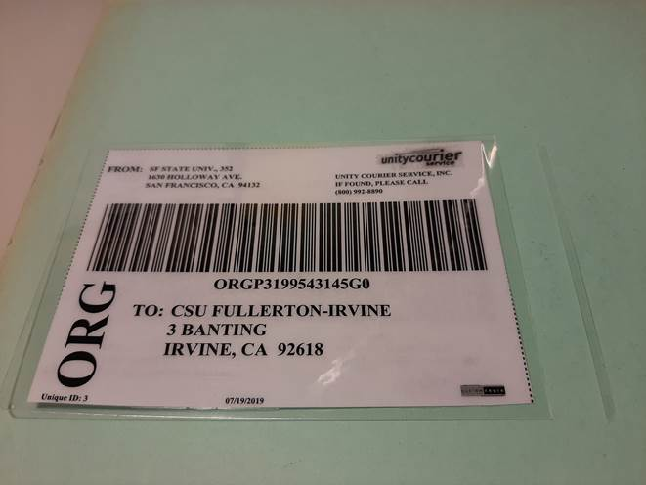

Now I’m sure some of you are thinking “I need visual symmetry!”  Ok then, trim a little off of both sides if you are going to be a trimmer and need symmetry.

But what about the people who want rounded corners but no bendiness for their cards?   Well, the aesthetic purists out there who don’t want to let the cards get bendy and who don’t want to modify their cards by trimming them can think about modifying their red bags.

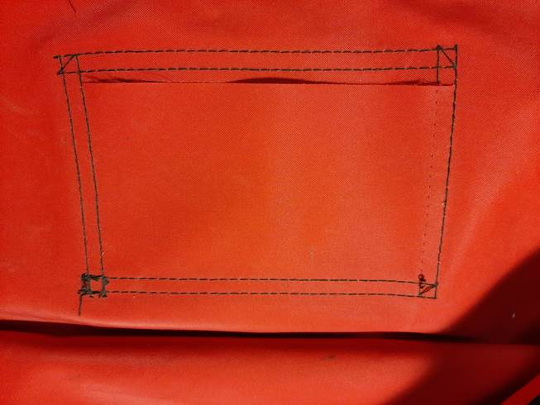

As you can see, the red bag’s window frame is normally held on by 8 lines of stitching.  If you take a razor blade or seam ripper to one of those inside lines of vertical stitching you will be making more room in the window for your cards.  You may be reducing the structural integrity of the window frame being attached  ever so slightly, but you still have 7 lines holding that thing on so you should be fine.  And if the window does ever come off, it can be reattached in a more colorful and artistic way.

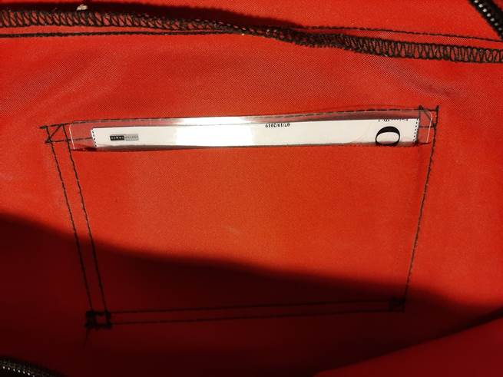

Ahh, yes.  Look how nicely that unmodified card fits when you give it a little more room.

But what if you don’t want to modify your cards or your bags and you don’t want to torture your eyes with bendy cards?  Well, if you have any of your old blue bags with your campus name on it with clean windows, these cards fit perfectly in those with no modifications necessary.  This flip card size issue only exists with the red CSU+ bags.

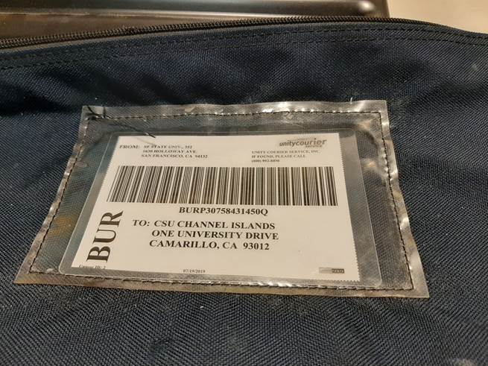

Have a look at the beauty of unmodified anything.  But this aesthetic masterpiece can also be a proof for those worried about modifying their bags by removing one line of stitching.  These old blue bags only have one layer of stitching to begin with.  That is 4 lines of stitch compared to the 7 lines of stich on the modified red bag.

So there you have it.  Many ways to deal with the flip card size issue that range from doing nothing to doing small somethings to make them fit better.

2.)  Now let’s get back to the card I cut.  The astute observer must be thinking “CSU Fullerton – Irvine” What the heck is that?  Well, that is CSU Fullerton’s satellite campus.  In fact, 4 of the Outstanding Campuses of the CSU have satellite campuses that are serviced by the Chancellor’s Office courier contract.  Currently all of these satellite campuses are only receiving book traffic from their main campus and that is why you likely have never heard of them.  However, Unity manufactured cards for these satellite campuses for all of us.  These satellite campuses are:

San Diego State University-Imperial Valley Campus located in Calixico

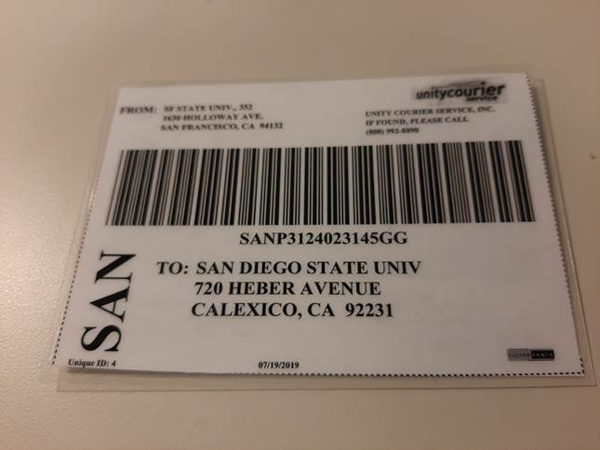

Stanislaus State-Stockton Campus located in Stockton.

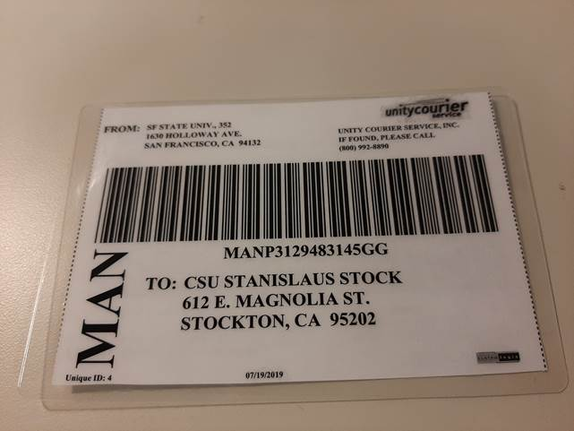

CSU San Bernardino-Palm Desert Campus located in Palm Desert

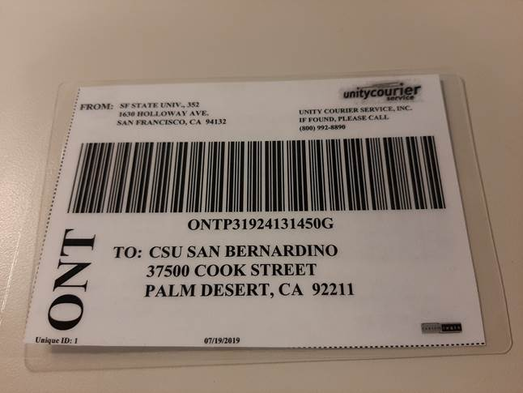

And of course, CSU Fullerton-Irvine Campus located in Irvine.

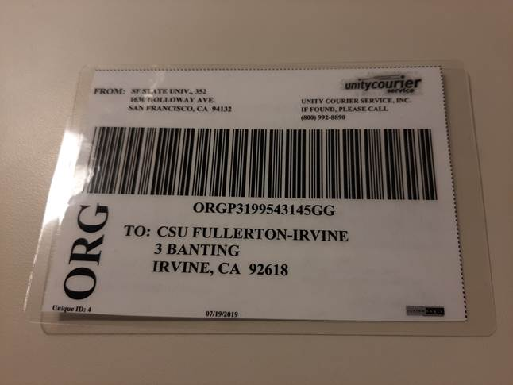

The first thing you should do when you get your stack of new flip cards is to grab the cards with the addresses you see above and stash them away somewhere.  You don’t want to have them get mixed up with the main campus cards and end up accidentally send something meant for the main campus to their satellite campus, because Unity will deliver the package wherever the card tells them.  But keep these cards somewhere safe just in case.  We don’t expect these satellite campuses to want direct delivery from all other campuses right now, but who knows.  Maybe one day one or all of them will and we will have the flip cards ready to be unleased.

While going through your cards to find the satellite campuses, you may notice that you also have flip cards for our UC courier partners.  Yes indeed.  If you want to quit printing stickers labels all together you can start using your flip cards for your UC buddies and never have to deal with those pesky stickers again.

3.) After going through your flip cards to remove the CSU satellite campuses you might be thinking to yourself, “Wow, I really love my new flip cards.  They are so fun to look at and play with.  But I only have 4 cards for each of my courier partners.  I want more!”  Yes, everyone will be getting 4 cards for each of their partners, but unfortunately at this time you cannot have any more.  This means that every campus match has 8 cards in the system.  This led to some of our early testers thinking that we would have to begin sending empty bags back to each other so our partners don’t run out of flip cards.  However, this led to an infinity loop where two campuses were sending an empty bag back and forth to each other for years on end.  Now obviously that didn’t really happen, but the potential for it to happen is there,  so let’s try to steer clear of the sending empty bags when we can.

But then you might be asking yourself,  “what happens if I run out of flip cards because one of my partner is a hoarder?”  Well, lucky for us Unity gives us two methods for shipping: the flip cards and the label printing website dst.unitycourier.com.  Now you could print a sticker from Unity’s site and use that to send books to your hoarding partner.  But the Unity CEO said it is totally fine if we print the label on paper and simply stick it inside the bag window.  So that is what I propose we do when using bags not already covered in stickers.  I did some experimentation and the best size for printing a paper label from dst.unitycourier.com is Avert 5664 and it looks something like this:

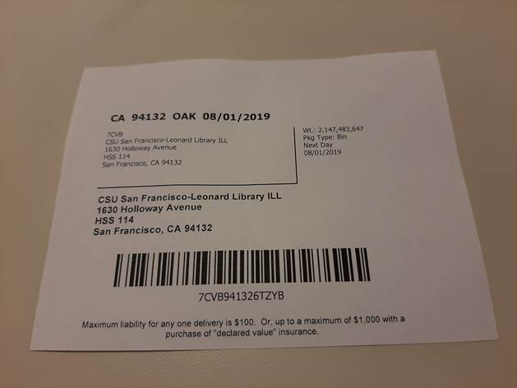

You will notice a few strange things with this example.  Yes, it is possible to print a label to send to yourself.  I’m not sure  what the utility would be, but maybe it is just for fun.  You will also notice that the max weight that you can possibly input into Unity’s label printing site is two billion one hundred forty-seven million four hundred eighty-three thousand six hundred forty-seven pounds.  I don’t know about you, but that sounds like an awful lot of books to me.  Paper labels like this can be printed on demand, or perhaps you may want to preprint one or two per campus to stash in your card box for when you run out of flip cards.

And maybe when you use one of these paper labels, you can write a note to your hoarding partner to ask them to send you some flip cards.  Maybe something a little like this would do the trick:

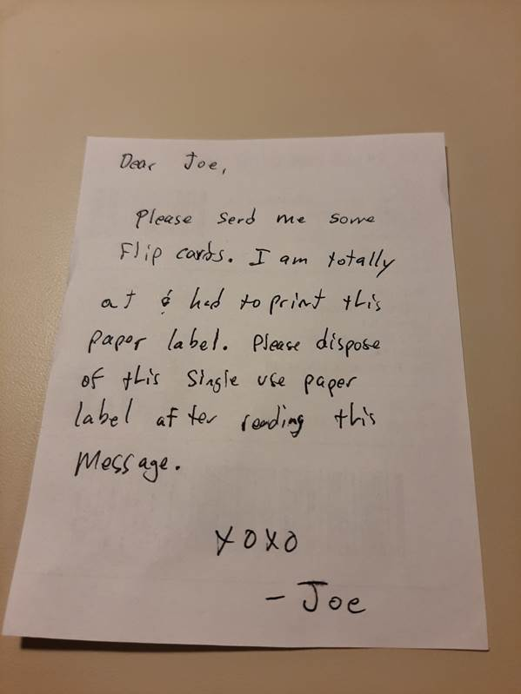

4.)  Now what about tracking?  Some of our testers reported back “I went to dst.unitycourier.com to try and track the package, but nothing came up.  What’s the deal with that?”  Well the deal is that the dst.unitycourier.com website is exclusively about printing and tracking the printed labels.  Not the flip cards.  Repeat.  dst.unitycourier.com is exclusively for your on demand printed labels and their tracking.  To track the flip cards you need to use the [www.unitycourier.com](http://www.unitycourier.com) website.  Go to “Package Tracking”, select “Full Package Barcode” and scan the barcode.  This will bring up the tracking information.  But outside of a testing situation, tracking a package in hand is not going to make any sense (unless you want to see how fast it came from the other CSU).  The point of tracking is to find the stuff that never showed up, meaning that you will likely not know the barcode number.

But there is a solution for this as well.  A few weeks ago Mallory sent you all an Excel sheet that listed your official Unity delivery times.  That document also contained your Unity delivery location number.  Don’t remember seeing that?  Go back and look.  It is in the far left column.  Drop that number into the “location number” field on Unity’s flip card tracking site and click search.  This will bring up all of the packages that you have shipped and received on that given day.  And there’s more.  You can go back to previous dates and find the barcode numbers of the packages you sent in the past.  Grab a suspect barcode and go back to the main package tracker and drop your barcode into “Full Package Barcode” and voila, you can find the tracking information for a potentially lost package.

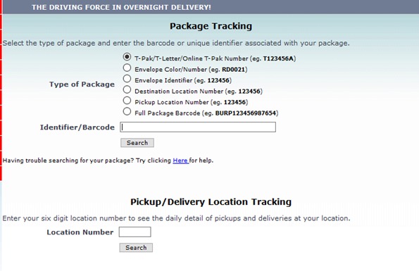

5.) Once you get your new flip cards please throw away (or save them as keepsakes that you vow never to use again) all of your old flip cards and Tricor printed labels.  I know this is wasteful, but that is why I am giving you the option to hold on to them as novelty souvenirs.  Just please don’t use them once you get your new flip cards.

There may have been some other small things uncovered during the flip card trial run but I can’t remember them at the moment.  It looks like I’m Unity blasted out.  So if any of our fastidious testers have information I missed please let me know. And of course, if you have any question that have gone unanswered in this Unity Mega Blast!!!!!!!!!, send in your questions and we will try to answer them.

Happy flip carding.

Over and out.