ULMS Survey Responses – Oct/Nov 2020

Executive Summary

Over the fall, we conducted a set of surveys to assess current satisfaction with Ex Libris as a vendor and Alma and Primo products currently in use systemwide. Surveys were distributed to CSU library staff and chairs of the ULMS working groups. The summarized results of these are contained in the document. We will share these results with both COLD and Ex Libris to better communicate the concerns and general satisfaction with Alma and Primo and to inform our contract renewal discussions in 2021.

Last year, I observed that CSU satisfaction with Alma and Primo was past its peak due to lower reported satisfaction with Ex Libris and its products compared to the first years in production. This year, CSU staff report higher satisfaction with Alma, Primo and Support, bringing their scores up to the levels reported by ULMS committee chairs. Collectively and individually, CSU library staff and faculty share a neutral-to-positive degree of satisfaction with the system.

While satisfaction with Ex Libris appears to have stabilized around an acceptable score, issues touched upon through this survey as well as less formal channels show expressed concern that Ex Libris is not responding to reported issues as well as they could, particularly with new releases and new products related to Alma and Primo. For example, the CDI rollout was universally problematic for the CSU, and while many see the promise of the product the continual fighting of fires caused by CDI changes is dimming enthusiasm about Ex Libris’ end goal. COUNTER 5 functionality was delivered as promised, but is missing support for important reports and, critically, for reporting both COUNTER 4 and 5 as will be necessary for the next year or two.

Ongoing issues with analytics outages and continued difficulty with escalating content issues with Ex Libris support continue to give Ex Libris a black eye with many of our staff. As a product, Primo continues to receive negative comments around quality of search, performance and UI/design. We need to continue to share with Ex Libris the impact these issues have on our workflows and ability to serve our patrons.

Chairs Survey Satisfaction Scores (n=7)
 | Alma | Primo | Support
2019-2020 | 7.3 | 6.7 | 6.4
2020-2021 | 7.0 | 6.9 | 6.4
𝚫 | -0.3 | 0.2 | 0.0

The ULMS working group chairs give Alma and Primo decent marks overall, with Primo pulling alongside Alma in terms of satisfaction compared to last year. There is little change between scores overall compared to last year. Ex Libris support also receives a fair score from the chairs. That there was no change in score between this year and last may indicate that the improvements Support has made towards reducing our backlog of cases and providing training to address weaker areas of understanding is counterbalanced by longer case resolution times and continued dissatisfaction with Content support responses. Development fixes continue to take longer to resolve than we experienced at the beginning of production, which may indicate greater product complexity, a greater strain on resources within Support, or even both. All committees report serious issues that need to be addressed by Ex Libris to improve satisfaction.

Staff Survey Satisfaction Scores (n=129)
 | Alma | Primo | Support
2019-2020 | 6.1 | 5.6 | 5.6
2020-2021 | 7 | 6.5 | 6.4
𝚫 | 0.9 | 0.9 | 0.8

CSU staff rate Alma, Primo, and Ex Libris higher than last year. Reported issues spanned the breadth of Alma and Primo and seem more indicative of general frustration with the system. Staff who work directly with the ULMS continue to express high levels of frustration with Alma and Primo. The CSU libraries are dedicated to supporting the needs of the library and the communities they serve and require a system that supports them in this. ULMS governance and Chancellor’s Office staff need to continue to share the needs of our staff with Ex Libris and work together to find solutions to any issues hindering staff from these goals.

It is important to note that although Primo received a higher satisfaction score this year, comments show much dissatisfaction with Primo’s search capabilities. As we evaluate Primo VE in the Spring, we will take care to compare VE’s search functionality against Primo’s to see whether VE addresses these concerns or exacerbate the impression we currently have about Primo as a discovery solution.

General comments show a mix of support for the ULMS and a “longing for the past”. It continues to be important to thoughtfully balance local needs against systemwide needs. ULMS governance needs to remain open and inclusive when making decisions to ensure staff participation in governance remains high and productive. It continues to be important to understand and communicate our pain points to Ex Libris during the year. Ex Libris is listening and is well-intentioned but need to demonstrate that they will address CSU concerns to make our partnership successful.

Ex Libris remains the best choice of library management system for our needs at this point, but we continue to scan the marketplace as we work with Ex Libris to address our issues and improve their responsiveness to our needs. As rising costs and decreasing budgets are a concern, we will continue to work with COLD and Ex Libris on a contract that works for us all.

Chairs’ Survey

The chairs’ survey was shared with the seven working group chairs, all of whom were asked to poll their committee and community of practice to provide a summary of how well Ex Libris and their products are working for them. As we anticipated little crossover between groups, we provide scores by group as well as an average score to show how much better or worse the products may be working for a functional area.

Q1: On a scale of 1-10, how satisfied are your committee and community of practice with how Alma currently performs in your functional area?

Average: 7.0

Acquisitions: 8
Analytics: 7
Discovery: 7
ERM: 7
Fulfillment: 7
Resource Management: 7
Resource Sharing: 6

Q2: On a scale of 1-10, how satisfied how satisfied are your committee and community of practice with how Primo currently performs in your functional area?

Average: 6.9

Acquisitions: 8
Analytics: 7
Discovery: 7
ERM: 6
Fulfillment: 7
Resource Management: 7
Resource Sharing: 6

Q3: Please list the top five issues you and your functional area are currently facing below.
On a scale of 1-5, how impactful is the issue to your community of practice?

Acquisitions | - Order date received refers back to the beginning of the new FY date, rather than payment date - 5  - Look up purchase order status (sent). Give brief display of current status – 5  - Search ALMA for invoices that are In Review or waiting for Approval. Need special search terminology to locate invoice. - 5  - The status of an invoice during processing reporting in analytics (review, approved, etc.) - 4  - Colored pop-ups minimized during ordering - 2
Analytics | - Cost Per Use data is too complex and doesn't include necessary information. – 4  - Network zone analytics for electronic resources is slow and unreliable. – 4  - Inconsistent labeling between Alma data labels and Analytics field names. - 4  - Overlap analysis doesn't include print and electronic - 3  - Fulfillment Area Statistical Category is Blank- 4
Discovery | - "Bad" metadata pertaining to the CDI switch is clearly the top problem based on our survey of the community of practice. We didn't get a lot of detail as to the exact problems with the metadata but I think at this point we're familiar with the number of Salesforce cases and types of problems that people are identifying - inaccurate holdings/full text information in both brief and full records (but not necessarily in both at the same time), merged records that contain inaccuracies, perceived persistence of duplicate records (it is unclear based on the survey if this is due to Alma and CDI records or if people are complaining about CDI records that should be merged), and books displaying in article results (scopes and advanced search). - 5  - Results ranking/relevancy ranking. Concerns here often included specific examples such as many failed known item searches, where the item is not on the 1st page of results. Another concern was the occasion that book reviews show up higher in results than the actual book. (Personally, I think this has improved greatly but a couple respondents claim this is still a problem, so I am passing it on.) - 3  - After the top two issues there was a considerable narrow tail of complaints that didn't really rise to a clear third issue. If I were going to group them under one heading it would be 'authentication'. Several campuses said they were having glitches in this area of unclear origin. Some also complained about the nature of how sign in is required to see specific services and options for holdings, a couple expressed the idea that the buttons to prompt authentication are still not prominent enough. - 2  - Likely pertaining to something in our consortial PNX norm rules, for at least 2 campuses, the facets for audio and video do not return accurate results that show all the various subtypes (e.g. LPs, CDs, streaming and VHS, DVD, streaming). - 3  - Three campuses reported problems with "date range" filters/facets. No specific examples were provided so it is not clear whether the problem here lies in the CDI metadata (which dominated the community's comments) or if there is something buggy with Primo itself. - 2
ERM | - CDI - both the configuration and management in Alma, and the way CDI records display in Primo - 5  - CZ package updates are slow and inconsistent - it generates more work and causes havoc on availability in OneSearch - it says we do/don't have access when we do/don't Additionally too many CZ records are so brief as to not be useful at all - some ebook packages have merely a title with no subject headings! - 4  - Record duplication issues - CDI/IZ/NZ/CZ - 3  - Alma Sushi management and COUNTER 5 implementation - difficult to manage, slow to be available some sushi vendors not available at all - 3  - Open Access collection link maintenance, article linking issues in Primo in general - 3
Fulfillment | - Alma is often slow to perform a task. This has been noticed entering/exiting a user record, checking out, checking in (both in the user record and in Return Items), and scanning in an item. Alma also refreshes the page at odd times, particularly since the last update and with the new UI. - 5  - The need to create a separate library for each pick up location is a burden, particularly when the second library serves the same book locations and as the main library. There needs to be the ability to create multiple pick up locations within a library. - 5  - Searching in Alma does not always bring up expected results. Keyword searches, particularly in the title field, don’t always bring up the items with those words in the title to the top of the list. This can make it difficult finding an exact bib or item record without having the MMS ID or barcode. In addition, each physical search type (bib vs. item) offers different functionality (i.e. you cannot mark an item missing from an item search). - 4  - An item with a temporary location does not return to that location after being loan via resource sharing. The temporary location is cleared, and the item moves to its permanent location. There is no indication that the item was in a temporary location before being shared unless the library has labeled the physical book. - 4  - Alma navigation, categories, and function names are not always intuitive, which can cause delays trying to figure out where to go. Even non-beginner users can have issues. - 3
Resource Management | - Implementation of Alma and MDE new interface/features/functions simultaneously or in an overlapping manner. For some folk, issues with a function were confusing, particularly when ExL Support said that the problem was with another function in Alma (i.e., a problem that is believed to be MDE issue, but ExL say it's The New Alma Interface, or vice versa, and there's lack of clarity about what goes with which. To some degree, it raises questions about the implementation of new functions, features and Interfaces. It's not clear to me that key personnel at ExL are thoughtfully crafting the implementation of new functions/features/interfaces, in order to ensure successful ongoing work, and ensure that most library personnel understand the relationships of various changes. - 5  - Implementing/releasing MDEditor incrementally, leaving major sections unavailable in the New MDE (Norm Rules is one example). It feels as though ExL have considered release of New MDE something that can be successfully released in parts, as though staff can use the New MDE in partial form successfully. I suspect that in large shops like UMinnesota, or University of Washington, or development partners like Boston College and Boston University, the roles are granular enough to do this successfully. In many CSU Libraries, the people using the MDE need most all of the functionality, requiring a New MDE that permits full functionality immediately. - 4  - Loss of functionality -- abrupt loss -- of Import Profiles that use Update Inventory and POLine as a match point. ExL implemented changes to API software that broke existing functionality that had been in use across 2 years and was under study for added details to work with Gobi Library Solutions. Additionally, removing the capacity to continue use of the API in a way that conforms to the Library's responsibilities to its Consortium and record supplier (both Gobi Library Solutions and OCLC, Inc.)  This, as with the first issue, indicates that ExL expect all libraries to be Development Partners, but leaving the Libraries to develop repair of functionality on their own, not necessarily with ExL's help.- 4  - Loss of 'return to Set' option in new MDE, currently. When one opens a record to edit in the MDE, one was able to return to the Set. That capacity has been lost, so far, in the habit of ExL to implement and expect the libraries to articulate what was lost. - 3
Resource Sharing | - The pandemic brought to light Alma's deficiencies in allowing multiple delivery methods. One issue is that in order to use Alma's personal delivery feature for home delivery, a user's Alma account needs to have the address type of 'home' populated. As a result, several campuses ran into issues trying to configure. When using Alma’s personal delivery feature for home delivery, you cannot limit to only home delivery but instead must allow two pickup options. The ability to allow users to enter an alternate address is also tricky. Not all labels can be relabeled. Additionally, there is no easy way to produce shipping labels. - 5  - Another issue affecting our ability to configure multiple delivery methods is Alma’s inability to offer multiple pickup locations without having to configure multiple libraries. Ideally, we would be able to provide multiple hold pickup options within a single Alma library. This would allow us to more easily and seamlessly configure curbside pickup, locker pickup and other delivery options. https://ideas.exlibrisgroup.com/forums/308173-alma/suggestions/41518042-provide-multiple-hold-pickup-options-within-a-sing - 5  - Currently the "ignorelenderduedate" setting in the Alma Customer Parameters Mapping Table is a global setting; it applies to all resource sharing partners. This is problematic for consortia who have resource sharing partners for consortia members, as well as a resource sharing partner for ILLiad. Setting "ignorelenderduedate" to "true" works for our consortia resource sharing standard checkout, but ILLiad due dates must be entered manually. Setting "ignorelenderduedate" to "false" works for the ILLiad lender due date, but then consortia due dates must be entered manually. If "ignorelenderduedate" could be configured separately, for different types of resource sharing partners, this would allow a more seamless ILLiad to Alma integration. As a result of Alma’s inability to configure different due dates for different types of resource sharing partners, only a small number of CSU libraries have integrated ILLiad and Alma with NCIP. https://ideas.exlibrisgroup.com/forums/308173-alma/suggestions/18510367-allow-ignore-lender-due-date-setting-to-be-custo - 5  - There are still issues with Alma’s “Convert to Resource Sharing” function. If a hold request cannot be filled because the item requested is missing from shelf, you have to cancel your patron physical item request, mark the item missing, then manually create a resource sharing request for your user -- all while keeping the patron and book title in your memory or writing it down/copy-pasting both into a separate doc. - 4  - If an item is in a temp location (such as with books on display or new releases) and is requested for resource sharing, it will revert to its permanent location when item is returned to lending library. Staff must remember to revert the items back to their temp locations. Ideally, if an item is in a temp location when it is shipped for resource sharing, it would revert to the temp location when checked in by the lending library. - 3

Q4: On a scale of 1-10, how responsive is ExL Support in addressing issues in your functional area?

Average: 6.4

Acquisitions: 7
Analytics: 6
Discovery: 6
ERM: 7
Fulfillment: 6
Resource Management: 7
Resource Sharing: 6

Q5: Any comments on why ExL Support received that score?

Acquisitions | Timing and lack of specific knowledge
Analytics | Some people are very satisfied with Ex Libris's responsiveness, but others complained about issues with no response. There were some comments about the recent all-day Analytics outage and the fact that the communication was not very clear.
Discovery | Responses to this question varied. No one was thrilled with ExL Support, though one respondent gave them an 8 most responses rated them considerably lower around 4-6 hence the average of 6. A consistent theme here was the unpredictability of both response time and resolution. Sometimes cases are resolved in a satisfactory manner and quickly but other times they either take a long time to be resolved (several respondents noted this is the case for inaccurate CDI records in particular) or the resolution is not satisfactory. Some people said they felt like what they think should be simple fixes for obvious bugs either are not fixed or languish "in development" for too long.
ERM | - I have filed numerous tickets in the past 2 months and I rarely hear back from Ex Libris on the status of my tickets.  - The documentation for CDI is not always accurate. There is not a lot of communication of changes or updates. Support tickets take longer and longer for a response.  - They answer all issues. They could be a bit quicker in their response times.  - Often, I get better answers from fellow CSU folks. It seems as if SF reps are only knowledgeable in pieces of ALMA/Primo which limits their ability to help. They also seem to assume I know more than I do.  - I believe Ex Libris does a fairly good job responding to my cases. Some issues take a long time to resolve.  - Documentation is consistently wrong, and our consortia seems to be more knowledgeable and capable of troubleshooting thank EL Support slowness in responding to deletions, Sales force cases  - Ex Libris support does make a real effort, but sometimes they seem overwhelmed by the volume of requests. At times they also have a tendency to fix the examples provided in a case instead of finding and fixing the root cause.
Fulfillment | After submitting a ticket, Support is often quick to respond, usually with questions or requests for clarification. The response then slows. Issues reported include not taking the time to understand the issue and a lack of communication from Support throughout the process, specifically when asked.
Resource Management | Support Staff have become more engaging, patient and helpful in many cases.
Resource Sharing | ExL responds fairly quickly to submitted cases. However, resolutions often take quite a while. Usually the first person who responds to the case is not somebody who actually has the power to resolve so they case usually gets forwarded to someone else. More often than not, the resolution is considered an "enhancement".

Q6: What needs does your functional area have that require Alma and/or Primo development to address?

Acquisitions | PeopleSoft - ALMA integration VAT/Use Tax Automation
Analytics | Cost per use functionality, more consistent labeling between Alma and Analytics, and further development of the overlap analysis tool.
Discovery | Some respondents expressed desire for a better way to highlight CSU+ availability and holdings in the brief results and full record GetIt menu area. Three respondents made comments about "bias" in Primo results and the inability to clearly understand why the results which do appear show for whatever reasons they do. Other suggestions which would require development are: 1) merging/deduplication of CDI and Alma records for the same title holdings, and 2) the ability to customize scopes more, specifically to pre-set filters for scopes which would not affect other scopes.
ERM | - Consistent/accurate results in Primo  - Better documentation for GES and DLR  - I think CDI needs some big improvements.  - I wish the criteria available for advanced search and analytics matched more CDI records incorrectly marked as "full-text available". CDI in general better and faster response to CZ update deletions  - Returning to my highest priority issue, the constant churn in e-collections seems excessive. I don't remember anything like this much maintenance when I was managing both SFX and Serials Solutions at the same time. While I appreciate updates, Ex Libris needs to make them much more seamless and do much more testing. It's not unusual to see the same portfolios listed again and again in CZUTL as Ex Libris makes changes to linking parameters, breaks the links, customers open cases, and then Ex Libris reverts the changes (Safari is a recent example).
Fulfillment | Alma  - The ability to add a second hold shelf / pick-up location within a library with the ability for users to choose the location when requesting in Primo.  - Enhance the personal delivery workflow to allow users to enter in their address, rather than rely on the address in their user record and provide the ability to use the School or Alternative address for personal delivery.  - The task widget is not sufficient for time sensitive Leganto alerts. Email alerts would be preferred.  - Enhance the process for creating an item record at checkout. Multiple steps & page refreshes slow the services to the patron. Allow libraries to determine whether the item is added to a work order.  Primo  - Enhance the Primo hold request form to allow for more library created fields.  - For article-level records, where the library has some print holdings, use the print holdings to determine availability of the article when determining how to display the ILL GES link. The link will often not display for articles when the library has physical holdings for that title but does not own the specific year.  - Signing in to Primo after performing a multi-line advanced search causes the search terms to appear on the same line, which will change the search results.
Resource Management | Coherent release of multiple functions, coherent release of new products, and repair of functionality that existed for multiple years in API Integration and Import Profiles
Resource Sharing | The resource sharing community would really like to see improvements in how Alma and Primo can be configured to allow for multiple delivery options. We would like to see Alma's personal/delivery feature improved. The requirement of a home address type in user account should be removed as it only serves as a roadblock. Additionally, we would really like to be able to configure multiple pickup locations in a single library. This would help tremendously with the CSU libraries who are or who have acquired lockers as well as those offering mail to home and curbside pickup delivery options.

Q7: Anything else that you want to tell me?

Acquisitions | Need to simplify Use Tax in ALMA. The receiving module Keep in Dept - check box, to stay in dept (missing), Entrusted User check mark missing. Sometimes disappears. May be due to search engine (Firefox). During manual invoicing, sometimes dropdown box for vendor subaccounts is blank.
Analytics | There were some comments about the complexity of Analytics and not having enough time/training to figure it all out, though that seems less an issue for Ex Libris and more just a consequence of people being overloaded with work.
Discovery | In case it wasn't already clear, the DFC ran a modified version of your Chairs' Survey 2020 and crowdsourced our responses that way. Most respondents were pleased that we sent the survey out and that someone 'cares' about how Primo is performing and working for the system. A few respondents urged for more centralization and support for the Central Package - there is a feeling at some institutions that they do not have the staffing level or training(?) to support Primo in the manner that they would like to. So at least some people want the CO or DFC to take the reins of their local situation more than is currently happening.
ERM | CDI implementation for consortia is a rolling disaster
Fulfillment | Overall the consensus is that Alma is functioning well, though most did not provide examples of what is working well. One staff did mention that the automatic loan and due date email reminders have significantly cut down on their workload. Some improvements could be made in the number of clicks certain workflows require, the amount of times an item needs to be scanned (removing statuses, transiting between libraries, etc.) and the language Alma uses throughout the system. A few responses included issues specific to their library, which were not included in questions above. One staff reported that they still have the burden of cleaning duplicate replacement fines due to the way fines were migrated from Sierra. Another staff detailed an issue where multiple requests for their laptops & hotspots froze those records. In this situation, ExLibris support was unable to fix the issue, causing the library to create duplicate records for those items. A third staff expressed frustration with the Analytics information delay, which causes issues providing up-to-date financial reports. A fourth staff reported that the way their campus in particular manages the Alma configurations makes it difficult for them to enact change in the system, particularly with the changes needed due to COVID and their campus closure. In addition, several staff who have used Alma since migration reported still having trouble finding certain functions due to the navigation and naming conventions ExLibris uses. One staff in particular often uses documentation found in the ExLibris Help and on the ULMS wiki when they are stuck.
Resource Management | Thank you for your patient and diligent work to keep the Company accountable and help them be a 21st-century corporation serving Libraries like the CSU.
Resource Sharing | We did receive comments that Alma can be slow at times.

Staff Survey (129 responses)

Q1 - On a scale of 1-10, how satisfied are you with how Alma currently supports your job tasks?

Average of 7.0

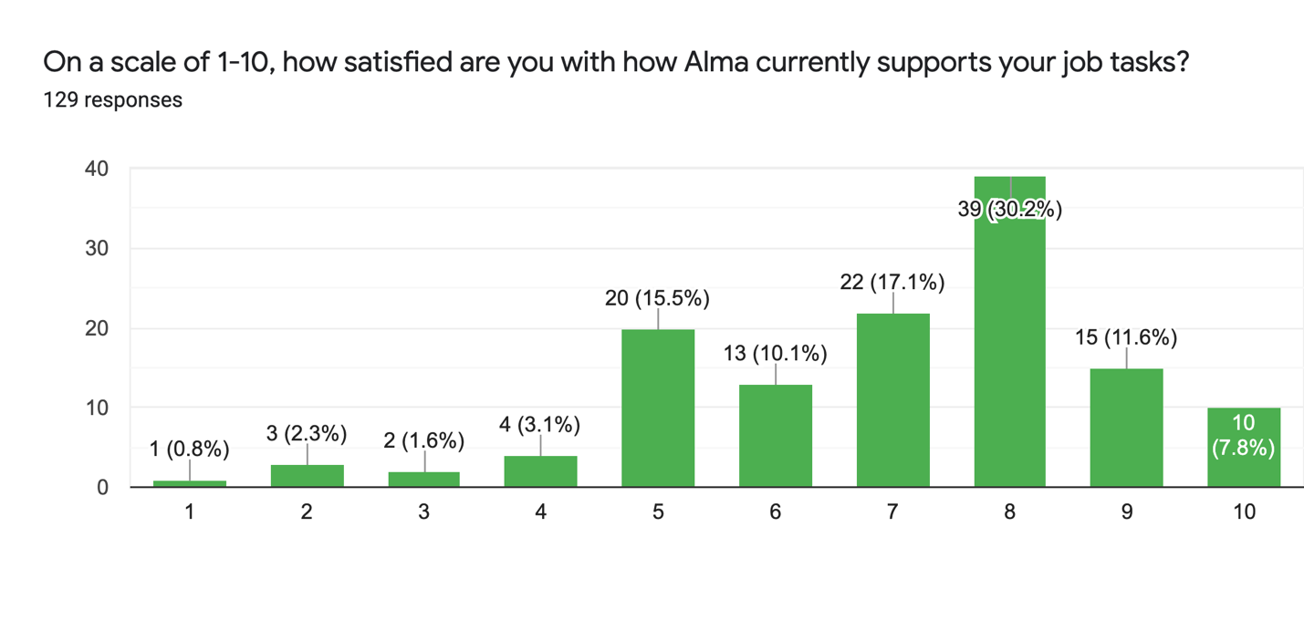

Q2 - On a scale of 1-10, how satisfied are you with how Primo currently supports your job tasks?

Average of 6.5

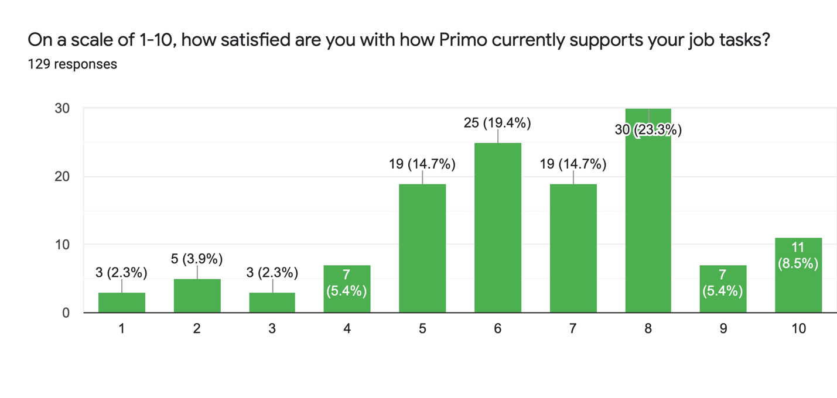

Q3 - On a scale of 1-10, how satisfied are you with the support that Ex Libris provides?

Average of 6.4

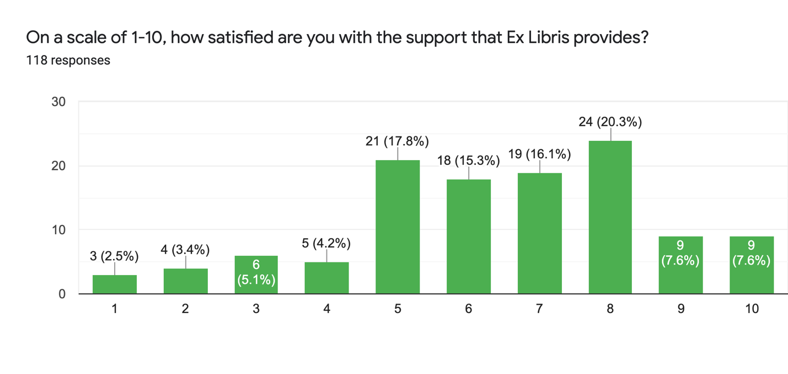

Q4 - What Alma issues currently affect how well you perform daily tasks, if any? (80 responses)

By design, responses to this question ranged widely across the product. A summary grouped by system/functional area follows.

Acquisitions: Purchase order lines in Alma are inflexible and do not support acquisitions workflows as well as is needed. Examples ranged from being unable to determine what was purchased from a POL to an inability to be able to add notes to a POL after it is closed to being unable to change a POL type. These issues cause slowdowns in processing workflows. Selectors are unable to follow up fund usage on their own and in general information about purchases that should be accessible tends to be hidden from easy view across roles.
Other issues noted were issues with encumbrances, unequal integration of receiving functionality across Alma areas and issues with changes to POLs being “reverted” both during data entry and after saving.

Analytics: Most responses focused on issues with compiling comprehensive reports (cost per use, collection use), noted the recent frequent periods of downtime as well as publishing/availability delays, and continued difficulties with SUSHI harvesting. Some still find analytics too complex to work with.

ERM: All responses in this area were directed towards the difficult and problematic ride we have experienced to date with CDI. Staff comments were general in nature (“CDI has been a mess”, “CDI is atrocious”) and indicative of an experience that has been generally negative. Called out were difficulties in troubleshooting issues, poor documentation surrounding CDI features and issues resulting from a decreased ability to edit records to put interim solutions into place.

Continued issues with broken/incorrect linking was also mentioned by a few. These types of issues are likely rolled into the larger CDI concerns as well.

Fulfillment: Course Reserves support in Alma is still considered a weak spot in Alma, as is calendar management. Support for COVID needs such as support of home delivery, multiple hold shelves to support different delivery mechanisms and processing large numbers of items in bulk were also called out as lacking in Alma.

General/UI: Like last year, there are many issues around the number of clicks required to perform tasks in Alma. Many also felt that navigation through Alma has remained unintuitive even after Ex Libris work in this area.

Another frequently reoccurring issue for our staff is the lack of customization offered by Alma to streamline views to support individual workflows. Reducing the amount and types of information displayed in search results, removing panels of data not of interest to the staff user and suppressing pop-up messages that do not benefit the specific user were examples given of areas where customization would decrease complexity and confusion when working with Alma.

Other items of note include inconsistencies in field labeling between functional areas of the system, lack of visual cues to help identify what part of a given workflow the user was in and the need to keep multiple Alma windows open to perform work.

Performance: There continues to be a lot of concern regarding Alma’s performance. Many comments contained mention of instability, delays in response and updating the screen, longer load times in the new UI, and the like. Performance issues aren’t new to Alma or past ILS experience, but this year the reports of slowness involve more specific functions such as checking out materials, updating POLs or scheduling jobs. It may be possible to focus Ex Libris on these areas and look for root causes.

Publishing: Delays in publishing data to Primo from Alma continue to persist, sometimes amounting to 2-3 days before seeing changes made in Alma reflected in Primo.

Releases: A few reported difficulties in keeping up with changes in functionality brought into Alma through monthly releases and with functions “breaking” when new changes are introduced through a release update. Regressions in functionality seem to be more difficult to engage Ex Libris on over the past year.

Resource Management: Issues working with and editing sets of records in the new MDE were reported, as well as issues converting and sorting month names in Chronology data were mentioned.

Resource Sharing: One mentioned the inability to request specific volumes of items over CSU+.

Searching: The inability to search Alma using all MARC fields or by call or card number were mentioned.

Training: A couple of responses mentioned that documentation lags behind monthly releases, or perhaps specific changes to functionality aren’t easily found in the documentation.

Updates: CZ updates can cause linking issues or loss of quality data as they are not properly vetted prior to release.

Q5 - What Primo issues currently affect how well you perform daily tasks, if any? (75 responses)

By design, responses to this question ranged widely across the product. A summary grouped by system/functional area follows.

CDI: CDI issues are broad and deeply impactful. The frequency of changes, decrease of control over portfolios and many linking and data issues have created a very poor first impression and current experience with the product. Troubleshooting issues in particular is mentioned as being especially difficult.

Display: Deduping continues to be an issue for items with multiple formats and for the apparent arbitrary nature that Primo uses to dedupe items. One response called for better display of availability for collections in search results.

Filtering: Primo’s filters and facets could be simplified for most patrons. One response characterized facets as less than reliable when used to narrow down searches.

Linking: The difficulties that CDI has introduced to managing full text links has increased the incidence of linking issues plaguing users and staff alike.

Newspaper: Newspaper support in Primo was called out as a “real pain” after introduction of the newspaper scope in OneSearch.

Performance: Primo sometimes take too long to load. The number of times this issue is mentioned decreased this year as opposed to last.

Publishing: Publishing time from Alma to Primo continues to take longer than expected (days instead of hours). Primo VE might be the ultimate solution to this issue.

Requesting: Support for a greater number of fields in request forms would be greatly appreciated. Resource sharing staff wish that Primo would disallow requesting for non-lendable items, rather than requiring resource sharing staff to cancel the requests themselves.

Searching: Complaints about searching ranged from difficulty in finding known items to a lack of faith in the results being accurate to slow performance to being overly complex to being difficult to use. Comments regarding search issues constituted 1/3 of all total Primo responses.

UI: There were many mentions of slow load times and search performance, duplication of items in display, and inconsistencies in display between levels of results (brief vs. full).

Q6 - What are we unlikely to have heard yet about how well Alma and/or Primo is working for you? (51 responses)

There were some generally positive or negative responses to this question that will not be called out here. Some further issues were reported here, although most were previously reported in the previous questions. Sample responses are below:

Positive:

“I appreciate the new UI that allows for a more streamlined look and ability to spread out more favorites along the tool bar.”

“I like DARA. I was skeptical at first, but it has been really useful for spotting problems that can be easily corrected.”

“It's robust and the complexity of the system allows for a lot of different tasks individual to the campus”

Negative:

“No much. Most issues are well known and talked about, but nothing ever seems to get resolved with those big issues so we learn to live with them.”

“That customer service is terrible, open tickets persist for years... YEARS! Example: Ullrich's (index that peer reviewed tag is pulled from) has a field for reviewed (as in there is a review of it) and refereed (peer reviewed). PRIMO shows both categories as peer reviewed so students constantly find resources that are not peer reviewed when they think they are.”

“Support is much faster in responding than in the past, but web development issues still take a long time to resolve. SUSHI has improved, but the usage still needs to be aggregated by individual platform. The webinars are improving, but old training and documentation can be confusing for trying to train new users.”

Q7 - Anything else that you want me to communicate to Ex Libris or to ULMS Governance?
(45 responses)

As above, there were some generally positive or negative responses to this question that will not be called out here. Some further issues were reported here, although most were previously reported in the previous questions. Sample responses are below:

Positive:

“I commend Ex Libris for offering the many webinars they offer as well as the low-cost ones they set up when Covid 19 hit and cancelled conferences. I appreciate that they participate in the Alma and Primo listservs. Some of the documentation in the KB is outstanding but I still find it difficult to find when searching for something specific. Most of my SF cases are answered timely and I often get the same analysts so I feel we have a relationship. I appreciate that. Some cases languish and I find that annoying. I appreciate when analysts provide explanations and documentation for the resolution of my cases.”

“Though I may sound unsatisfied, I do want to remark that by and large the CSU implementation of Primo has been successful, and a vast improvement over the previously balkanized division between catalog and databases. The fact that most of the CSU instances look and act pretty much the same also makes it easier to field questions for other campuses on chat. Actually, one can see Primo at more and more national and international institutions while providing global chat, and this too makes it easier to help patrons, having a kind of "standard" tool.”

“Thank you ULMS!”

Negative:

“Ex Libris needs to move faster on reported problems that need to be fixed. They need to be more responsive.”

“I'm not especially impressed with support. It seems they are communicating more, but not really moving on cases any more quickly. The first message of "I will be assuming responsibility for your case" followed by relative radio silence isn't really an improvement.”
“Please straighten out CDI. Some of the design features of CDI, such as displaying the "best" record even when it isn't from a collection a library has activated, have made troubleshooting nearly impossible for people on the ground. And as usual, it feels like the behavior of new features in an NZ-IZ environment was not well thought out.”

