ULMS Survey Responses – Dec 2021

Introduction

Over the winter, we conducted a set of surveys to assess current satisfaction with Ex Libris as a vendor and Alma and Primo products currently in use systemwide. Survey responses were collected from CSU library staff and chairs of the CSU Unified Library Management System (ULMS) committees. Comments from both surveys are contained in the document in their entirety. We have shared these results with both the Council of Library Deans and Ex Libris to detail our concerns and share a sense of our general satisfaction with Alma and Primo with our stakeholders and partners.

This year, I am happy to report that CSU staff continue to report higher satisfaction with Alma, Primo and Support. Satisfaction scores reported by our committee chairs, however, decreased in comparison with last year’s survey. These scores impart a sense that, while users in general are satisfied with these products and services, the experts among the CSU libraries continue to experience issues that negatively impact their work and therefore their satisfaction with the systems. Major recent changes in Primo (with our move to Primo VE) and Support (migration to a new Support Portal) may account for the decrease in survey scores but given there were major issues voiced in the survey in both areas it is prudent to put attention towards addressing their concerns to improve satisfaction with Ex Libris and their products.

The libraries and Electronic Resource Management Committees continue to report major issues with CDI and with Ex Libris’ support of linking. These issues were first reported in last year’s survey, and we feel that Ex Libris has not yet improved their services in these areas. We recognize Ex Libris’ continued efforts to improve their offerings and support of ERM yet have had unsatisfactory discussions with Ex Libris to date around our concerns. Last year, Ex Libris suggested we simply need “more training” or otherwise lack understanding of how CDI works. After spending last year pursuing more training opportunities and meetings with Ex Libris, we look to Ex Libris to treat our concerns as legitimate shortcomings with their product requiring further attention by Product Management and Development.

Similarly, in our first months with Primo VE we have run into substantial issues with its functionality that are treated as “known issues” with no plans to address. While we realize that there are limits to what Ex Libris can commit developmental resources in their products, this message has a cumulative negative effect that undermines satisfaction with both the product and vendor over time. Issues such as the “merged record” issue in this report threaten to radically impact our satisfaction with Primo VE and left unaddressed, will kickstart CSU efforts to find alternative discovery solutions. Ex Libris must put more effort in reflecting their understanding of the pain these “known issues” cause to their customers and find ways to reprioritize resolutions to these issues.

Ex Libris has made efforts to improve support for their customers, yet our satisfaction with Support has remained consistently lower than desired since the Survey first began. Issues with Support are to be expected, but it is worth noting that the messaging around these issues has recently changed. In the past, issues with Support largely revolved around case resolution times and differences in support provided by individuals in Support. This year, Support is increasingly seen as lacking sufficient understanding of how consortia work with their products to provide satisfactory support, pointing to underlying problems more systemic in nature and therefore more concerning. As Support is the “face” of Ex Libris to most of our library staff, it will be well worth Ex Libris’ time to explore ways to change that impression.

Chairs Survey Satisfaction Scores
 | Alma | Primo | Support
2019-2020  (n=7) | 7.3 | 6.7 | 6.4
2020-2021  (n=7) | 7.0 | 6.9 | 6.4
2021-2022  (n=6) | 7.5 | 6.5 | 6.3
𝚫 (last two years) | 0.5 | -0.4 | -0.1

On average, the ULMS working group chairs gave Alma a good satisfaction score this year, with Primo and Support receiving a decline in their satisfaction scores. Taken at face value, these decreases may reflect issues that the implementation of Primo VE and Support’s recent migration to the new Support Portal have brought. As there is one less committee reporting this year due to the dismissal of the Acquisitions Committee, the net decreases shown above for Primo VE and Support may be due to statistical differences. It is safe to assume that satisfaction among the committees and their communities of practice has at best stayed stagnant, and at worst has decreased.

It should be noted that Primo VE received the lowest marks from the Analytics Committee and the Discovery Committee. As these committees engage the deepest with Primo VE, their dissatisfaction with Primo VE carries more weight in terms of representing the CSU’s true satisfaction with Primo VE.

Issues reported in the chair’s survey represent the top problems affecting satisfaction with how Alma and Primo function for the “power users” in the CSU and are prioritized accordingly in this report.

Staff Survey Satisfaction Scores
 | Alma | Primo VE | Support
2019-2020  (n=129) | 6.1 | 5.6 | 5.6
2020-2021  (n=129) | 7 | 6.5 | 6.4
2021-2022  (n=61) | 7.3 | 7.3 | 7.2
𝚫 (last two years) | 0.3 | 0.8 | 0.8

CSU staff continue to report increased satisfaction with Alma, Primo VE, and Ex Libris. There were fewer items of feedback to the open-answer questions compared to previous years, even taking the decreased number of total responses into account. The feedback we received showed that staff are still bothered by UI layout issues such as the number of clicks needed to perform functions in the system and by decreased centralized control of Primo VE compared to “Classic” Primo.

While we have not yet begun formal evaluation of Primo VE, early returns show some initial promise mixed with continued room for improvement. Issues with display of results, ranking, and e-resource links resolving incorrectly remain after the migration and may combine to tarnish the positives that Primo VE brings. We hope to spend the next several months identifying issues and looking for solutions either homegrown or developed in tandem with Ex Libris.

Ex Libris remains the best choice of library management system for our needs, but we will continue to scan the marketplace as we work with Ex Libris to address our issues and improve their responsiveness to our expressed needs.

Top Issues Raised in the Survey

Primo VE

As a product, Primo VE offers much of interest to its customers. Our interest in VE over the years, however, has been tepid due to fear losing flexibility in customizing our discovery experience to fit the needs of our users. However, as concerns regarding Primo Back Office’s search and ranking support rose and the compromises in indexing and updating inherent in PBO’s architecture seemed less compelling, our interest in VE slowly grew. After being assured that VE would work better for our needs by Ex Libris over the past two years, we decided to implement VE in the Fall.

While we have seen the benefits of near real-time indexing and have noted differences in search ranking between the two systems, we have run across issues of great concern to the CSU. Chief among them are the issues around title merging and deduping in VE. As reported by the Discovery Committee and confirmed in discussions with other consortia throughout North America, these include “over matching of results, under matching of results, different format matching, and title matching issues”. These problem records are numerous throughout the system, causing great confusion among users. Examples of these issues have been reported to Ex Libris Support through SalesForce, but we have been informed that, while the issues are known, there is no intention of correcting the underlying behavior, which seems to result in large part from inaccurate title matching when no unique identifiers exist between records. The workaround given by Support, modifying title fields to include extra information that would cause the records to be identified as different, brings its own set of issues while “passing the buck” to CSU staff to put into effect. That these merging and dedup issues are difficult to find in advance means that any widespread effort to locate these problem records is impractical, while adding unnecessary data to a title field to create more difference between records is inefficient and potentially deleterious to the user. The best path forward here is for Ex Libris to be willing to devote effort to addressing this “known issue” through development.

Another anticipated benefit from VE was easier management of Primo functions through VE’s Alma management tools. In practice, the potential benefits have been hamstrung by the “complexity of configuration, documentation, menu organization, management features, norm rules, display logic rules, and letter configuration” found by those responsible for managing VE among the CSU libraries. We find VE documentation to be fragmented, sometimes lacking, and confusingly dispersed through the Knowledge Center. VE configuration screens are equally difficult to locate and arranged in Alma in ways that defy logic. We hope that Ex Libris will devote time and energy towards reorganizing documentation and client alike to assist in finding desired configurations and functionality.

We hope to spend time in the upcoming year evaluating how much VE improves our search experience compared to PBO. We have found issues with existing functionality that we hope Ex Libris will consider correcting. These include issues with LC subject browse, date facets, “search within journal” functionality and configuration difficulty with ranking and dedupe. Many of these issues seem to be caused by or affected by missing metadata in CDI and CZ records, which are difficult or impossible for us to fix ourselves.

Finally, we continue to experience performance issues with VE that necessitate reindexing, frequent browser reloads and difficulty with activating product features.

CDI, Linking and E-Resource Updates

The top issues currently experienced by CSU staff using CDI are with bad/inaccurate metadata in Community Zone and CDI records. Many of the largest-scale issues we have experienced over the past year stem from changes made by ExL employees. Portfolios have been batched updated several times with bad parsers or metadata that cause access and holding issues for staff and users alike. Fixes for these errors take several weeks, if not months, to roll out, which is an unacceptable amount of time to resolve these types of issues. So-called “brief” CZ records cause the same types of record merging issues as already observed in the Primo VE section, except there are no workarounds available to the CSU to address. Greater care needs be taken by Ex Libris in making batch changes to avoid the access outages their work causes. When these unfortunate issues occur, we look to Ex Libris to improve their response and rollback times to minimize impact upon our staff and users.

In addition to the record merging issues, data errors in CZ collections affect entitlements, activations, collection management and the usefulness of open-access collections. We are aware of discussions within Ex Libris around data quality improvement initiatives and want to put our weight behind the need for these initiatives to proceed apace to correct these types of issues.

Support

Support continues to receive negative comments around the time cases take to be addressed and resolved and with product knowledge differences between Support personnel. Many experts in the system seem to receive more responses to create enhancement requests than actual answers to the issues. While these suggestions may be the right response from a support perspective, they tend to be received poorly and have led to a decrease in reporting of future issues.

More users report a general lack of understanding in the Support organizationof consortial use of Ex Libris products than in the past. More CSU staff time is spent explaining how we use a feature, or how feature development changes affect consortia differently than individual institutions, to Support than ever before. Undoubtedly, product development creates greater complexities that are difficult to stay abreast of for a customer, let alone Support, but there is an expectation that Support should put effort towards accepting this is the case, rather than having to be convinced by their customers

The new Support Portal has created real issues through the loss of access experienced by most of our users to cases created by other members of our consortium. We must spend more time responding internally to questions regarding how widely shared a potential issue is in the CSU, rather than being able to check SalesForce themselves.

Analytics

Analytics still lacks sufficient support for COUNTER 5 reports, is missing consortial features in overlap analysis and Network Zone-managed e-resources and finds Primo VE analytics “inadequate for assessing performance and usage” of the product. Users still feel that Alma analytics is too complex for the everyday user, and there is difficulty is retaining understanding of how to use analytics when use is only occasional.

Chairs’ Survey

The chairs’ survey was shared with the seven working group chairs, all of whom were asked to poll their committee and community of practice to provide a summary of how well Ex Libris and their products are working for them. As we anticipated little crossover between groups, we provide scores by group as well as an average score to show how much better or worse the products may be working for a functional area.

Q1: On a scale of 1-10, how satisfied are your committee and community of practice with how Alma currently performs in your functional area?

Average: 7.5

Analytics: 7
Discovery: 8
ERM: 7
Fulfillment: 7
Resource Management: 8
Resource Sharing: 8

Q2: On a scale of 1-10, how satisfied how satisfied are your committee and community of practice with how Primo VE currently performs in your functional area?

Average: 6.5

Analytics: 5
Discovery: 6
ERM: 7
Fulfillment: 7
Resource Management: 7
Resource Sharing: 7

Q3: Please list the top five issues you and your functional area are currently facing below.
On a scale of 1-5, how impactful is the issue to your community of practice?

Analytics | - Reporting on NZ-managed e-resources too limited - 5  - Overlap analysis - IZ, NZ & cost-per-use reporting still confusing or not available – 4  - Primo Analytics data is not reliable or blank or wrong – 4  - Analytics for configuration changes and who changed them, retaining the whole history of each field change – 3  - Have a full history of the users that updated an item/field, not just the last modified by - 3
Discovery | - Many consortia campuses are reporting record dedup issues. These include: 1) over matching of results, 2) under matching of results, 3) different format matching, and 4) title matching issues. The overall effect is that dedup can cause records to disappear from search results or combine in unwanted ways. The documentation and settings for dedup control (is) are complex and many campuses do not have the time or resources to resolve the issue. – 5  - Primo VE management is overly complicated. The CSU system had the expectation that moving to an integrated solution such as Alma/Primo VE would be easier to manage than Alma/Primo because both tools would reside within the same place. However, the complexity of configuration, documentation, menu organization, management features, norm rules, display logic rules, and letter configuration has created frustrations among the 24 campuses within the CSU consortia. These complexities have caused a strain on resources and personnel at individual campuses and has diminished the value of consortial control over consistent metadata and customizations. – 4  - Features are not working as expected or as we understand them to work. For example: 1) LC subject browse does not return expected results, 2) Date Newest facet only works when specific metadata is present in records, which is inconsistent in CDI and Alma records, 3) Search within journal feature is nice but only works when ISSN is present and can only be disabled using CSS, 4) Ranking configuration still eludes many campuses in the consortia, and 5) performance issues with indexing, front-end load times, and feature activation - 4  - Performance issues continue to affect consortia members. Primo VE front-end loading is slow at times and produces little to no indicators to inform the user that results are loading. At times the entire interface is blank and only loads after results have been retrieved. - 3  - Primo VE analytics is inadequate for assessing performance and usage of the discovery tool. While the metrics do provide insight into what users do within Primo VE, page views, realtime stats, and navigation pathways are not possible due to the analytics data delay and the inability to configure third-parts tracking code such as Google Analytics. - 3
ERM | - In Alma the top issue is Community Zone updates, 6 responses described this issue. Here are some of the responses:  - Community Zone updates continue to be a source of constant work and frustration. I don't feel like I can trust any portfolio to stay active and untouched by some Ex Libris process, which is problematic for managing our perpetual entitlements.  - I would appreciate better quality control checks by Ex Libris before they implement changes. Community zone update task lists always have some kind of error.  - "This past year, we've seen a number of errors in which portfolios were accidentally deleted or localized or bkeys, jkeys and parameters were incorrectly changed. Ex Libris did respond fairly quickly; however, we hope that they have found ways to test changes before they implement them. I rely on the CZ Task Updates List to catch these.  - There are still CZ collections with brief metadata for the bibliographic records. This is resulting in records merging in VE based on title since primary identifiers are lacking. Hoping that fuller richer records might fix this problem."  - The Community Task List sometimes gave errors, eventually they get taken care of. "There have been issues with collections being deactivated by the system, other collection services being deactivated while deleting another collections service, collections being deleted by Ex Libris without another collection in its place, for example the American Psychiatric Publishing Books and Guidelines - Collection ID: 6180575120002908 MMS ID: 991013259252402908 - this had legacy material that isn't replicated in any other AP collections. Alma slowness at times "  - She is an overly complicated system. Updates usually break more things than they solve. Changes are made without usability testing, at least it seems that way. - 4  - Bad metadata is a big issue here are some comments (Ilda's comment, I'm giving this a level 3 urgency because I know there's a lot of metadata to manage but I still think this is important):  - There are still CZ collections with brief metadata for the bibliographic records. This is resulting in records merging in VE based on title since primary identifiers are lacking. Hoping that fuller richer records might fix this problem.  - Some CKB records are not updated frequently. Some CKB Metadata quality is poor.  - The metadata in the CDI records can be poor.  - mismatched metadata (e.g., the CDI record has a different publication date than the Alma record  - The usual problems--poor quality metadata, inappropriate metadata (e.g. for titles not part of the collection), hidden metadata, and overly broad retrieval (e.g. hidden series titles containing phrases such as "electronic books" retrieved by title searches for "electronic").  - Some CKB records are not updated frequently. Some CKB Metadata quality is poor.  - Biggest issue right now is probably the hit and miss quality of open access ecollections. - 3  - Linking is an issue, there were 4 responses detailing linking issues, here are some comments:  - Constant linking issues, ghost records, incorrectly merged CDI records  - Some CDI records cause linking issue with our subscriptions. Sometimes, Google Scholar linking works better. Newspaper CDI records are not complete. A lot of newspaper articles can't be found.  - CDI metadata is getting better, still have issues with linking to APA PsycArticles, not sure if that is CDI/VE or CDI/Alma issue but it is the majority of issues reported recently. - 3  - There were comments from the responses stating that CDI is confusing to understand or hard to manage:  - "It is really confusing to understand. It is not clear when something is a CDI problem vs. a Primo or Primo VE problem. I also don't like how you have to open a SalesForce case to report a CDI metadata problem, it should have its own form that is shorter."  - "The usual problems--poor quality metadata, inappropriate metadata (e.g. for titles not part of the collection), hidden metadata, and overly broad retrieval (e.g. hidden series titles containing phrases such as ""electronic books"" retrieved by title searches for ""electronic""). In addition, the entire process of activating and managing CDI collections is bewilderingly complex."  - "It's clear that Ex Libris is still working on improving the CDI rollout. I appreciate that but unfortunately, customers feel exhausted trying to keep up, e.g., moving to hybrid collections, changing settings, etc." - 2  - Limitations of display logic/GES:  - "It's fine for the most part but hopefully the upcoming fix for GES rfr_id issue will solve one big headache with VE."  - "Moving to VE was problematic for display logic rules. Thankfully we had Chris Lee to help rewrite our rules to make them work for ILLiad and CSU+ I realize this falls into Fulfillment but usually ERM staff do the work for this. With only one resource type in VE, the government documents suffer. Government documents are not just one resource type, so, discovering these records if one filters/facets by government documents is not ideal."  - "Limitations on what and how fields can be displayed." - 2
Fulfillment | - Record Duplication in Primo - multiple results for the same title - 5  - Call # searching in Alma is not intuitive - 4  - In Transit configuration - Items are scanned in at the wrong desk and go into transit. Would like a 'cancel' function so that the item doesn't go into transit - 3  - Call Number is not an option in Course Reserves Analytics - LC Call Number criteria does not provide entire call number - 3  - Overdue and Lost Loan Profiles are confusing - 3
Resource Management | - Improving the quality of poor CZ bib records. Insufficient bib records negatively impact discoverability. Some records are also merging inappropriately. Campuses are also reporting records with short titles and no standard identifiers (such as videos) where the search overmatches when determining availability (such as they match only on title). - 5  - CZ tasks update errors. Campuses are reporting that Ex Libris has accidentally deleted portfolios or collections, uploaded the wrong portfolios for a collection, edited bkeys that resulted in failed links, or are just slow to make collections available. One campus had a concern that Ex Libris makes changes without warning which means more work for the campus having to explain the errors to library patrons when it isn't the library's fault at all, but Ex Libris's fault. - 5  - The process for reporting CDI metadata issues in SalesForce and chat is inconvenient. One campus suggests having a separate form or channel for reporting these issues. A dedicated CDI team would also be helpful. - 4  - Campuses using Collections (not Electronic Collections) or the feature in Alma which aggregates bib records would like Collections to be easier to manage. For example, the Title List in the Collection Resource Editor appear to be in MMSID order and with no other way to re-sort the results. The only way to manage Collections is through bulk processes which is difficult and inconvenient. - 3  - Documentation. New layout, new Alma MDE, updates have been confusing, unclear, or not presented to users clearly. No announcements about a major change is given before the rollout is finished, leaving users puzzled or frustrated about tasks they were able to do in Alma but can't do anymore. - 2
Resource Sharing | - Delivery methods for users: Cannot configure different pickup locations unless you set up different libraries. We should also be able to set up different pickup locations for the resource sharing request form and the pick from shelf request form. For example, if we have several different libraries/pickup locations, we should be able to customize which ones show on each form. As distance education becomes more common this issue is becoming more important. Patrons are accustomed to being able to choose “store pickup” or “ship to home” from nearly every retailer and not having this option at the library is perplexing. Likewise, for mail to workflow and services to work many libraries removed the alternate address option because this required the patron to toggle to alternate address and use the drop-down menu to select the delivery location of mail or library. This two-step process that was redundant to users meant many users would only toggle alternate address and not do the drop down. This left requests in the pathway for pick up when the user had wanted them mailed to an address. Staff used the workaround of eliminating the alternate address field on the request form and instead repurposed the comments section for the address which is messier to then more time consuming in creating a shipping label. Library users are accustomed to being able to choose “store pickup” or “ship to home” from all other services they interact with and not having this option be efficient for users or staff at the library is perplexing. - 5  - Shipping labels: Address printing for returnables needs improvement as the current workflows for circulating items is not compatible with utilizing and Alma letter to print a shipping label. Staff check in the books at the circulation desk to clear the patron's account and the letter is tied to this step however these staff aren't the ones utilizing the letter. Staff are also used to printing a batch of labels on one paper while the current method of relying on Alma letters requires an entire piece of paper for one shipping label. An improvement in this process is pertinent as we look to borrow and lend beyond the CSU. - 5  - workflow improvement: When cancelling a request because we can't fill it the workflow could improve by providing an option to mark it as missing. Currently after cancelling an item staff must copy the title, perform a search for the item, and go to the item record and take action to toggle missing. Perhaps after listing the reason for cancellation, and confirming, ALMA could prompt if staff wanted to toggle the item status to missing or at least support a means of a quick navigation to the item to toggle it missing. - 4  - analytics: Resource Sharing analytics reports do not contain lending request call numbers. The borrower cannot create a report that contains lending request call numbers within the IZ and NZ accounts are limited. Having this information readily available is important for several reasons. One being that when lending requests get mistakenly shelved in with our local collections, there is no report we can run to be able to get the call numbers to perform shelf checks. Many libraries do this if they see a long period of time has elapsed since an item was returned and shipped but not yet received by lender. Another reason for this capability is to be able assess what topics our borrowers are requesting. This helps us understand our users and informs collection development. - 4

Q4: On a scale of 1-10, how responsive is ExL Support in addressing issues in your functional area?

Average: 6.3

Analytics: 6
Discovery: 6
ERM: 7
Fulfillment: 7
Resource Management: 6
Resource Sharing: 6

Q5: Any comments on why ExL Support received that score?

Analytics | There is a general experience with reporting Analytics issues in Support that those cases go nowhere, or we are told to submit an enhancement request, so we don't bother reporting them. Another general experience is that Ex L will acknowledge something is a problem in Analytics but they will not fix it. Ex L Support is good at answering questions about the meaning of fields, however.
Discovery | Responsiveness, quality, and time constraints continue to persist with support. While some support responders are timely and knowledgeable, and chat support works well in the morning hours (Pacific Time), the time to submit, communicate, and resolve an issue can be a deterrent for campuses to report issues. Furthermore, issues that begin in Primo VE may be related to functionality in Alma (or other products) which causes delays in communication and resolution.
ERM | I gave this a score of 7 because overall it seems that ExL support has received an average score. They respond to cases but their success in resolving the issue or knowledge of the problem seems to be missed here.  These are all the comments relating to ExL support:  - It's slow. Otherwise okay.  - I think customer support is okay and they're responsive enough. I just feel that they expect me to have more knowledge of their product and to me, it doesn't sit right.  - Reps have good customer communication skills but often they are not broadly trained. They cannot answer a question because ALMA/PRIMO is so complicated and they are only knowledgeable in some areas.  - Takes Ex Libris customer support over a month to resolve an issue.  - "It's hit and miss sometimes depending on the complexity of the case. Sometimes I receive immediate attention and resolution. Sometimes a case gets little attention until I ask several times and still may not get resolved.  - The only major issue I have so far with the new support portal is the lack of seeing other cases. That seems to cut off shared community communication. "  - Support can be hit and miss. Sometimes they answer very quickly and sometimes it takes weeks, and then I completely forget about the ticket because it takes so long. And some support people don't answer the full question. They fix the problem but don't give reasons for why there was a problem in the first place, but this is only some of the support people - most give great explanations.  - Response time and knowledge of issues. I often find myself explaining to the rep how something works in Alma.  - It takes a long time to resolve a case or no solution sometimes.  - This is an average score, at times there are weird glitches that can't be properly explained by Ex Libris  - Support is good for the most part. I've had some replies to NZ CDI settings (inheritance) that haven't been correct, and I've had to clarify how inheritance works. Also, it can take weeks to get a reply to issues or fixes. Metadata issues in Alma portfolios are resolved quickly but anything else, especially NZ licenses, can take a little longer for support to reply.  - As I've noted in other surveys, my biggest source of dissatisfaction with Ex Libris customer support is their lack of expertise with consortial implementations and environments.
Fulfillment | Issues that should be addressed are demoted to "make it an enhancement request". It takes a month to receive a response that just refers to existing documentation.
Resource Management | Overall, a positive experience, but an inconsistent experience. Ex Libris needs to respond quicker more consistently. Sometimes support is quick, sometimes support needs to be prodded at or reminded that cases are still pending. Support's response time is unreliable. At worst in terms of timing, support responds more than 2 months later, or it takes more than 2 months to resolve, or the case filer feels like they're shuffled from one support analyst to the next. At worst in terms of help, Support is lacking knowledge for consortial environments. One campus reported that they were met "far too often with silence, confusion, misinformation, or suggestions to submit an enhancement" and suggests a "dedicated consortial support" team.
Resource Sharing

Q6: What needs does your functional area have that require Alma and/or Primo development to address?

Analytics | Two items mentioned: 1. I am still waiting on development regarding the important inclusion of the section_type and data_type fields from COUNTER 5 Master Reports. These cases were opened in February 2020.  2. I wonder whether reports of Alma analytics can be formatted easy to read. We used Serials Solutions before, and I still miss those overlap analysis reports produced by Serials Solutions.
Discovery | More control over Primo VE display customizations is desired. For example: 1) better control over the visual display and layout of request forms, 2) ability to add static text to request forms, 3) better messaging control for unavailable items, 4) multiple resource types for government documents are not possible, and 5) the ability (inability) to hide IZ records from displaying in the DN but still show them in the IZ (i.e., laptops and equipment).
ERM | These are some of the comments I received:  - Please give us an easy way to preform overlap analysis, this IZ/NZ/CZ split makes it really complicated. Same goes for Analytics, we can't just pull one report because of the split.  - When ExL update CKB records, they need to do thorough testing before releasing them.  - Would like to know why Alma can be very slow at times.  - It would be nice to have webinars specifically for NZ CDI libraries.
Fulfillment | Record duplication should be fixed. Better way of searching to make it easier while using Alma. Primo is slightly better but there has been a lot of confusion amongst student over Find It and digital book links. Improving those can help make a better library system.
Resource Management | CZ bib record quality needs to be improved or given more care in terms of updating, adding, edited portfolios to prevent huge errors that need to be undone and then redone. This would help solve the resource management issues related to activating portfolios and search.
Resource Sharing | All reported issues pertain to development.

Q7: Anything else that you want to tell me?

Analytics | Three items mentioned:  - The new data viz feature has promise but they need to be usable in reports or widgets, not trapped in their own little module.  - I am not completely satisfied with the report for determining success or fail of SUSHI harvest. I'm not sure if it’s an issue with the vendor data or the way they designed the report.  - I like how powerful it is, but it's too complicated for most of our users.
Discovery | The inability to see our consortia salesforce cases is disappointing. This creates a siloed support approach that may cause confusion amongst consortia members. We would like the ability to see our consortial cases but not publish them for everyone to see.
ERM
Fulfillment
Resource Management | Ex Libris needs to come across as more knowledgeable or helpful for the CSUs since we're in a consortial environment. I like the idea of having a dedicated team that will know how releases or changes will affect a consortium.
Resource Sharing

Staff Survey (61 responses)

Q1 - On a scale of 1-10, how satisfied are you with how Alma currently supports your job tasks?

Average of 7.3

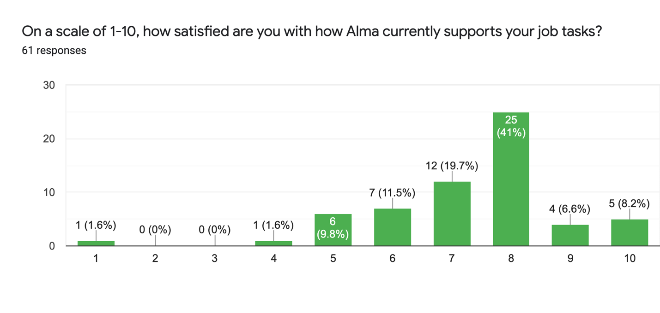

Q2 - On a scale of 1-10, how satisfied are you with how Primo VE currently supports your job tasks?

Average of 7.3

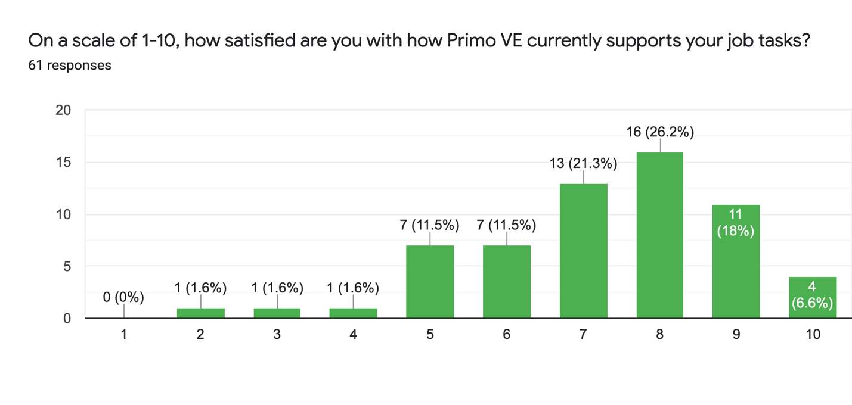

Q3 - On a scale of 1-10, how satisfied are you with the support that Ex Libris provides?

Average of 7.2

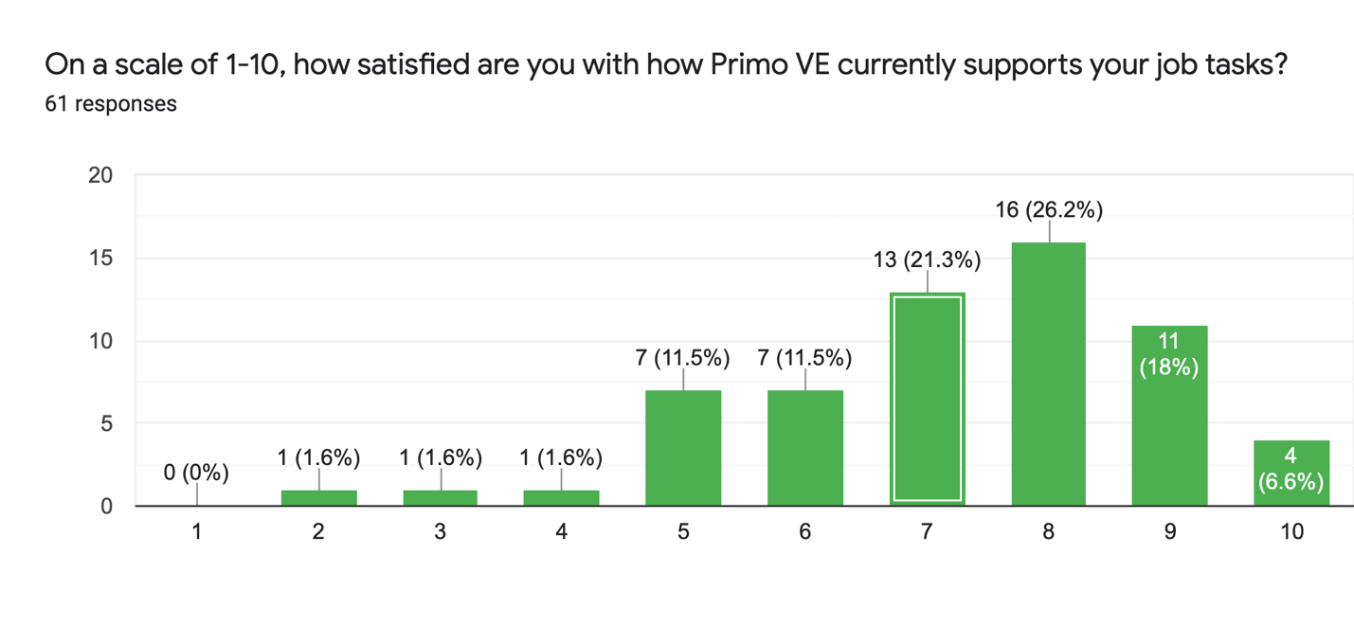

Q4 - What Alma issues currently affect how well you perform daily tasks, if any? (38 responses)

1) Alma analytics is not very intuitive. Even finding saved reports I created is difficult. 2) I've been trying to improve some elements of user experience of Primo VE, and it's really confusing where to go in Alma to fix what I want to fix. Sometimes it's in the Discovery menu, sometimes in the Alma menu. It makes no sense to me. And, since ExL documentation is lacking, I often have to ask colleagues where to find something (like updating citation format options - was not where I expected it to be).
All the different lookups you have to do to figure out what's going on with items or to make things happen with items.
Alma slow running of daily scheduled jobs
Alma workflows are okay but it would be great to have a better LC call number criteria in Analytics under Course Reserves
Analytics daily stats data retrieval
cdi issues, bad citations, etc.
Content management continues to be a trial. The Community Zone Updates Task List remains an endless source of work, with urgent (but often mysterious) changes needing immediate action buried under tons of minor changes and useless churn. It's been a particularly rough year with Ex Libris staff committing several major parsing errors and erroneous mass portfolio deletions. CDI of course also continues to bewilder and frustrate, just from the sheer complexity of it and the difficulties involved in troubleshooting.
CZ records update frequency and CZ Metadata quality
CZ update task lists constantly has errors with their updates.
difficult to use when searching for materials; its search functions are not intuitive.
Feel like I can do my daly task, but feel like if I know more I could do more.
Harder to look up items with call numbers, which is something library patrons often ask for.
Hold Shelf processing items showing up on weekly Requests reports to patrons cause so much trouble and no resolution from ExLibris, Course Reserves very time consuming to manage, Home delivery requires many workarounds.
I am not fond of the patron's account info being on the right side of the screen; I think this info should return to the upper area of the screen.
I feel it's an incredibly robust system, but I wish it was more customizable in order to reduce the amount of clicking, saving, overriding, etc...
I need more training regarding year end closing. I used the webinars from 19.20 but still had problems. This year I need to straighten this out! I suggest new users be paired up with mentors to increase user efficiency during the learning curve.
I really wish it didn't time out so often, both Alma & Analytics, and I don't get much warning that it is timing out (if at all). I will be in the middle of a demo or teaching and it will time out and then I have to log in all over again.
I think confusion over the CDI indexes is probably my biggest problem. It's tough to understand search results sometimes but I know things change fast so honestly I don't think the search results are a big deal.
I would like to see more functionality in the Network zone. And more functionality in receiving and sending items.
It sometimes runs super slow making it harder to be productive.
layout/organization of processes
XML/letters still difficult to set up
Never received any training, only links to self-directed training. Very challenging to make time to do that and also I prefer learning from an instructor, at least initially.
Not really a Alma User. But would like to suggest a way to help shelving crew do weeding. Like https://github.com/Georgetown-University-Libraries/AlmaInventory If this could also check across all CSUs to help with dropping 5th or 6th copy
Open Access linking problems
Please keep in mind that I only have about 9 months of experience using Alma.
During my initial months working with Alma, I've been dong a lot of SUSHI set up and cleaning up some COUNTER usage data. Despite project COUNTER, I think certain aspects of COUNTER reports, such as when the usage data is not available yet or when the usage for the month is 0, are not standardized especially with various file formats (json vs. excel, etc.) So Alma is not able to tell whether there was 0 usage for a month when usage is being harvested in json format and keeps trying to reharvest usage for the months that had no usage.
Additionally, it would be nice if Alma had better functions in managing COUNTER reports in Alma. One of the enhancement requests that is being "planned" is allowing the multiple reports to be deleted at once. When this is implemented, this would be a huge time saver.
A fix that I am waiting on (to be released this month) is how Alma keeps "multiple copies" of usage data for the same vendor+platform+year+month instead of overwriting the older usage data with the most recent usage data. So to get ready for ACRL reporting, I was going through the usage data and deleting the duplicates but found out that the release would be this month.
Quality control of subject headings very important! Abundance of dead end subject headings, and keywords. Keywords buried in MARC records don't show up in user records. Search terms are often not hightlighted in records. Removal of certain filters. Can't isolate print books in records without getting a bunch of govt documents.
Since not all the EBSCO records were indexed in CDI, we need to figure out the best practice to make EBSCO records accessible to users.
Sluggishness in some processes such as Relinking
Still delay in response time with barcode scanning. Alma should be able to process as quickly as we are able to scan in a barcode.
The analytics reports are not immediately available after invoice posting completed but available the next day. Please have the reports available to review/print shortly after posting.
The number of clicks to accomplish one task.
There are so many places to look just to get an idea of what is going on with an item
There's been progress in the last year to provide fuller bibliographic records coming from the CZ. Appreciate the effort. However, as we have learned when we switched to VE, brief records for ebooks or videos are merging with other records on the title since essential identifiers are missing. Hoping that if fuller records are added to the CZ, then, this problem may resolve?
I still have concerns about what is being flagged as "open access". Ex Libris merges records, taking the preferred one and then adds an open acess indicator though it's possible the resource is not available to us. Ex Libris is examining this since many customers noted the confusion for end users. Still want them to know this is a high priority. We shouldn't have to rely on the "unpaywall feature" to somewhat solve this. That's like applying a band aid without investigating the root cause.
Too many clicks required, e.g. when viewing an item record there is no edit button on that page. The save button is too close to the new button in the mde, it takes too much effort to click the little down arrow next to save. Sometimes after I enhance a record I cannot make further edits until I save it

Q5 - What Primo VE issues currently affect how well you perform daily tasks, if any? (29 responses)

CDI metadata accuracy
Primo VE merged same titles if there is no ISSN or ISBN, which caused unexpected merge.
Display Logic Rules - very confusing to implement and still a work in progress
Feel like I can do my daly task, but feel like if I know more I could do more.
Having only one resource type is problematic for Government Docs. We can't apply the solutions we did in PBO. Therefore the GovDocs filter in the front end is essentially worthless and misleading. Would like to figure out a solution or workaround.
As we learned during the VE evaluation, Ex Libris seems to forget to design features that also work for consortia. An example is that we came up with our own solution to hide the unwanted 856 URLs that appeared in the "links" section of records. This is more a comment about remembering consortia needs.
We discovered that when filtering by date newest, we're not seeing the latest and that's because (we believe this is why) the CZ bib records are missing crucial details related to date. As noted in the Alma section, metadata seems to be key.
I actually would like to see if we own something that is checked out in Primo. Maybe this is a local setting though.
I can usually find what I am looking for--our patrons however, get overwhelmed with facets, non-exact matches, and duplicate entries
I don't think our electronic holdings are well-reflected but I'm not sure if that is what you're asking here.
I encountered an occasional issue when emailing records to myself. The email could arrive without the item information, and/or without a link, to revisit/relocate the item in OneSearch. I tested the email function while being signed in and not signed in, and the issue happened for each situation but not consistently. One time, I received the email containing notes I had typed (one has to be signed in to add notes to the email) but the email did not contain any item information or link back to the item. Funny :)
I miss the centralized options we had in Primo Back Office, so much more work has been passed down to individual campuses
If not all resources are searched (EBSCO?), then end up doing a search in multiple places, adds work. Realize this is somewhat out of our control.
If records have no ISBNs or ISSNs, Primo VE will merge records based on titles, although authors or formats are different. It may affect many records. We see IZ streaming media merged with NZ eBooks. Some local streaming media having the same titles are merged, yet they are different videos.
It's slow. Relevancy ranking is still poor, although slightly better than before.
Lack of ability to control quirks in records. Commonly hear at local level "that is not under our control" Why does toggling down to "subject heading exact" go haywhire? (it reverts to title exact).
Large serial/multivolume holdings require scrolling through HUGE number of "show more items" without the former version's tabs or other "jumping" mechanism.
Multiple records listed for the same title and edition can be confusing - all have different requesting options when you click on the record; separate ebook and print book records
No search index for location (we would like to have this). It would be great to be able to exclude individual subject headings/topics in facets.
Primo VE CDI records are messy - bad metadata that
Public item notes do not display well at all. local subjects do not display and are not discoverable
Showing too many duplicate portfolios that's not necessary
the issues with bad citations which involves filing many problem reports
The lack of accurate numbers for "Full-text online" or any other filters hinder students' abilities when doing research to determine if their scope is appropriate (i.e.: too broad or too narrow) at first glance. The lack of integration with Zotero also hinders faculty and student research which I assist with regularly (weekly but probably not daily)
The problem of CSU+ requests being cancelled remains frustrating.
There are constantly issues that come up with Primo not performing as it should. As a small campus, we don't have the person power to be fixing things all the time.
There is a daily parade of user problem reports, often from poor quality metadata leading to bad links. Gaps in the documentation have made implementation not a one-time project but an ongoing effort to root out serious bugs like the one where staff roles were imported when users were auto-created, and much of the problem hinged on a setting that Ex Libris had failed to mention or document. It is frustrating that we keep encountering profound differences in the way things are done in VE, that Ex Libris simply neglected to mention during implementation, or soft-pedaled to make the migration sound easy. The difficulty in getting our Digital Commons feed to work properly has been ridiculous--we had nowhere near the problems with PBO, even with rich-text fields and other challenges.

Q6 - What are we unlikely to have heard yet about how well Alma and/or Primo is working for you? (19 responses)

ALMA is not intuitive and heavy on clicks to get to places. Terms like portfolio are an example. Customer service and learning platforms - not good. Sales force seems to be hit or miss. Ticket processing is clucky. Questions as to why are not answered. Some tickets we do not get answers on. Training materials are hit and miss. Primo VE CDI records are messy - bad metadata that effect Primo.
Continuity of communication with status
direct linking is something I'm looking forward to
Getting the emails from Primo VE to be nicely formatted is proving a challenge. It is frustrating that you can't save a search URL that includes a location filter (yes we know we can build them manually, and do so, but this is not a great system). On the praise side, I'd like to mention that our campus is VERY excited to be able to start using Collection Discovery in VE.
I think overall Primo VE is an improvement.
I would like to know more about how other libraries have things set up.
It has improved markedly from when we first got it, but still more improvements to fast and easy use would be appreciated as time goes on.
It's amazing what can be accomplished with this management system, as I think back and compare it to the early days of library automated systems.
My understanding is if issue tix is submitted -the response time is quick. Even if the response is "that would be an enhancement.'
New Customer Service portal seems to be more responsive that previous Salesforce
Re: Primo VE (OneSearch) --- I'd like to see item Publication/Creation dates in the initial brief search results of Articles. Maybe that is a local setting that can be adjusted. Publication/Creation dates are shown for in the brief search results for Books, but not for Articles.
Sometimes hearing back on salesforce tickets take a while

Q7 - Anything else that you want me to communicate to Ex Libris or to ULMS Governance?
(17 responses)

Excellent
ExL support still takes months to address issues. It's really outrageous how long it takes even for simple, straightforward problems (like metadata errors).
I can't think of anything given our library's structure.
I like the new Support Portal but it's not designed for consortia. We should be able to see other CSU cases.
Implement chat for late afternoons/evenings (PST)
updated information on ExLibris knowledge portal for Primo VE, MDE, etc.
In general, I'd like to see more organization and communication around the Primo VE norm rules. It looks like it's starting to move in a better direction but it still lacks transparency and equitable needs assessment across campuses. Also, the documentation on what any given rule does is inadequate. I'd like to see, at minimum, a *complete* list of each field a rule touches and the expected final transformation. It can be quite difficult to parse the rules themselves to understand the intent and impact.
In general, the system works well for my purposes and I appreciate the ability to save items, to email items, to report issues, all within the same platform. As a librarian who leads a service unit (IV Library), I would like access to and training/proficiency in more areas of Alma. I realize this is more about our structures than the system.
Is there a "Help page" or product manual online somewhere that lists the different possible Primo/OneSearch features and explains what they do/how they are supposed to work? Thank you!
Love the webinar/trainings - Thank you!
Nope, please keep your great work. I think Open forum sessions is highly effective providing communication and support to all the campuses. Thank you!
Suggest mentor opportunity for new user on-boarding.
The rollout of the support portal has been awful and makes my daily work so much harder.

