Unity Courier Report 2022/2023
  - By The Resource Sharing Functional Committee and Christopher Lee

Introduction
The Unity Courier ships Resource Sharing materials between the California State University (CSU) campuses and several in-state partners at a flat monthly rate. This reduces costs and turnaround times compared to traditional shipping methods. Over the past couple years, the CSU has successfully added several additional University of California (UC) stops to the CSU contract without increasing costs. This expands the number of partners we can share with without being billed for individual shipments as we would through the USPS, UPS, or FedEx.
The more available partners on Unity, and the more we prioritize Resource Sharing relationships with those partners, the better. More partners will help materials get to our patrons faster while reducing costs. The Resource Sharing Functional Committee (RSFC) and the Resource Sharing Manager (Christopher Lee) propose the following actions to increase the use of Unity over traditional shipping services. These projects are related, but not exclusive. They can all be implemented independently.

Increasing Use with Existing Partners
For additional partners on Unity to be useful, Resource Sharing units need to direct requests to our partner libraries before those requests go to libraries outside the courier contract. An unintended side effect of Rapido is that some of our Unity partners are being skipped because Rapido sends items through Rapido pods before sending them to ILLiad where requests can go to partners not using Rapido or Alma Resource Sharing. This has led to a rise in shipping costs, but there are several options to reduce or eliminate these costs.
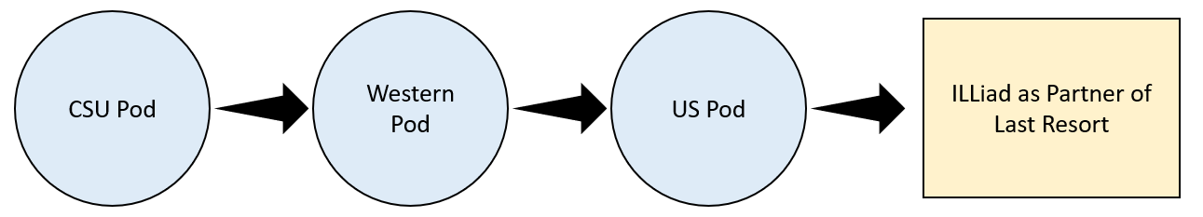
Figure 1 Diagram showing requests going through Rapido pods and eventually ILLiad.

Hybrid Pod with Alma Resource Sharing
The reason Unity partners, such as the UC libraries, are being skipped within Rapido is because they aren’t on Rapido. Since they aren’t currently using Rapido they aren’t in the Western or US pods, so the only requests that go to the UCs are requests that weren’t filled in Rapido and ended up in ILLiad or WorldShare. Ideally, the UCs would be the Rapido pod immediately after the CSU pod in priority. Thankfully, there is a way to add libraries on Alma, but not Rapido, to a Rapido pod.
Last year a handful of CSU libraries began testing Alma Resource Sharing rotas with a few libraries outside our Alma Network Zone. This worked well before we went live with Rapido but improved dramatically after Rapido go live. These Alma rotas were replaced with Rapido Hybrid Pods where some libraries in the pod use Rapido and some use traditional Alma Resource Sharing. For the Rapido libraries this added real time availability checks, easier configuration and system maintenance, and let us prioritize the pod. For the Alma only libraries this made setup easier and continued to act like an Alma Resource Sharing rota.
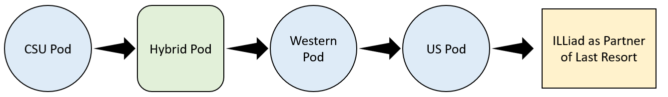
Figure 2 Diagram showing requests go through the pods with a Hybrid Pod.
The UC libraries are all on Alma and Ex Libris can easily add a hybrid pod between the CSU and UC libraries. This pod would let us prioritize the UC libraries and add real time availability checks on their materials in Rapido. The RSFC asks for permission to approach the UC libraries on the Unity contract and ask them to create a hybrid pod with the CSU. We would like to move quickly to reduce shipping costs as soon as possible.

Hybrid Pod with ILLiad
Ex Libris claims a Hybrid Pod can be made with ILLiad partners, but the configuration and setup is much more complex. So far, all our Unity partners are on Alma so this may not be a configuration we need to make. If we ever add Unity partners not using Alma, we will explore this setup.

Growing the Unity Partners Network
While the UC libraries are the only libraries we pay to share with on our Unity contract, there are many more libraries using Unity we do not have partnerships with. Representatives from the Statewide California Electronic Library Consortium (SCELC) recently reached out proposing a Unity partnership. They want to create a statewide Unity route where member libraries pay to join the route and can share with all the libraries on the route. This would be a similar system to the Link+ route contract instead of how our current contract works where each library needs to be individually added to the contract and paid for separately.
So far, all the libraries interested in joining the statewide Unity route are on Alma. As part of the agreement with sharing with each other on the Unity route, we suggest asking libraries to join a statewide Hybrid Rapido pod. The CSU’s and any other Rapido libraries would get the full benefits of Rapido, while other member libraries would be able to share through Alma Resource Sharing as we did with CSU+. This will help grow our local priority partners to reduce costs, decrease shipping times, and send less materials to ILLiad as Partner of Last Resort.
To make this work we would need to amend or renegotiate the terms of our Unity contract. To start this process, we simply need to add language to the contract allowing additional partners besides the UC libraries. When it is time to renew our contract, we can renegotiate with Unity to simplify the overall process.

Staff Workload
Prioritizing existing Unity partners through a shared pod and adding additional partners will likely reduce staff workloads. Many staff have said processing items to ship through Unity is a faster and easier workflow than shipping through the USPS, UPS, or FedEx. With Unity shipments we put all the items in a reusable canvas bag or plastic bin, zip it closed, and add a reusable shipping card. All other items are individually packaged for each library and shipping labels are made using courier specific software.
The same number of requests will likely be made regardless of if we ship through Unity or another service because these changes wouldn’t make much of a different in Primo. Instead, more requests will go through Rapido’s unmediated workflows instead of winding up in ILLiad.

Conclusion
Over the next year we propose two main projects to improve Unity and Rapido. We want to reach out to our Unity partners to try and create a Hybrid Rapido Pod. We also want to lay the groundwork for creating a statewide Unity route with SCELC by adding a few test libraries while approaching additional potential partners. This should help reduce all over shipping costs and grow our Rapido network.
Please let us know if you have any questions.

Thank you,
Christina Dwyer, CSU Chico
Astra Gleason, CSU Sacramento
Stacy Caron, CSU Fullerton
Debbie Blair, CSU San Marcos
Sara Larson, CSU Northridge
Priscilla Ortiz, CSU San Bernardino
Christopher Lee, Office of the Chancellor

