These procedures should be applied when you have one e-collection to pair with one order. If you have multiple e-collections that need to be tied to one order (ie. there is a single cost for multiple e-collections – Gale Access, OmniFile, etc.), use the procedures **NZ Opt-in Ordering (Multi).**

**Part One**

Make a list of NZ opt-in e-collections to order

* Search Electronic collection where Collection available only for = [your library] AND Internal Description (Electronic Collection) Contains Keywords opt-in

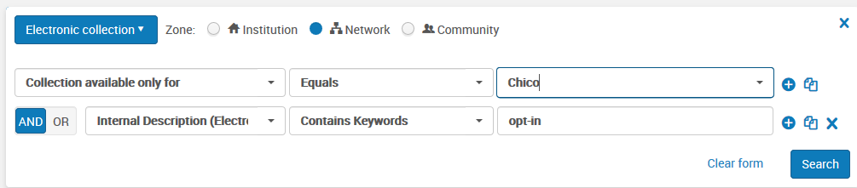

* Export results list to Excel so that you have a list of exact e-collection names
* Edit this list
  + Not all opt-ins will be in the NZ yet, so add collections that are not listed that you expect to see
  + Not all opt-ins in the NZ will be ready to order, so compare the Excel list to the Alma results and note which do not have an “Order” button on the right

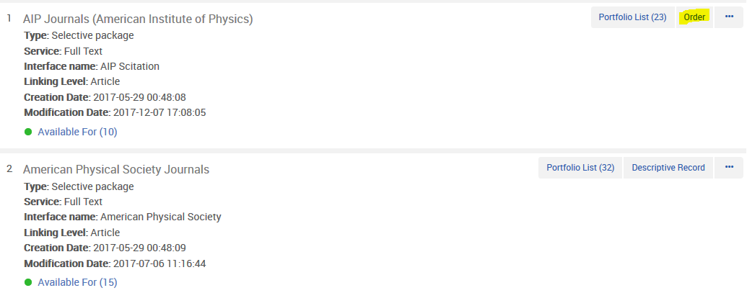

Ready to

order

Not ready to order

* Check any discrepancies/questions
  + If a collection doesn’t look right, consider checking the NZ instance of Alma
    - Use the licenses login to search for a license (either by directly searching licenses or searching for e-collections and clicking on “Other details”)
    - In the license, check the Negotiation Details tab to see your library’s price for the resource and compare this price to your current orders/subscription memos
    - If this is the license you are looking for, click the Inventory tab and copy the name of the NZ e-collection to use for ordering

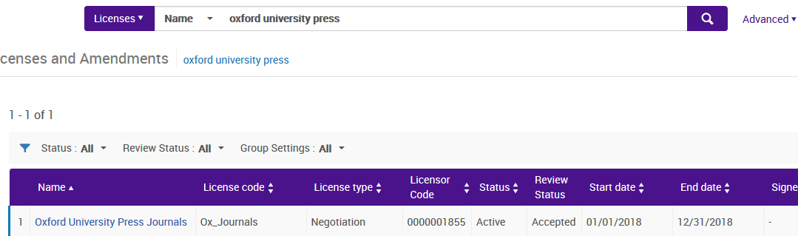

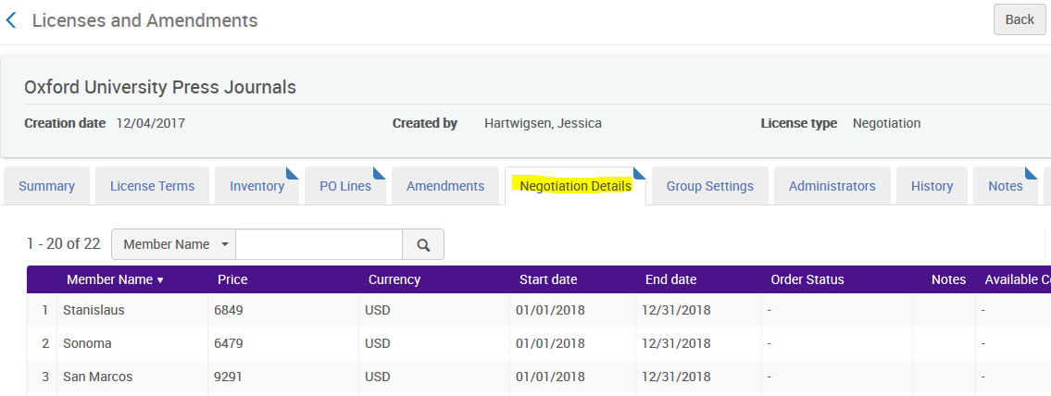

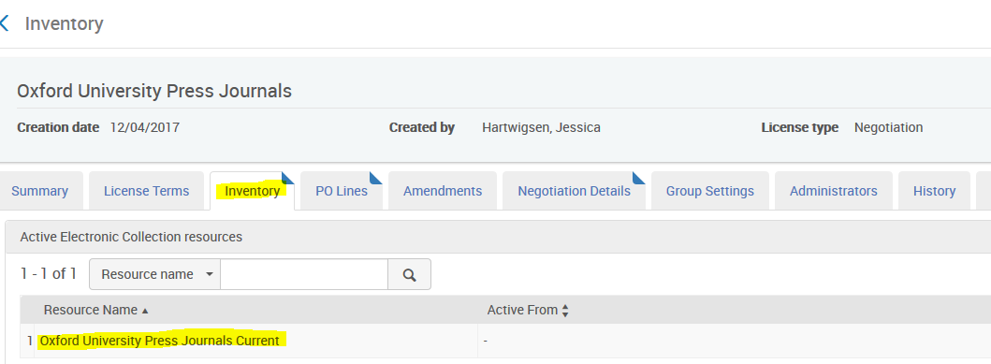

**Part Two**

Create a local e-collection in the IZ for each NZ e-collection (if desired)

* Add a database type local e-collection
* Use the same name as NZ collection
* Add an internal description note that this collection is to hold the opt-in order, but title links are in NZ (if desired)
* In the general information tab, add your current POL as an Additional PO Line
* In the additional information tab, add collection level URL
  + Add a bib in the Additional descriptive information field to make collection visible in Primo (if desired)
  + Check the NZ for a collection-level bib before bringing one in from Connexion
    - [If you bring one in from Connexion](https://calstate.atlassian.net/wiki/spaces/ULMS/pages/62423139/Provider-Neutral+Records+Use+of+Database-Level+Records), use a provider neutral, PCC bib where possible

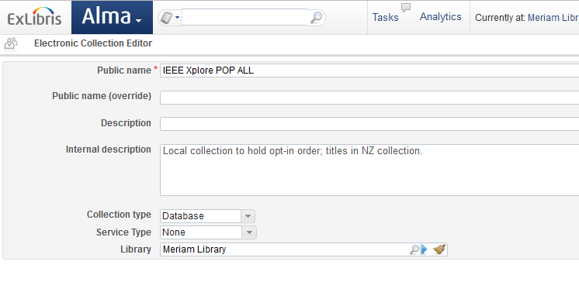

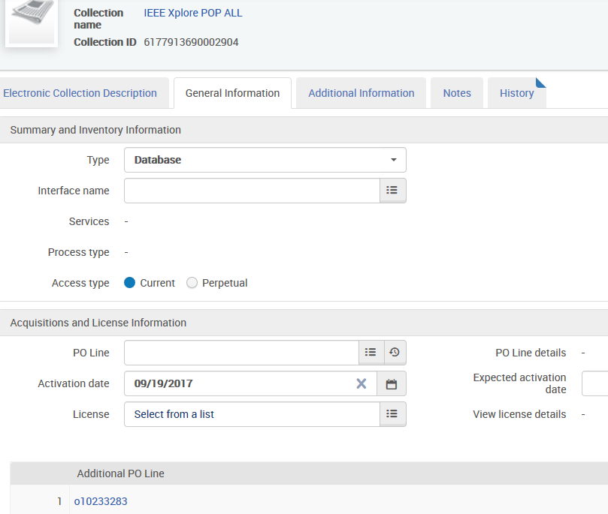

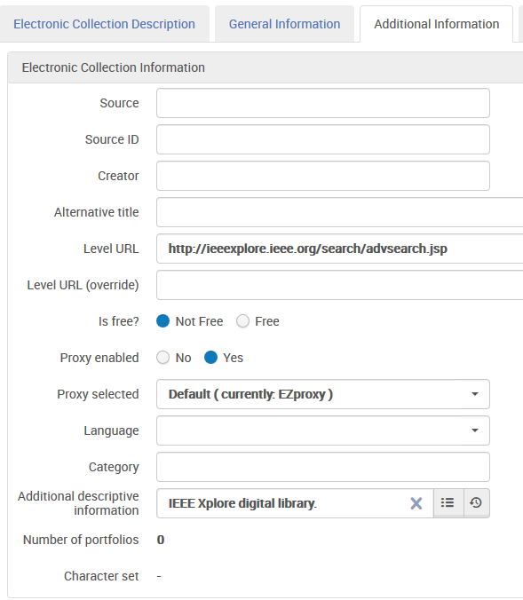

**Part Three**

Order e-collection in the NZ

* Find the e-collection in the NZ
  + Confirm that it is available for your library and available to order
* Use Electronic Collection – Subscription for your line type
* Use CO as the material supplier
* Fill in all other fields (fund, reporting codes, renewal, etc.) in accordance with your library’s policies
* Associate old POL to new in the Additional area at the bottom

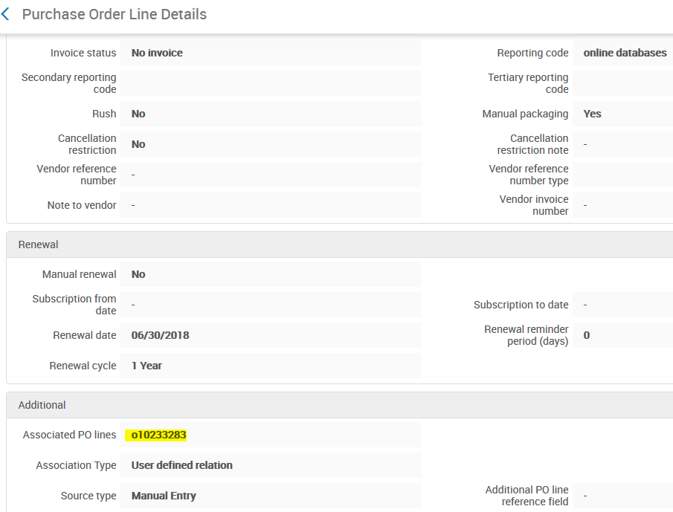

Edit IZ e-collection

* Add new POL as main POL to e-collection

Close your old order

* Best to wait on this until it is linked to all e-collections desired

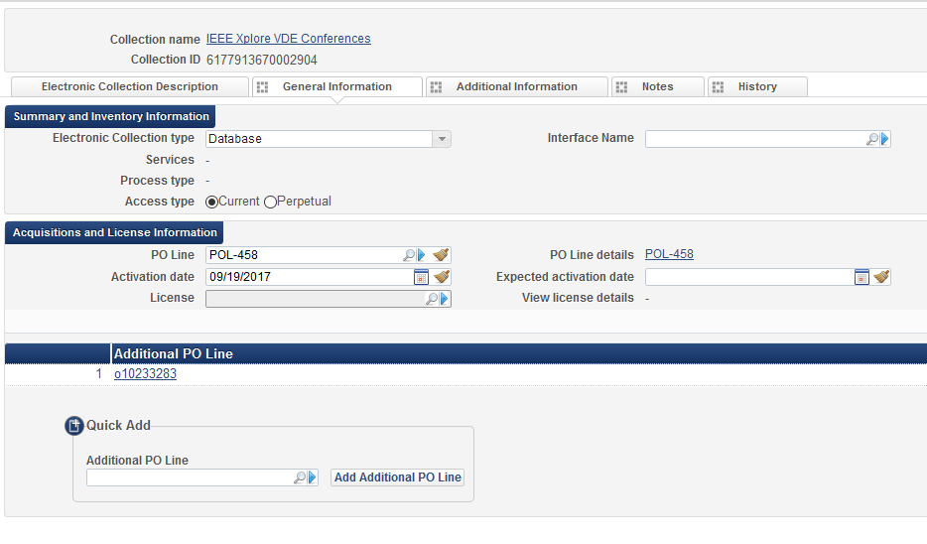

A few additional notes:

* You can’t attach an NZ e-collection order to a bib record, only an e-collection
  + Functions like an Alma order without inventory
* You can link closed orders to e-collections, but it requires an extra step to search for the inactive order
* You can link one old POL to multiple e-collections as an additional POL
  + (useful for things which may have been lumped together on one order and now have an order for each e-collection)
* You can link an order without inventory POL to an e-collection as an additional POL
  + It cannot be the main POL
* You do not have to add a local e-collection if you do not want to. The NZ order can stand alone.