These procedures should be applied when you have multiple e-collections that need to be tied to one order (ie. there is a single cost for multiple e-collections – Gale Access, OmniFile, etc.). If you have one e-collection to pair with one order, use the procedures **NZ Opt-in Ordering (Basic).**

There are three ordering options for this scenario.

**Option One**

* Create an Order without Inventory in your IZ
* Order each e-collection in the NZ as a technical order
  + List no price or fund
  + Add your Order without Inventory as an associated POL
* Add local electronic collections (if desired) to your IZ following the NZ Opt-in Ordering (Basic) procedures

**Option Two**

* Order one of the e-collections in the NZ according to the NZ Opt-in Ordering (Basic) procedures
  + If desired: add a note to the order listing the e-collections included in this order
* Order each of the remaining e-collections in the NZ as a technical order
  + List no price or fund
  + Add your initial NZ order as an associated POL
  + If desired: add an explanatory note to the order
* Add local electronic collections (if desired) to your IZ following the NZ Opt-in Ordering (Basic) procedures

**Option Three**

* Order one of the e-collections in the NZ according to the NZ Opt-in Ordering (Basic) procedures
  + If desired: add a note to the order listing the e-collections included in this order
  + If desired: change the title of the order to reflect the package, not the individual ordered e-collection
* Add local electronic collections (if desired) to your IZ following the NZ Opt-in Ordering (Basic) procedures

**Choosing an Option**

Your choice of procedure hinges on POL purchase types and whether you want each collection to have its own order.

**Option One vs. Two**

An Order without Inventory (part of option one) can only be an Other Service purchase type. In this case, Other Service – Subscription. This means that if you do a set/an analytics report of Electronic Collection – Subscription POLs, this order would not be included.

You could make it a policy to include Other Service – Subscription POLs in any analytics reports/sets, but this could get complicated if you also use orders without inventory for other types of charges.

If you want all your database POLs to have the same purchase type, choose option two. If the purchase type isn’t as important as having all the POLs for a package the same (instead of a unique one with a price), choose option one.

**Options One/Two vs. Three**

Options one and two will allow you have an order for each specific collection in the package. This may be helpful for analytics reports. Option three will allow you to place, track, and update fewer orders, but in analytics ordering reports it will only show up as one e-collection order. If you want to indicate that it represents multiple collections, you will need to indicate that in notes, etc. in the report.

**Preparation (all options)**

Make a list of NZ opt-in e-collections to order

* If you don’t have the list from Jessica, it is easiest to look at the Inventory tab of the license using the NZ licenses login to determine the exact list of e-collections included in the package
* You can export this list to Excel to facilitate ordering

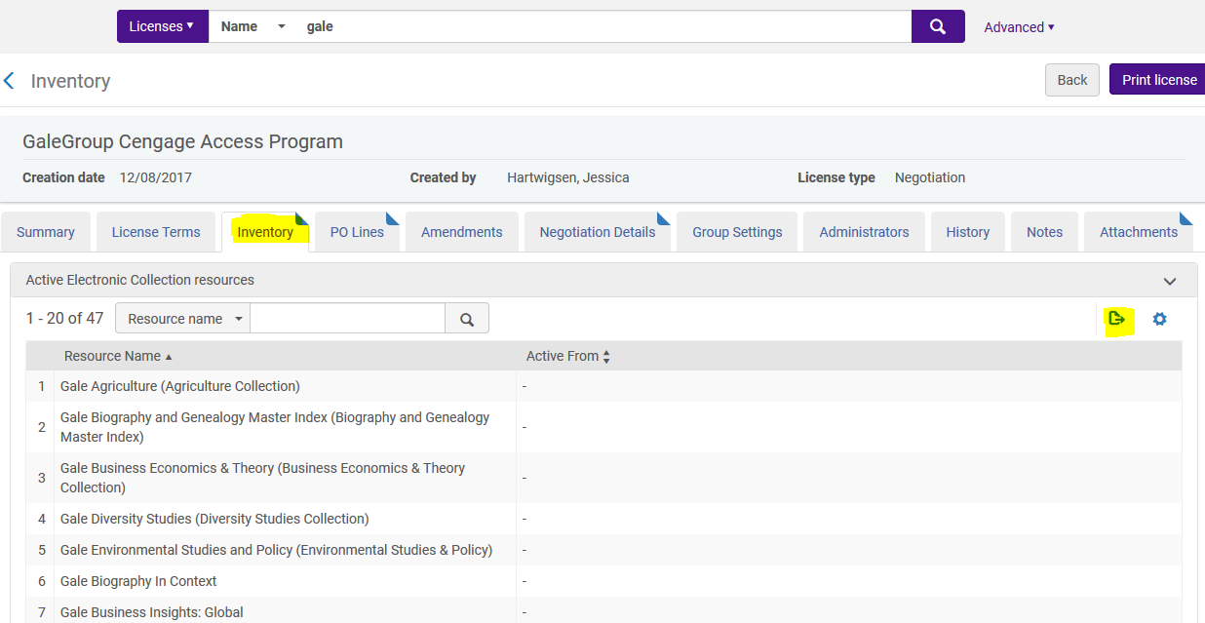

**Option One**

**Part one**

Create an Order without Inventory in your IZ

* Go to Acquisitions -> Order Without Inventory
* Add an order heading (aka. name), alternative heading, and description as desired
* Use purchase type = other service – subscription
* Add your library as the POL owner

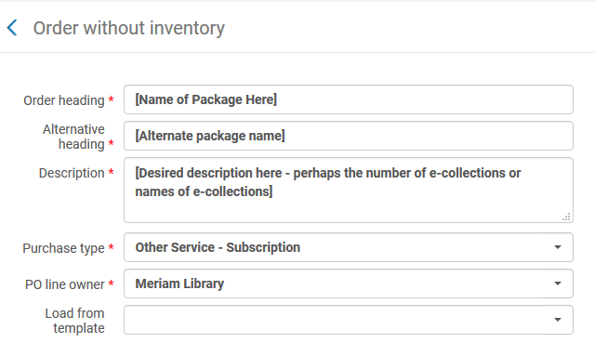

Complete the POL

* Use CO as the material supplier
* List the total package price
  + If you are unsure, check the Negotiation Details tab of the license in the NZ login
* Fill in all other fields (fund, reporting codes, renewal, etc.) in accordance with your library’s policies
* Consider adding a note to the POL indicating which collections are included in the order
* If applicable, add your migrated POL as an associated POL

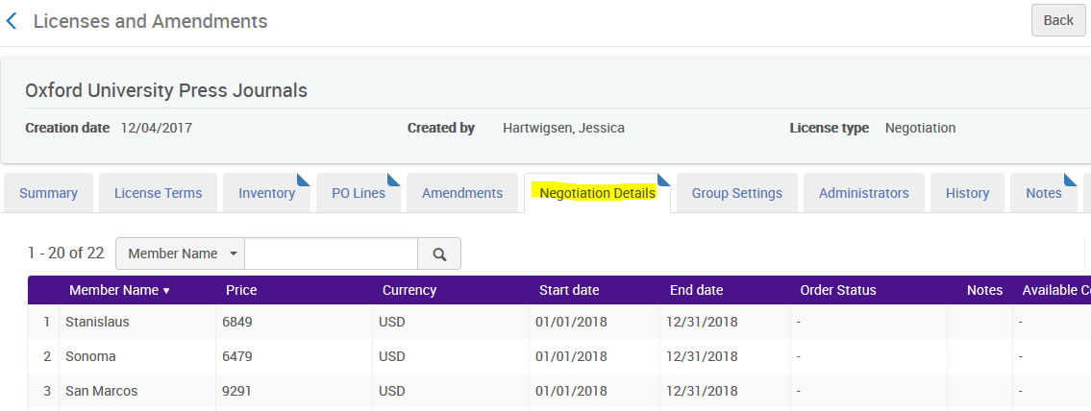

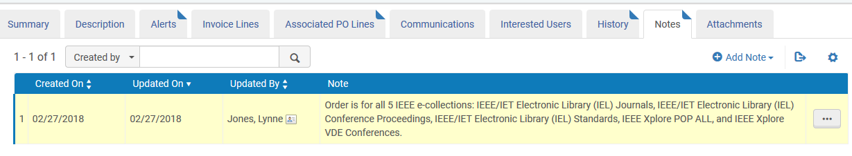

**Part Two**

Order each e-collection in the NZ as a technical order.

* Find the e-collection in the NZ
  + Confirm that it is available for your library and available to order
* Use Electronic Collection – Subscription for your line type
* Use CO as the material supplier
* Set the list price as 0.00

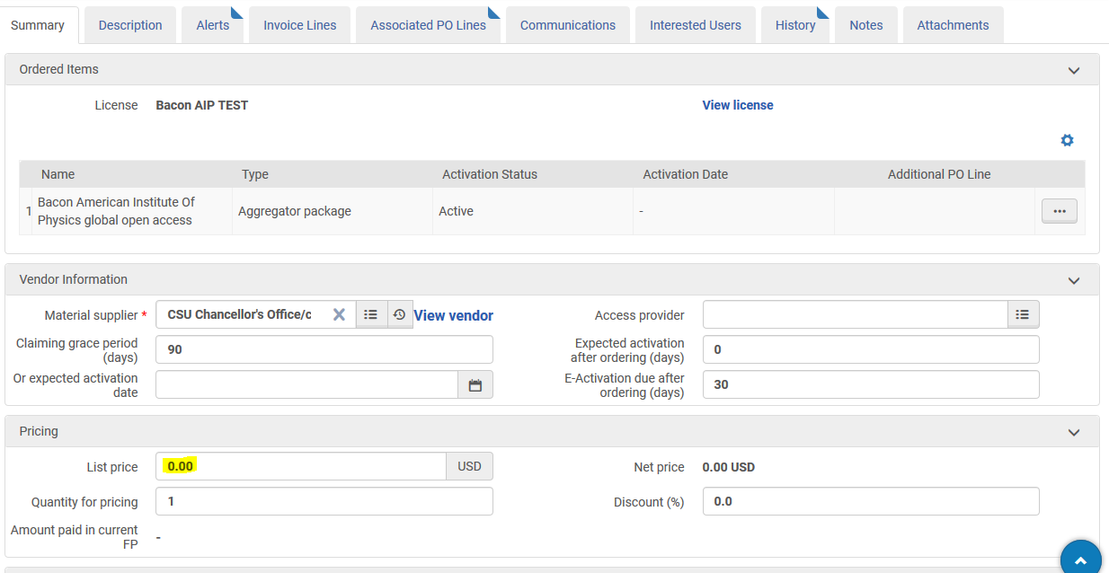

* Do not include a fund
  + You cannot have a fund without a price
* Set the Acquisition method to Technical
* Associate the Order without Inventory POL to this POL in the Additional area at the bottom

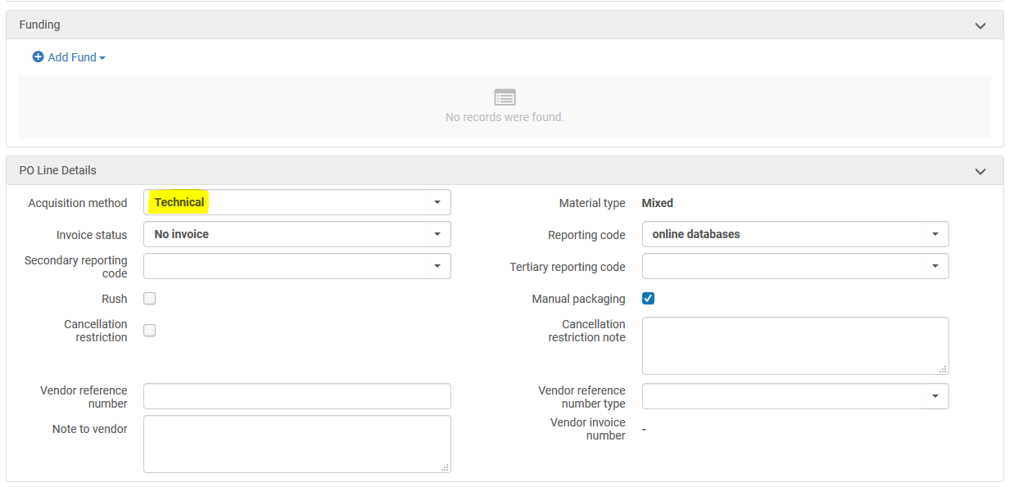

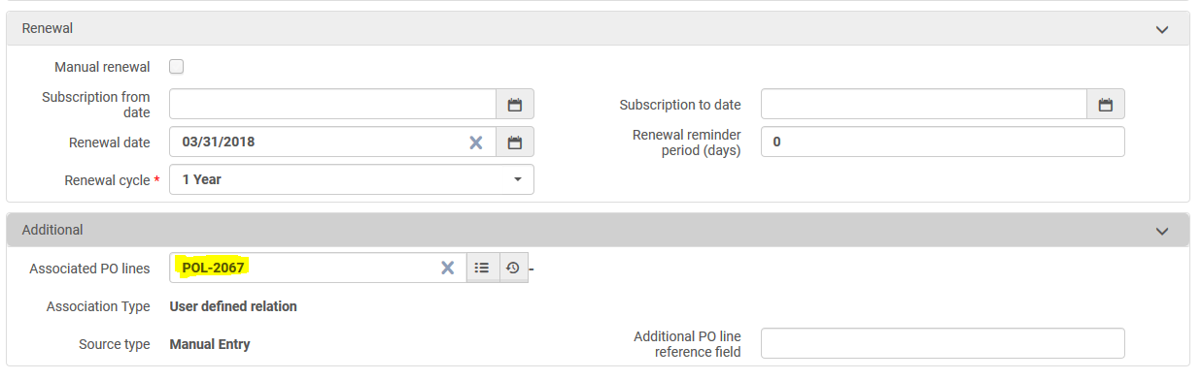

**Part Three (if desired)**

Create a local e-collection in the IZ for each NZ e-collection

* Add a database type local e-collection
* Use the same name as NZ collection
* Add an internal description note that this collection is to hold the opt-in order, but title links are in NZ (if desired)
* In the additional information tab, add collection level URL
  + Add a bib in the Additional descriptive information field to make collection visible in Primo (if desired)
  + Check the NZ for a collection-level bib before bringing one in from Connexion
    - [If you bring one in from Connexion](https://calstate.atlassian.net/wiki/spaces/ULMS/pages/62423139/Provider-Neutral+Records+Use+of+Database-Level+Records), use a provider neutral, PCC bib where possible
* In the general information tab, add the appropriate technical POL as the main POL
  + Add your migrated POL and the Order without Inventory as Additional PO Lines

**Option Two**

**Part One**

Order any one of the e-collections in the NZ

* Find the e-collection in the NZ
  + Confirm that it is available for your library and available to order
* Use Electronic Collection – Subscription for your line type
* Use CO as the material supplier
* Fill in all other fields (fund, reporting codes, renewal, etc.) in accordance with your library’s policies
* If desired: add a note to the order listing the e-collections included in this order
* Associate old/migrated POL to this one in the Additional area at the bottom



**Part Two**

Order the remaining e-collections in the NZ as technical orders

* Find the e-collection in the NZ
  + Confirm that it is available for your library and available to order
* Use Electronic Collection – Subscription for your line type
* Use CO as the material supplier
* Set the list price as 0.00



* Do not include a fund
  + You cannot have a fund without a price
* Set the Acquisition method to Technical
* Associate the initial NZ POL (with price and fund) to this POL in the Additional area at the bottom





**Part Three (if desired)**

Create a local e-collection in the IZ for each NZ e-collection

* Add a database type local e-collection
* Use the same name as NZ collection
* Add an internal description note that this collection is to hold the opt-in order, but title links are in NZ (if desired)
* In the additional information tab, add collection level URL
  + Add a bib in the Additional descriptive information field to make collection visible in Primo (if desired)
  + Check the NZ for a collection-level bib before bringing one in from Connexion
    - [If you bring one in from Connexion](https://calstate.atlassian.net/wiki/spaces/ULMS/pages/62423139/Provider-Neutral+Records+Use+of+Database-Level+Records), use a provider neutral, PCC bib where possible
* In the general information tab, add the appropriate technical POL as the main POL
  + Add your migrated POL and the Order without Inventory as Additional PO Lines

**Option Three**

**Part One**

Order any one of the e-collections in the NZ

* Find the e-collection in the NZ
  + Confirm that it is available for your library and available to order
* Use Electronic Collection – Subscription for your line type
* Use CO as the material supplier
* Fill in all other fields (fund, reporting codes, renewal, etc.) in accordance with your library’s policies
* If desired: add a note to the order listing the e-collections included in this order
  + Only the one you ordered will show in the inventory section of the POL
* Associate old/migrated POL to this one in the Additional area at the bottom
* Go to the Description tab and change the title of the POL to your desired package name

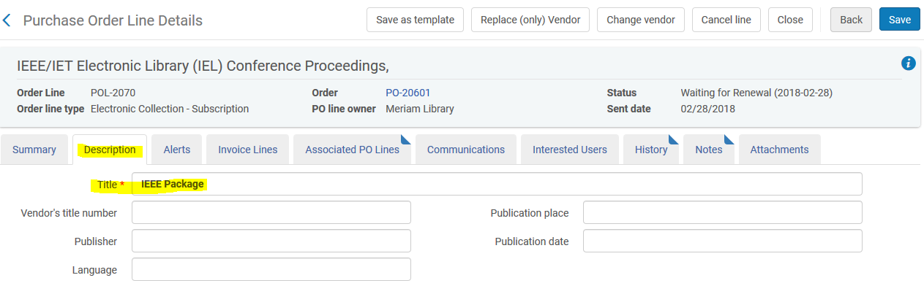



**Part Two (if desired)**

Create a local e-collection in the IZ for each NZ e-collection or for the package

* Add a database type local e-collection
* Use the same name as NZ collection/package order title
* Add an internal description note that this collection is to hold the opt-in order, but title links are in NZ (if desired)
* In the additional information tab, add collection level URL
  + Add a bib in the Additional descriptive information field to make collection visible in Primo (if desired)
  + Check the NZ for a collection-level bib before bringing one in from Connexion
    - [If you bring one in from Connexion](https://calstate.atlassian.net/wiki/spaces/ULMS/pages/62423139/Provider-Neutral+Records+Use+of+Database-Level+Records), use a provider neutral, PCC bib where possible
* In the general information tab, add the new POL as the main POL
  + Add any migrated POLs as Additional PO Lines