Compiled list of Solution Conversations where available 2018

Req. ID 3929 Article details in RS borrowing requests in Analytics

**Reports by NERS**

Journal details (title, volume, pages) are needed to be added to the Analytics Borrowing Request subject area to identify multiple articles being requested from the same journal issue.

**Is this a correct evaluation of what you want?**

Below is a screenshot of borrowing request of citation type “article”

Please confirm that the fields I have put in red squares are the ones you want in analytics.

If not, please do the same in return: take a real live borrowing request of citation type article and make a screenshot and put in red squares the fields you want in analytics.

Only in this manner will we unequivocally be sure we are all talking about the same fields.

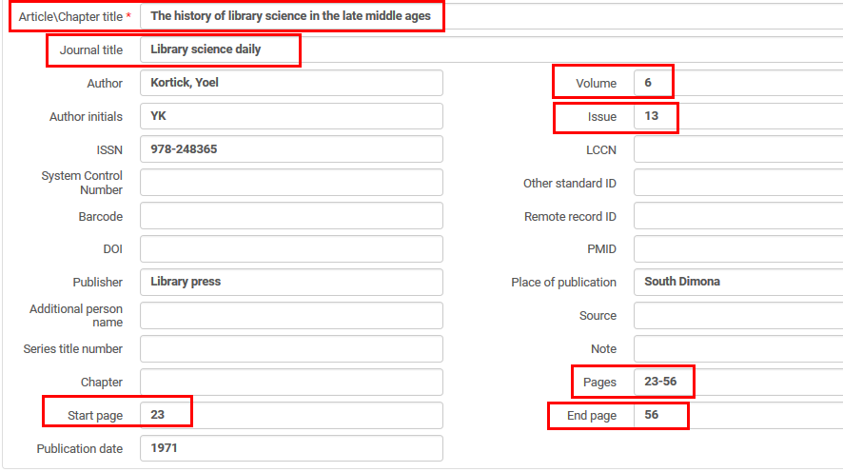

Req ID 4787

"Alma’s Community Zone search will be enhanced such that when searching a portfolio, an indication will be added if the collection it belongs to is activated (held) by the institution the staff user is viewing from."

Req ID 5041

**Suggest solution:**

1. The contents of the 035 subfield ‘a’ will go to the csv file which is the output of the job ‘Export Physical Items’.
2. It will be semicolon delimited and the column name will be called “Other System Number” (the name of the index in which it is indexed).
3. It will be hard-coded and not via an option such as a checkbox “include 035 field” because the assumption is that having the 035 field there will not “bother” anyone or cause a regression.

making sure we are exporting the main OCLC ID

Req ID 5340

We understand this request to be focused on the aspects of improving the GetIt display of related records.  
  
Currently, when there is a related holdings record it is displayed with a simple label saying 'related holding (see attached)

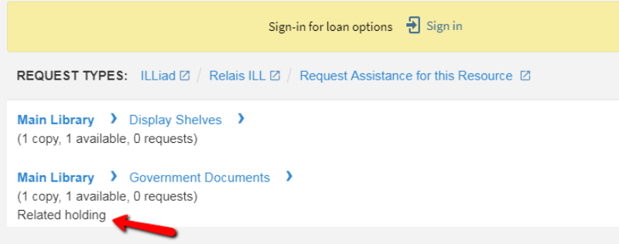

The lablel should have a place holder to show what the related record is, as is displayed when viewing the related record (see attached).  
  
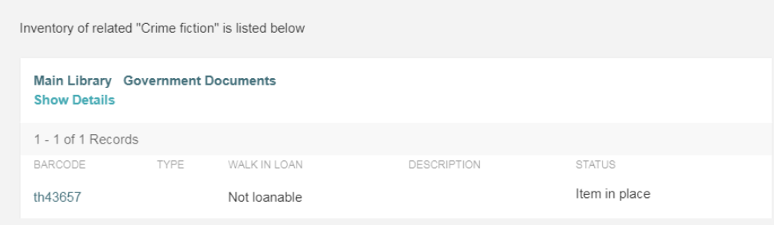

In both places (in the list and when viewing the specific holding), the label should be bold.

 It will also be possible to turn off the display of related holdings in the GetIt altogether

Req ID 5395

The current behavior is that lost item check-in message does not appear if no lost item replacement fee and refund policies of the lost loan fines have been configured. I would like to suggest that this be changed without a configuration option, i.e. that the message will **always** be issued, regardless of whether there are refund policies. The message will indicate whether lost item fees were charged and whether the lost item return triggered any refund.

Req ID 5594

We're thinking along the lines of - 

1. Currently there is only a Proxy For tab. The tab should have two modes of display:
   * User is proxy for (like today)
   * Users that are proxy for the user. In this mode the system will:
     + Show the users that are proxy to the current user
     + Allow adding users to be proxy for the current user
     + be able to look at a user record, and toggle the Proxies tab's view mode so that it will display either users that this user is 'proxy' for, or users that this user is 'sponsor' for.
2. Adding\removing a proxy should send a notification to the proxy and the sponsor.
3. The proxy relation between two users will have an expiration date. After the expiration date, the proxy relation will be considered inactive, and be ignored by the system.
   * The date of expiry will be updateable in the Proxies tab of the user form.
   * A customer parameter will enable to set the number of days before expiry that a notice will be sent to the sponsor user, warning that this proxy is about to expire. This will be done by a job that will scan the proxy expiry days and the parameter on  daily manner
4. Adding a proxy will trigger an email to the sponsor with the name of the proxy, and the expiry time.

Req. ID 5612 Description Field of Predicted Items

Below is a detailed graphic and textual explanation of how Alma works, preceded by the report from NERS.

Please tell us in a similar fashion (graphic, textual, and detailed) how you want Alma to work instead.

Thank you.

**Reported by NERS:**

When opening predicted items, the Description-Field is populated by the data provided in “Next Predicted Item´s information” and displays these data in a certain interpunctuation-logic. Unfortunately, this logic is not equal to the description- (and interpunctiation-) logic used in German speaking countries (which is following ZETA-Standard) – and there is no possibility to edit this. Since there has to be a correct description (for sorting etc.), the only way is to open and edit every single item once it is created by prediction pattern. This is causing a lot of unnecessary work to be done manually - we need the description template to be editable so that items with a correct description can be created automatically in the first place!

**Here is how Alma now works:**

**ONE**A POL of type “Print Journal Subscription” is created for journal “The Australian Women’s Weekly”.

It is POL FUN2018-40929 MMSID 9958588990502883

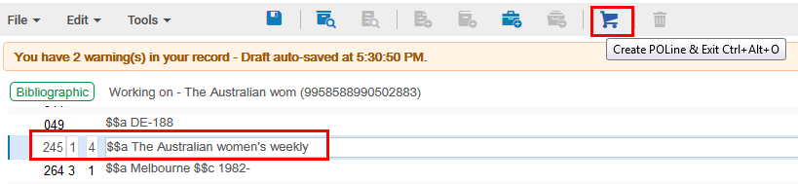

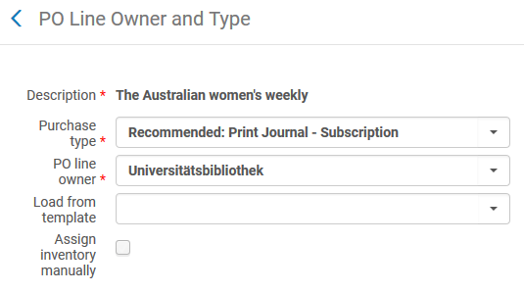

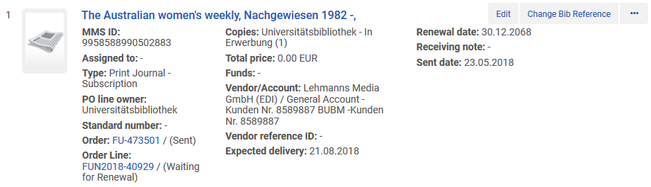

**TWO**

The holdings record is edited and an 853 is added from the template “Serial prediction quarterly months”.

It has field

85303 $$a v. $$b no. $$u 4 $$v r $$i (year) $$j (month) $$w q $$8 1

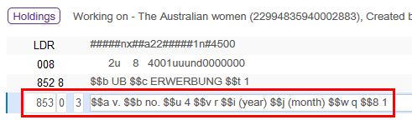

**THREE**

We do “Tools > MARC 21 Holdings > Next Predicted Item’s Information” (or F3).

We fill in as follows:

First level of enumeration(a) = 7

Second level of enumeration(b) = 1

First level of chronology(i) = 2018

Second level of chronology(j) = 01

Issue Date = 20180101

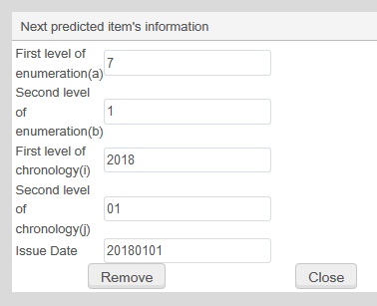

**FOUR**

We do “Tools > MARC 21 Holdings > Open predicted items”

The item description uses the prefixes and parentheses from the 853 field

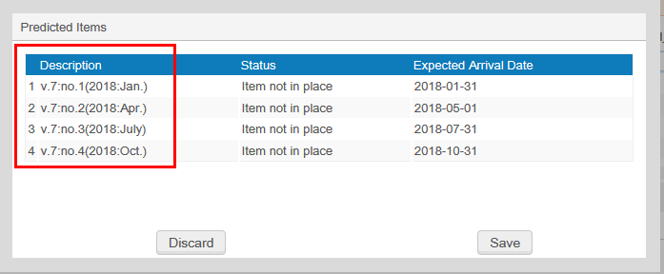

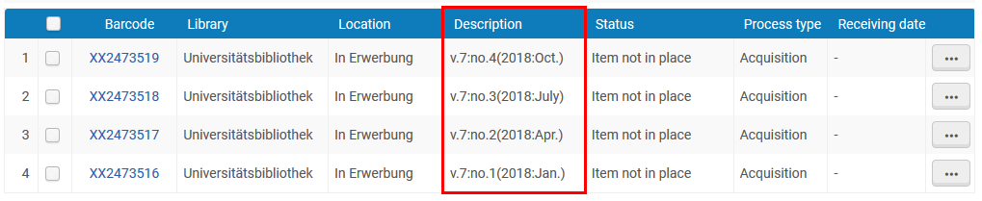

**FIVE**

For example the first issue has description:

v.7:no.4(2018:Oct.)

The holdings record has

85303 $$a v. $$b no. $$u 4 $$v r $$i (year) $$j (month) $$w q $$8 1

There is a “v.” before the “7” because it comes from subfield a

There is a “no.” before the “4” because it comes from subfield b

Req ID 5659

we focus on completed requests - borrower and lender side. When viewing a completed request (in the Completed filter) a row action will enable to 'Reactivate Request'.

I. For **borrowing requests -**

* This will  recreate the stub item using the previous barcode.
* The item will be with a process status of 'in resource sharing'.
* Library and location will be the defaults of the resource sharing library, as when the item is initially created.
* The hold request will be re-initiated if the request was not yet on loan.
* The operator will have the option to re-initiate the loan.
* If no loan is initiated the request status will be 'Request Reactivated'

II. For **lending requests -**

* This will relink the shipped item and set it with a process status of 'in resource sharing'.
* The request status will be 'Request Reactivated'.
* If the item is in another process then it is an error.

In either case, the request will have the same external ID as before it got completed.

In case of an Alma to Alma request, the peer request will also be reactivated if it is complete.

This is relevant only for peer to peer requests.

Req ID 5683

A solution approach would be to enable turning off the current availability+IP based sorting, and listing an institution set prioritized list of libraries/locations instead.

The institution will be able to define list of libraries, in a prioritized order, and list of locations within a library. There may be groups of equal locations/libraries that are prioritized higher than another list of locations/libraries. The prioritization within the group is random.

1. When publishing availability to Primo, if the published record has multiple availability location lines, they will be published in the order that has been defined by the institution.

2. When displaying list of locations in the GetIt tab, if the record has multiple holdings the will be listed in the order that has been defined by the institution.

 Where the institutional priorities have not been defined or are not relevant alphabetical sorting should be used.

add another configuration option to consider patron campus affiliation, so as to pop up locations that belong to the campus with which the patron is affiliated. This will come before the above mentioned considerations.

Request ID 5713

The suggested solution is along the lines of:  
  
1. Configure code table of 'Limited access user roles'. OTB - all roles except patrons  
2. On the user manager/administrator role - allow a parameter for 'allowed access to all users'. This will be on for existing customers, and will be the default.

A user with manger/administrator role will have access only to records of users that don't have any of the roles in the  'Limited access user roles' table, unless his role has the  'allowed access to all users' attribute on.

This attribute will be selectable for all roles that can access the user list (circ desk operators)

What I suggest to add to the proposal is that the described limitation will only be when accessing the full user record edit form, but no limitations will be imposed when accessing the Quick User Management form, i.e. the one that is accessed when clicking 'Edit User Info' (see <https://www.screencast.com/t/MfZVYNnJHl>). This form gives no access to roles but does allow changing contact information. By having this form always open, users will never be blocked from changing emails/address, but may be prevented from touching roles and status.

Req ID 5725

We are thinking along the lines of having the item update job enabled with a new option for 'remove current processes'.

If selected, items that are in any process will be changed to be considered in place. The relevant processes will be terminated (loan closed, request cancelled).   
  
That said, this may be done for processes such as work orders, loans and hold requests, assuming this action in intended to be used to brute force a correction to data errors. However, in a more complicated workflow, such as items in order, that sounds like a complicated and potentially harmful option.

Req ID #5730

We understand the main issues to be about the difficulty to configure the printouts in a more structured manner. The solutions we're thinking about are along the lines of:  
  
1. Allowing to make use of letter XML files that are automatically stored in the system, rather than having to generate them as today. For example, the system may store XMLs for a number of letters when they are triggered by the system. These automatically generated XML files will be available from within Alma for the administrator that will be working on the XSL. This will achieve the benefits of:  
   a. Having XML files in the system that make use of local data  
   b. XML files are readily available when starting to configure a letter, and do not have to be artificially generated at that point  
   c. XML files are up to date with the ongoing additions  
  
2. Organizing the existing menus in a more wizard like UI. For example - The Letter Customization Tool will be a single UI where, after selecting the notification to work on:

    a. An upper part drawer allows managing the XSL

    b. Another upper part drawer is like the current  Notification Template screen, with an option to select the language, and a button for 'Preview'. The button will open a separate window with the generated HTML.

    c. Lower part drawer of the screen shows the XML.

    d. Lower part drawer allows editing the notification's labels code table  
  
This achieves the goal of having a one page configuration screen that gives access to the relevant XML and XSL tools, and to preview the results of the work being done.

Req ID 5746

So, just to recap, the current proposal in this discussion thread is:  
1. The UI mentioned in my May 30 comment, accumulating printouts rather than sending them as email, and allowing to print the accumulated printouts vi the browser printer  
  
2. Allow configuring multiple printers to a circulation desk. When selecting a new 'current at', user will be prompted for the printer (if there is more than one).

Req ID 5753

1. We will extend the time an inactive session is kept active to at least 60 minutes  
2. In addition, activities such as running a query, will extend the session from that point for an additional period of time (i.e. at least 60 minutes)  
3. A popup warning of a sesison timeout in Alma Analytics is not technically possible so this cannot be included in the proposed improvement.

Request ID 5779

The suggested solution is that it should be possible to define a minimal loan period policy, so that when a loan is recalled the new due date will be set so that it will not be less than this number of days since the loan date.

Req ID 5782

Please note that my understanding of the request in the context of regular (i.e. not resource sharing) loans is that the courtesy notice will include information on why the loan was not renewed. The reasons could be 'Item Requested','Loan Recalled','Maximum Renew Date' or 'No automatic renew policy'.

Req ID 5683

A solution approach would be to enable turning off the current availability+IP based sorting, and listing an institution set prioritized list of libraries/locations instead.

The institution will be able to define list of libraries, in a prioritized order, and list of locations within a library. There may be groups of equal locations/libraries that are prioritized higher than another list of locations/libraries. The prioritization within the group is random.

1. When publishing availability to Primo, if the published record has multiple availability location lines, they will be published in the order that has been defined by the institution.

2. When displaying list of locations in the GetIt tab, if the record has multiple holdings the will be listed in the order that has been defined by the institution.

 Where the institutional priorities have not been defined or are not relevant alphabetical sorting should be used.