**Acq Taskforce Discussion Topic: Fund, Vendor and Financial System Code Relationships, 12/7/2016**

**Context:**

During a taskforce discussion regarding the feasibility of implementing “Shared Vendors” in the Alma NZ, questions arose regarding the functionality of fund, vendor and financial system codes with regard to CFS integration.

**Conversation:**

The Financial System Code (as *we* *[SJSU]* migrated it, anyway) is what links vendors between the library and a campus CFS, but don't confuse this with the vendor code. Some code translations below (probably too much info, but in case anyone is foggy on the whole relationship:)

* **Vendor Codes**(Vendor Code in Alma, VENCODE in Sierra)  - Functionally speaking as far as I know, this code is generated manually and serves the purpose of linking the vendor to an order record, and searching by vendor code.  It doesn't do anything in PeopleSoft that I am aware of.
* **Financial system codes** (Financial System Code in Alma, ALTCODE in Sierra, Supplier ID in PeopleSoft) are the link between the Sierra/Mill vendor and the campus vendor record, and that's it (again, the way *we* have it set up.)  It tells PeopleSoft *who* to pay for an invoice.
* **Chartfield codes or Chartfield strings** are how the fund codes map from the library system into different PeopleSoft accounts.  This is maintained in PeopleSoft via a "Speed Chart" (I think that's a PeopleSoft common term, anyway) where each library fund code is mapped to a precise campus account, or Chartfield. (see screenshot below.)  Our library accountant maintains this chart in PeopleSoft for library funds to match each specific fund code we use in Sierra, so it tells the PeopleSoft system exactly which fund to charge for that payment, be it Lottery or Trust funds, subscription or 1-time, etc. This detailed mapping is what allows us to output our invoice data from Sierra and send it to PeopleSoft to semi-automatically generate payments, and this is part of what the Alma-CFS Task Force is hoping to help all the campuses set up if they choose to.

**Alma Vendor:**

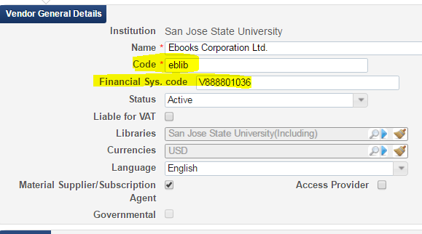

**Sierra Vendor:**

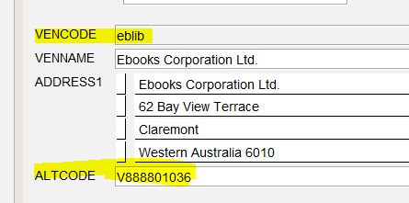

**PeopleSoft Vendor:**

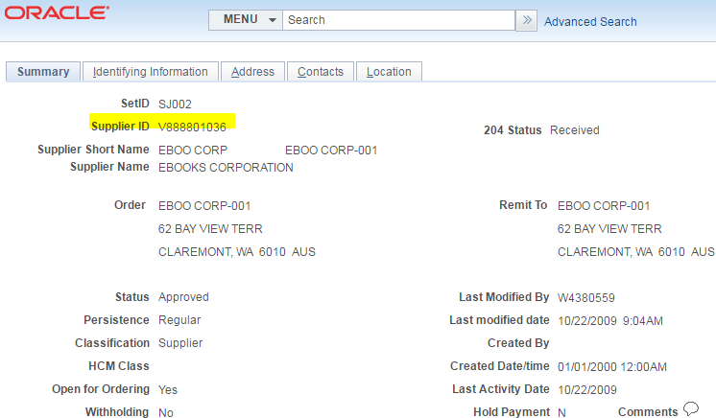

**Chartfield/payment account Mapping**

The screenshot below is a snippet of our SpeedChart.  The left column is our Sierra fund codes. The chunk I highlighted, for example, are all one subject area (Urban Planning.) So "030A" stands for "Urban Planning Approvals", "030EB" stands for "Urb Plng ebooks", etc.  Each of our subject areas has this kind of array of fund codes so that we can automatically identify the precise accounts to charge by just entering the fund code in an order record.

When the order is paid in Sierra, the payment is output and mapped accordingly into PeopleSoft.  I think some campuses have mapped their funds in a similar fashion, but not all have.  Some use a very broad fund code in the system and then have to assign more specificity before they can pay.

**PeopleSoft SpeedChart:**

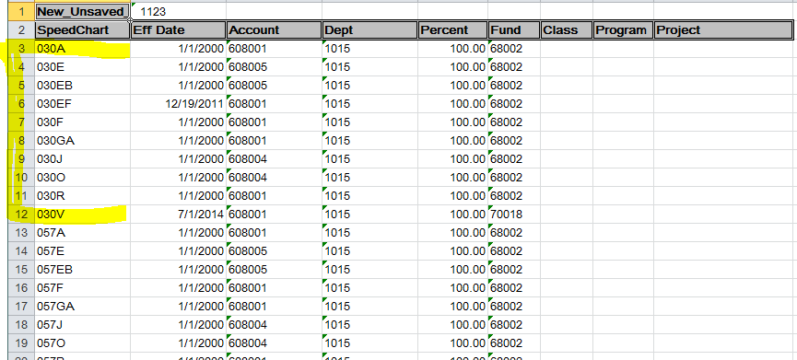

We migrated our funds to Alma in a similar structure, but are using Ledgers to categorize the big buckets of money, so in our case, General, SSETF and Trust funds.

**Alma Fund structure:**

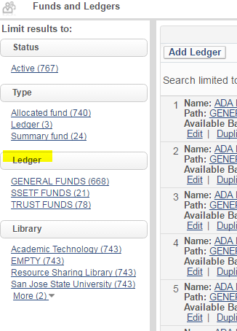

**Same fund codes (as shown in speedchart) as appear in Alma:**

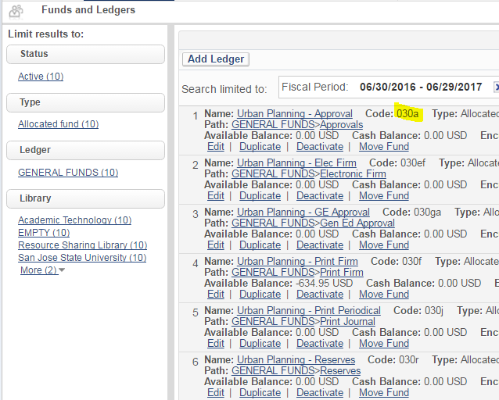

I hope this doesn't confuse more.  Let me know if you have questions.

Carole @SJSU